**Mechanics 1.1 AS 90940 Mechanics**



Formula revision Part 2

**Success Criteria:** We know we have achieved this when we can:

**Remember to answer questions:**

1. Write down formula

2. Rearrange formula if needed

3. Show working

4. Give answer with units

* Construct a Formula equation for Work, Power and Energy
* Be able to give the names and units used in each Formula
* Be able to solve a simple question using each Formula

**1.** Calculating **work** - Fill in triangle and give names and units for each Letter



|  |  |  |
| --- | --- | --- |
| Letter | Name | Units |
| W |  |  |
| F |  |  |
| d |  |  |

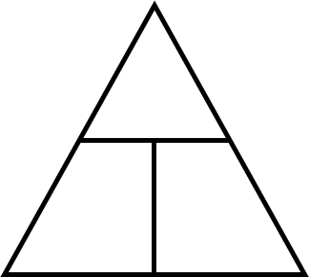

1. Sample Question: A motorbike of mass **150 kg** is lifted **2 m** onto a display stand.

What is the work done to lift the motorbike onto the display stand?

_________________________________________

____________________________________________

____________________________________________

____________________________________________

**2.** Calculating **power** - Fill in triangle and give names and units for each Letter

|  |  |  |
| --- | --- | --- |
| Letter | Name | Units |
| P |  |  |
| W |  |  |
| t |  |  |



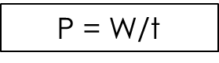

1. Sample Question: A crane lifts **800 kg** of concrete a height of **25 m** in **20 s**.

Calculate the power needed by the crane to lift the concrete.

____________________________________________

____________________________________________

____________________________________________

____________________________________________

**3.** Calculating (gravitational) **potential Energy** - Fill in triangle and give names and units for each Letter



|  |  |  |
| --- | --- | --- |
| Letter | Name | Units |
| Ep |  |  |
| m |  |  |
| g |  |  |
| h |  |  |



mg

Sample Question: A dog, mass **45 kg**, jumps off a bridge into the water below. The bridge is **1.5 m** above the water. Calculate the **gravitational potential energy** the girl loses when she hits the water.

____________________________________________

**Remember to convert mass to weight:**

F (weight) = Mass x Gravity

Acceleration due to gravity = 10ms-2

____________________________________________

____________________________________________

____________________________________________

**4.** Calculating **kinetic energy** - Fill in triangle and give names and units for each Letter

|  |  |  |
| --- | --- | --- |
| Letter | Name | Units |
| Ek |  |  |
| m |  |  |
| V2 |  |  |





½ m

Sample Question: The world record for a men’s team sprint of 1000 m sprint is an average speed of **23.9 ms−1.** If the mass of a rider was **70 kg + 7 kg** for his bike, calculate the riders **kinetic energy** output when he crossed the line.

____________________________________________



____________________________________________

____________________________________________

____________________________________________



