Chemistry 2.7 AS 91167 Demonstrate understanding of oxidation-reduction
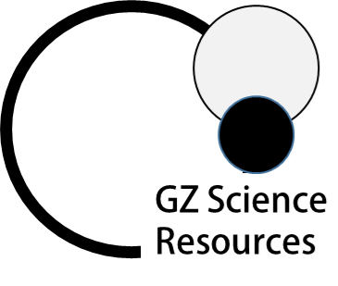
EXAMPLE:
Mix acidified potassium dichromate solution and iron(ii) sulfate solution

REPORT:
Justify why this is an oxidation-reduction reaction. Your answer should include:

1. Balanced half and full equations
Identify the reactants from the question and write two half equations then balance
Cr₂O₇²⁻ → Cr³⁺
The reactants are given but you will have to remember the products
Fe³⁺ → Fe²⁺
1. balance atoms
2. balance O with H₂O
3. Balance H with H⁺
4. balance electrons

14H⁺ + Cr₂O₇²⁻ + 6e⁻→2Cr³⁺ + 7H₂O
(Fe²⁺ → Fe³⁺ + e⁻) x 6
14H⁺ + Cr₂O₇²⁻ + 6Fe²⁺ → 2Cr³⁺ + 7H₂O + 6Fe³⁺
Electron number must be the same before adding ½ equations together.
Cancel off H₂O and H⁺ on oposite sides

2. An explanation of oxidation and reduction in terms of electron transfer or oxidation number change
Oxidation numbers
+6 +3
Cr₂O₇²⁻ → Cr³⁺ the oxidation number of dichromate reduces from +6 to +3 of the chromium ion, therefore this reaction is a reduction reaction (and Cr₂O₇²⁻ is the oxidant)
+2 +3
Fe²⁺ → Fe³⁺ the oxidation number iron (ii) ion increases from +2 to the +3 of iron (iii) ion, therefore this reaction is an oxidation reaction (and Fe²⁺ is the reductant)

Electron Transfer
Cr₂O₇²⁻ gains 6 electrons therefore this is a reduction reaction (and Cr₂O₇²⁻ is the oxidant)
Fe²⁺ loses 1 electron therefore this is an oxidation reaction (and Fe²⁺ is the reductant)

3. Species linked to the provided observations

Orange dichromate ion, Cr₂O₇²⁻ is reduced to green chromium (iii) ion, Cr³⁺ and the rust orange Fe²⁺ ion is oxidised to pale green Fe³⁺ ion.

PRACTICE QUESTION:
Mix hydrogen peroxide solution and potassium iodide solution

REPORT:
Justify why this is an oxidation-reduction reaction. Your answer should include:

1. Balanced half and full equations
Identify the reactants from the question and write two half equations then balance
Oxidation: _____________________________________________________
Reduction: _____________________________________________________
½ _______________________________________________________________________________________________
½ _______________________________________________________________________________________________

Full ______________________________________________________________________________________________

2. An explanation of oxidation and reduction in terms of electron transfer or oxidation number change
Oxidation numbers

oxidation: _____________________________________________________________
__________________________________________________________________________________________________________________________________________________________________________________________________

reduction: _____________________________________________________________
__________________________________________________________________________________________________________________________________________________________________________________________________

Electron Transfer
___________________________________________________________________________________________________________________________________________________________________________________________________________________________________________________________________________
3. Species linked to the provided observations

____________________________________________________________________________________________________________________________________________________________________________________________________________________________________________________________________________________________________________________________________________________________________________________________________

