Physics 1.1 AS 90935 Investigation leading to linear relationship
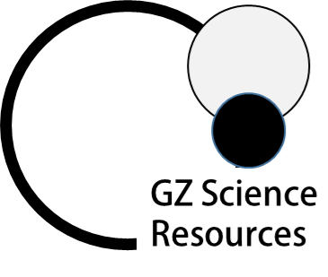
Processing the Data
Success Criteria: We know we have achieved this when we can:
- Construct a line graph from given data
- Make sure your line graph has the following features; line of best fit, title, labels, units
- Understand that the relationship of variables can be written as a mathematical equation
- Calculate the gradient in a line graph

1. Make the headings for the data table (in the shaded boxes) below from the following Aim: How does the length of string on a bob of a pendulum, affect the time for one complete swing?
 | Trial 1 | Trial 2 | Trial 3 | Average
10cm | 0.7s | 0.7s | 0.8s
15cm | 0.8s | 0.9s | 0.9s
20cm | 1.3s | 1.3s | 1.4s
25cm | 1.5s | 1.5s | 1.6s
30cm | 1.8s | 3.8s | 1.9s

2. From the data above which of the values does not appear to look correct? ____________________________
When a value looks much different from what an expected value it is called an outlier and we remove it by placing a line through it.
3. Average the following data in the table above. (After removing the outlier)
4. Using the following information draw a line graph below. Include title, line of best fit, labels and units

5. Calculate the gradient from the graph above using the following formula
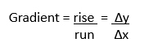
- Remember the y axis will be the dependent variable
- The x axis will be the independent variable
- Select a good length of the straight line to calculate the gradient
- Do not start the gradient at 0,0

6. The relationship of the variables is stated as a mathematical equation Y = gradient x X + intercept
Write the equation for the line above.

7. A conclusion looks for patterns in collected data from an investigation. Both the variable that is changed (independent) and the variable that is measured (dependant) must be included in the conclusion statement.
The data is used as evidence in the conclusion. Write a conclusion for the investigation above.
