**Physics 1.1 AS 90935 Investigation leading to linear relationship**



Writing conclusions

**Success Criteria:** We know we have achieved this when we can:

* Write a conclusion including the independent and dependent variables, linking to your aim
* Use data as evidence in your conclusion
* Include in your conclusion whether the relationship between Independent and Dependent variables is positive or negative

**1.** Use the following graph to **write a conclusion**



**2.** Write a suitable **title** for the graph. Remember to include both the **Independent** and **dependent** variable

**3.** Is this linear relationship negative or positive?

This would indicate that the dependent variable **increases / decreases** as the independent **increase / decreases**

(cross out one)

**4.** Calculate the gradient on the graph below

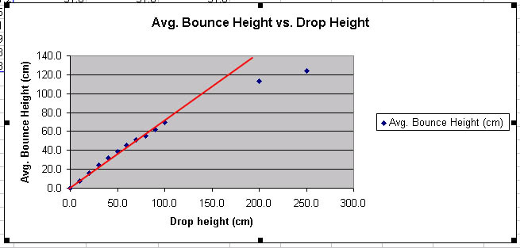



**3.** Is this linear relationship negative or positive?

**5.** Write a mathematic equation for the graph above. (Assume the intercept is 0,0)



**6.** Write a **Conclusion** for the investigation above.

Remember: Both the variable that is changed (independent) and the variable that is measured (dependant) **must be included in the conclusion statement**. The **data is used as evidence** in the conclusion.

**7.** Write the key features that your conclusion must include when writing **your Internal Assessment** in order to work towards an **Excellence** level

