Physics 1.1 AS 90935 Investigation leading to linear relationship
Developing a Discussion
Success Criteria: We know we have achieved this when we can:
- Understand the key areas needed in a discussion; reliability, accuracy, Science ideas, areas of improvement
- Define and explain 'parallax error'
- Define and explain 'zero error'

1. Using the information from the conclusion below write a suitable Aim, list the Independent and dependent variables as well as variables that would need to be controlled.
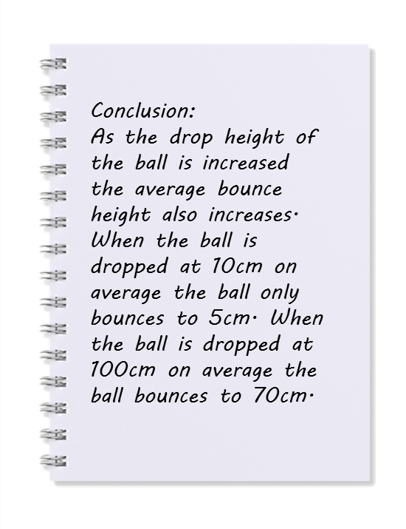
Aim | Independent variable | Dependent variable

Controlled variable | How will the variable be controlled?

2. Accuracy: How will you ensure parallax error is avoided when measuring the height ball bounces?

3. Accuracy: How will you ensure zero error is avoided when measuring the height the ball bounces?

4. How was the reliability (the investigation can be repeated with similar results) ensured in this investigation? Name TWO key features of this investigation.

