Chemistry 2.4 AS 91164 Demonstrate understanding of bonding, structure, properties and energy changes
Writing Excellence answers to Bond enthalpy questions
Bond enthalpy QUESTION
Question: Ethene gas, C₂H₄ _{(g)}, reacts with bromine gas, Br_{2(g)}, as shown in the equation below.
Calculate the enthalpy change, ∆_{r}H°, for the reaction between ethane and bromine gases, given the average bond enthalpies in the table below. Show your working and include appropriate units in your answers.

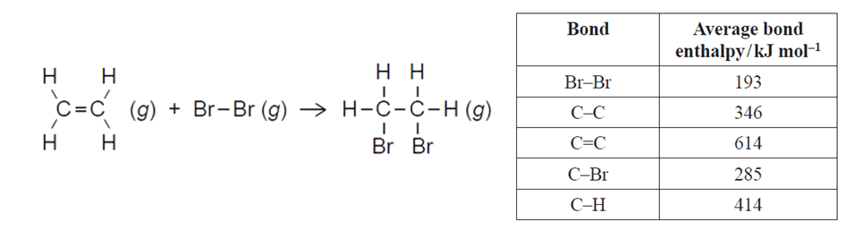
ANSWER
1. list types of bonds for reactants (bonds broken) and products (bonds formed) AND number of each, in a table. Watch for double or triple bonds as these are separate  (Draw Lewis structures if not given) | Bonds broken (reactants) |  |  |  | Bonds formed (products)
2. write bond type for each reactant (bonds broken) and product (bonds formed). Watch for double and triple bonds as they are different. Cross off on lewis diagram as you go | Bond type | number | enthalpy | Total enthalpy | Bond type | number | enthalpy | Total enthalpy
3. write the number of each bond type beside
4. multiply bond enthalpy by number of each bond
5. total reactant bond enthalpy and total product enthalpy

6. bond broken (reactants) enthalpy total minus bond formed enthalpy (products) = enthalpy change, ∆_{r}H°  total enthalpy and calculate enthalpy change (sign, units and 3sgf)  Δ_{r}Hº = ΣBond energies(bonds broken) – ΣBond energies(bonds formed) | Total Enthalpy  (bonds broken) |  |  |  | Total enthalpy  (bonds broken)
 | Total enthalpy =
7. you may have to rearrange equation if enthalpy for a bond is required
Δ_{r}Hº = ΣBond enthalpy (bonds broken) – ΣBond enthalpy (bonds formed)
NOTE: The white column is how your answer would appear on your test paper so make sure you write out complete sentences. The grey area is just to help you structure your answer and would not appear in the question.

