Chemistry 2.4 AS 91164 Demonstrate understanding of bonding, structure, properties and energy changes
Writing Excellence answers to Comparing Actual and Calculated enthalpy data questions
Comparing Actual and Calculated enthalpy data QUESTION
Question: The accepted enthalpy change for the combustion
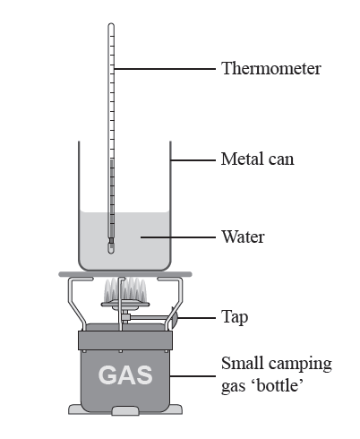
reaction of butane gas, C₄H_{10(g)}, is Δr H = –5754 kJ mol^{–1}.
Explain why calculated enthalpy is different to the accepted value.
In your answer, you should include at least TWO reasons.

ANSWER
1. state values for both calculated data (worked out from a previous question on experimental data) and accepted data
Units, sign and 3sgf
2. link results from experimental data to errors in experimental design

3. explain error number 1.

4. explain error number 2.

5. explain error number 3.

6. explain error number 4. (may need only 2 or 3 in answer)

7. make summary statement linking that not energy released is transferred to heating the water

NOTE: The white column is how your answer would appear on your test paper so make sure you write out complete sentences. The grey area is just to help you structure your answer and would not appear in the question.

