Chemistry 3.6 AS 91392 Demonstrate understanding of equilibrium principles in aqueous systems
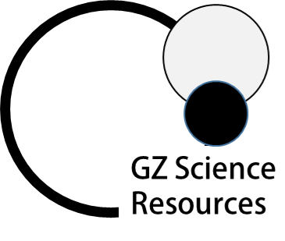
Conductivity and Ions QUESTION
Question: The table shows the pH and electrical conductivity of three solutions. The concentrations of the solutions are the same. Compare and contrast the pH and electrical conductivity of these three solutions. Include appropriate equations in your answer.
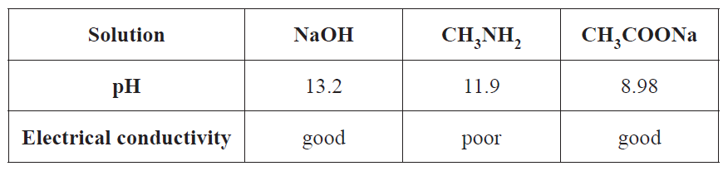
ANSWER
1. Identify each solution as either being a weak or strong acid or base (or salt) linked to the pH (and presence of ions)
2. State requirements for conductivity

3. Solution NaOH (pH 13.2)

Write equation AND link ions formed to conductivity and level of dissociation
4. pH Solution NaOH (pH 13.2)

Link amounts of H₃O₊ / OH⁻ ions to pH
5. Solution CH₃NH₂ (pH 11.9)

Write equation AND link ions formed to conductivity and level of dissociation
6. pH Solution CH₃NH₂ (pH 11.9)

Link amounts of H₃O₊ / OH⁻ ions to pH (compared to previous solution)
7. Solution CH₃COONa (pH 8.98)
Equation 1. [salt dissociation]
Write equation AND link ions formed to conductivity and level of dissociation
8. Solution CH₃COONa (pH 8.98)
Equation 2.[acid reaction]
Write equation AND link ions formed to conductivity and level of dissociation
9. pH Solution H₃COONa (pH 8.98)

Link amounts of H₃O₊ / OH⁻ ions to pH (compared to previous solution)
Writing Excellence answers to Conductivity and Ions questions
NOTE: The white column is how your answer would appear on your test paper so make sure you write out complete sentences. The grey area is just to help you structure your answer and would not appear in the question.

