Science 1.1 AS 90940 Demonstrate understanding of aspects of mechanics
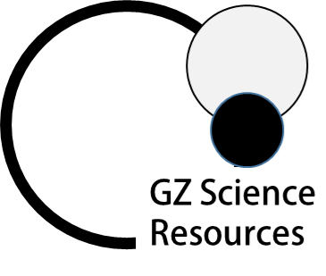
Writing Excellence answers to Conservation of Energy questions
Comparing Energy QUESTION
Question: A crane was lifting wood. The cable broke, and 150 kg of wood fell 12 m to the ground below.
The wood had 15 000 J of kinetic energy just before it landed on the ground below.
This was different from the amount of energy the wood had when it was hanging from the crane.
Explain why there is a difference in the energy the wood had when it was hanging from the crane compared to just before it hit the ground.
In your answer you should:
• name the type of energy the wood had when it was hanging from the crane
• calculate how much energy the wood had when it was hanging from the crane
• calculate the difference between the kinetic energy of the wood just before hitting the ground and the energy the wood had when it was hanging from the crane
• justify the difference in energy of the wood when it was hanging from the crane and then just before it hit the ground.
ANSWER
1. link the type of energy to the position at maximum height and minimum speed (velocity)
2. link the type of energy to the position at minimum height and maximum speed (velocity)
3. calculate the potential energy at maximum height
∆E_{p} = mg∆h

4. compare the Difference between E_{P} and E_{K} (you may have to calculate E_{k} in some questions)
5. link the difference in energy to other types of energy due to friction.
Conservation of Energy QUESTION
Question: Ian jumps into the pool from the 5 m platform.
Calculate Ian’s speed as he is about to hit the water (assuming conservation of energy).
In your answer you should:
• name the types of energy Ian has before he jumps, AND as he is about to hit the water
• calculate Ian’s speed as he is about to hit the water.
ANSWER
1. compare energy types at maximum and minimum height

2. state the assumption about the conservation of energy

3. state E_{p} = E_{k}

4. rearrange equation to make v² the focus (cancel m on both sides)
5. calculate v

NOTE: The white column is how your answer would appear on your test paper so make sure you write out complete sentences. The grey area is just to help you structure your answer and would not appear in the question.

