Science 1.1 AS 90940 Demonstrate understanding of aspects of mechanics
Writing Excellence answers to Interpreting motion-time graphs questions
ION FORMATION QUESTION
Question: Describe the motion of the runner through sections
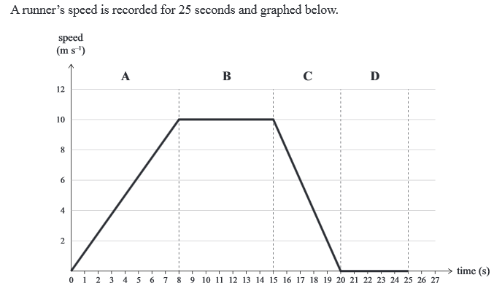
A, B, C, and D.
Your answers should include descriptions AND any relevant
Calculations

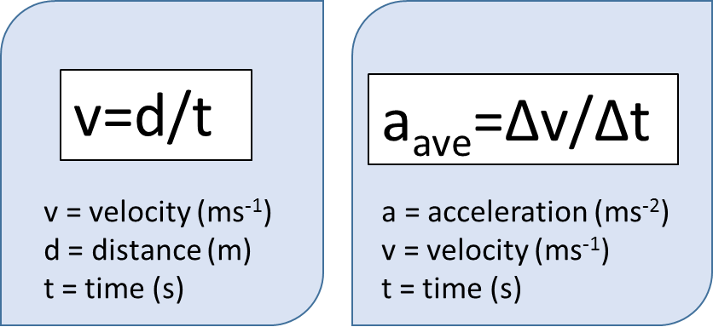

ANSWER
1. state the type of graph used (distance-time or speed-time graph)
2. starting with section A describe the type of motion (stationary, constant speed or acceleration)
3. state the starting speed and final speed, as well as total time taken (use correct units)
4. calculate the motion in section A using either v = ∆d/∆t or a = ∆v/∆t
Show working and use correct units
5. next with section B describe the type of motion (stationary, constant speed or acceleration)
6. state the starting speed and final speed, as well as total time taken (use correct units) – calculation not needed for stationary
7. next with section C describe the type of motion (stationary, constant speed or acceleration)
8. state the starting speed and final speed, as well as total time taken (use correct units)
9. calculate the motion in section A using either v = ∆d/∆t or a = ∆v/∆t
Show working and use correct units (make sure to use a – sign if acceleration negative)
10. finally with section D describe the type of motion (stationary, constant speed or acceleration)
11. state the starting speed and final speed, as well as total time taken (use correct units)
NOTE: The white column is how your answer would appear on your test paper so make sure you write out complete sentences. The grey area is just to help you structure your answer and would not appear in the question.

