**Chemistry AS 91391** C3.5 Organic Chemistry

**This achievement standard involves describing the structure, physical properties, and reactions of organic compounds.**

* Organic compounds will be limited to those containing one or more of the following functional groups: alkene, haloalkane, amine, alcohol, aldehyde, ketone, carboxylic acid, ester (including triglycerides), acyl chloride, and amide.

**Reactivity of organic compounds will be limited to**

* Substitution reactions using the following reagents: concentrated HCl, HBr, ZnCl2/HCl, SOCl2, PCl3, NaOH, KOH (in alcohol or aqueous solution), concentrated NH3, primary amines, primary alcohols/H+, primary alcohols, H2O/H+, H2O/OH– (Substitution reactions include esterification, condensation, hydrolysis, and polymerisation.)
* Oxidation reactions using the following reagents: MnO4–/H+, Cr2O72–/H+, Tollens’, Fehling’s and Benedict’s. Reduction of aldehydes and ketones with NaBH4
* Elimination reactions using the following reagents: KOH in alcohol and concentrated H2SO4 (includes major and minor products from asymmetric alcohols and haloalkanes)
* Polymerisation reactions of formation of polyesters and polyamides including proteins
* Addition reactions of alkenes (used for the identification of the products of elimination reactions).

Appropriate information relating to other oxidants or reductants will be provided.

**Physical properties of organic compounds will be limited to**

* solubility
* melting point and boiling point
* rotation of plane-polarised light.

**Special notes**

Constitutional isomers are those that have the same molecular formula, but a different structural formula.

Systematic naming of amines is restricted to primary amines. Candidates will not be expected to recall the common names of amino acids.

Knowledge of principles of organic chemistry covered in [Chemistry Level 2 AS 91165](http://www.nzqa.govt.nz/nqfdocs/ncea-resource/achievements/2015/as91165.pdf) will be assumed.

**Organic chemistry is the chemistry of compounds that contain both carbon and hydrogen**

Carbon has four valence electrons. The electronegativity of carbon is too small for carbon to gain electrons from most elements to form C4- ions, and too large for carbon to lose electrons to form C4+ ions. Carbon therefore forms covalent bonds with a large number of other elements, including the hydrogen, nitrogen, oxygen, phosphorus, and sulfur.

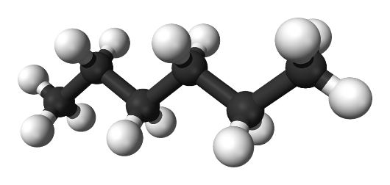

**Organic Chemistry Formula**

**Molecular Formula** – type and number of each atom.

i.e. Propane C3H8

**Structural Formula** – placement of each atom.

**Condensed Structural Formula**

CH3-CH2-CH3

Structural **isomers** are molecules with the same molecular formula but **different** structural formula.

**Alkanes -** generic formula C*n*H2*n*+2

Compounds that contain only carbon and hydrogen are known as **hydrocarbons**. Those that contain as many hydrogen atoms as possible are said to be *saturated*. The saturated hydrocarbons are also known as **alkanes**.

**Straight-chain hydrocarbons**, in which the carbon atoms form a chain that runs from one end of the molecule to the other .i.e. butane

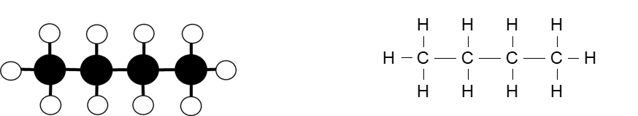

Alkanes also form **branched** structures. The smallest hydrocarbon in which a branch can occur has four carbon atoms. This compound has the same formula as butane (C4H10), but a different structure, known as a structural isomer.

**Prefixes are used to indicate number of carbon atoms in the longest carbon chain**

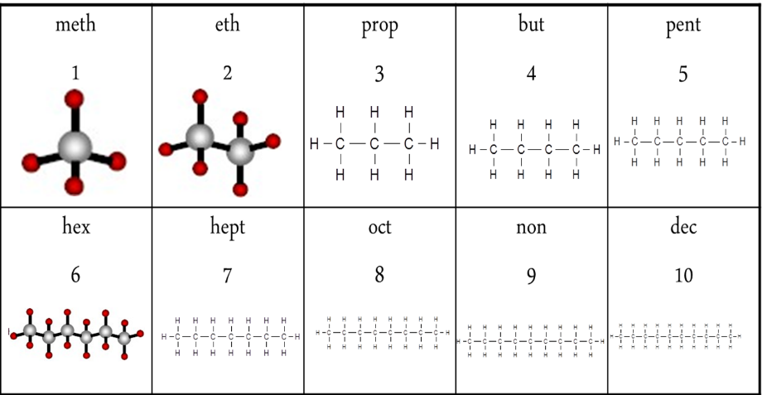

**Naming Branches**

|  |  |  |
| --- | --- | --- |
| **methyl** | **ethyl** | **propyl** |
| **1** | **2** | **3** |
| **-CH3** | **-CH2CH3** | **-CH2CH2CH3** |

**Naming Alkanes**

|  |  |
| --- | --- |
| 1. Identify the longest C chain 2. Identify any branches 3. Number the C atoms in longest chain so branches are on the lowest numbers | 4. Location of branch  5. Name of branch  6. Prefix of long chain  7. -ane |

**Alkenes** - generic formula C*n*H2*n*

Functional Group – One double carbon-carbon bond C=C. A functional group is the part of the molecule responsible for reactions typical of the homologous series.

**Alkene Nomenclature**

Alkenes are named in a similar way to alkanes, *but the longest continuous carbon chain is numbered to give the carbon atoms in the double bond the lowest possible numbers*.

The position of the double bond is given by the smaller number of the two carbon atoms involved.

After numbering the longest chain C1-C2=C3-C4, the compound is named 2-butene or but-2-ene, but not 3-butene nor but-3-ene.



Write name as

1. Location of branch

2. Name of branch

3. Prefix of long chain

4. Location of C=C

5. -ene

6. If in an alkene there are more than one double bond is present, it named as a –diene or –triene.

For example; 2,5-Dimethyl-2,4-hexadiene, here double bond located at 2 and 4 position with two substituent (methyl group) at 2 and 5 positions.



**Summary of solubility in Water – Alkanes and Alkenes**

Alkanes and Alkenes: Not soluble in water. These molecules are non-polar (there is no negative or positive ends to the molecule) compared with water which is polar (having a negative area near the oxygen atom and positive area near the hydrogen atoms) so they are not attracted to each other. Alkanes and alkenes are immiscible (two or more liquids that will not mix together to form a single homogeneous substance) and form a distinct layer from the water. Smaller C chained alkanes and alkenes are less dense than water and float on top.

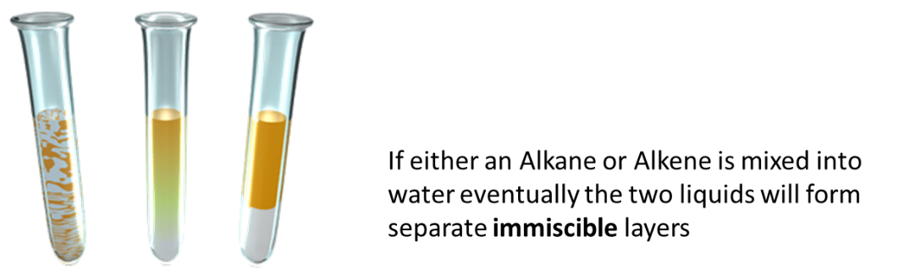

**Summary of Boiling points**

**Alkanes:** The smaller the alkane molecule the lower the boiling point and the more volatile (easier to combust) the alkane. As the molar mass (Mass number of all the atoms combined) increases, the boiling points also increase as the strength of the intermolecular (between molecules) attractions increases.

The alkanes: methane to butane (C1 – C4) are all gases at room temperature Alkanes with between 5C and 15C atoms are all liquids Alkanes with over 15 C atoms are soft solids

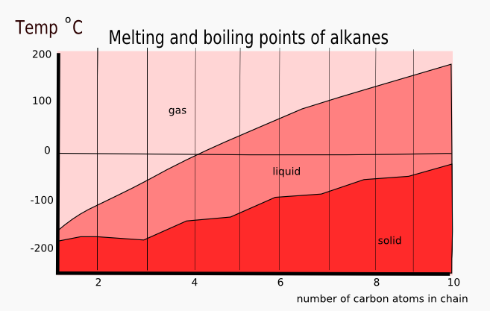

**Alkenes:** The boiling point trend is similar to alkanes where the larger the number of C atoms in the chain the higher the boiling point. The equivalent length C chain alkene has a slightly higher point than that of the alkanes.

Alkenes are non-polar molecules and are bonded together by weak intermolecular forces. As the number of carbons increase so does the Molar Mass of the molecule. The larger the molar mass the more total valence electrons are available.

These valance electrons can randomly cluster on one side or the other creating an instantaneous polar end – thereby creating a bond to another molecules instantaneous polar end.

The greater the number of carbons, the stronger the bond between molecules therefore the higher the melting and boiling point.

**Haloalkanes (alkyl halides)**

Haloalkanes are saturated functional groups that contain one or more halogens attached to a single bonded alkane. Haloalkanes can be classified as a chloroalkane, bromoalkane, fluoroalkane or iodoalkane. Or a combination with the position of the halogen given by the appropriate number of the carbon that it is attached to in the chain.

Haloalkanes have a higher melting and boiling point than their corresponding alkane due to the attached halogen forming a dipole. The boiling point increases down group 17 as molar mass increases, and as the alkane chain increases due to instantaneous dipoles being the most significant factor in bonding.

**Haloalkanes** are only very slightly **soluble** in water. The hydrogen bonding in water is stronger than the attractions between the haloalkane molecules and water so the halogens tend to stay intact (insoluble)

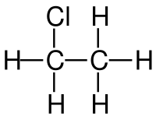

**Naming Haloalkanes**

This leads to the existence of

* primary (1°) – bonded to a C that is bonded to only 1 other C
* secondary (2°) – bonded to a C that is bonded to 2 other C
* tertiary (3°) – bonded to a C that is bonded to 3 other C

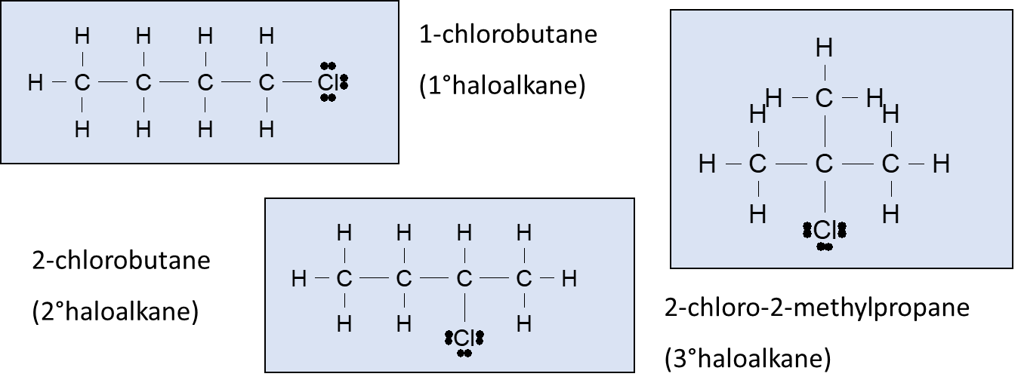

**Halo alkane Prefixes**

|  |  |
| --- | --- |
| **Atom** | **Name used in haloalkane** |
| Bromine  Chlorine  Fluorine  iodine | bromo  chloro  fluoro  iodo |

**Alcohol**

Alcohols are not considered hydrocarbons as they have one or more oxygen atoms attached in addition to the hydrogen and carbon atoms. Alcohols are organic substances however and share many of the same chemical and physical properties of the alkanes and alkenes. Alcohols are used as solvents and fuels and ethanol (a two-carbon alcohol) is used as a drink.

Functional group is the hydroxyl group –OH (not a hydroxide)

**Naming alcohols**

1. Location of branch
2. Name of branch
3. Prefix of long chain
4. an-
5. Location of OH (if multiple di, tri, tetra)
6. –ol

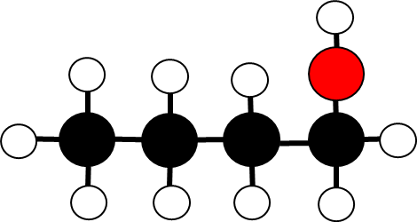

Alcohols are classified according to the position of the hydroxyl group bonded in the molecule.

This leads to the existence of

* primary (1°) – bonded to a C that is bonded to only 1 other C
* secondary (2°) – bonded to a C that is bonded to 2 other C
* tertiary (3°) – bonded to a C that is bonded to 3 other C

**Alcohol properties**

Small alcohol molecules are polar and the presence of the OH group means they are able to undergo intermolecular **hydrogen bonding**. The large difference in electronegativity between the O and H atoms means the O-H bond is very polar and the slightly positive charge on this H atom is attracted to the non-bonding electron pairs of the oxygen on another molecule. This means small alcohol molecules are highly soluble in water. However, as the length of the non-polar hydrocarbon chain increases this solubility in water decreases.

Aqueous solutions are neutral. The presence of the OH group in this molecule is NOT the same as the OH- in sodium hydroxide, NaOH (an ionic compound).

**Solubility in Water - Alcohol**

Alcohols: **Soluble in water.** These molecules are polar (due to the –OH end) and water, also being polar, will bond with the alcohol. The alcohol molecules will therefore disperse and mix within the water molecules.

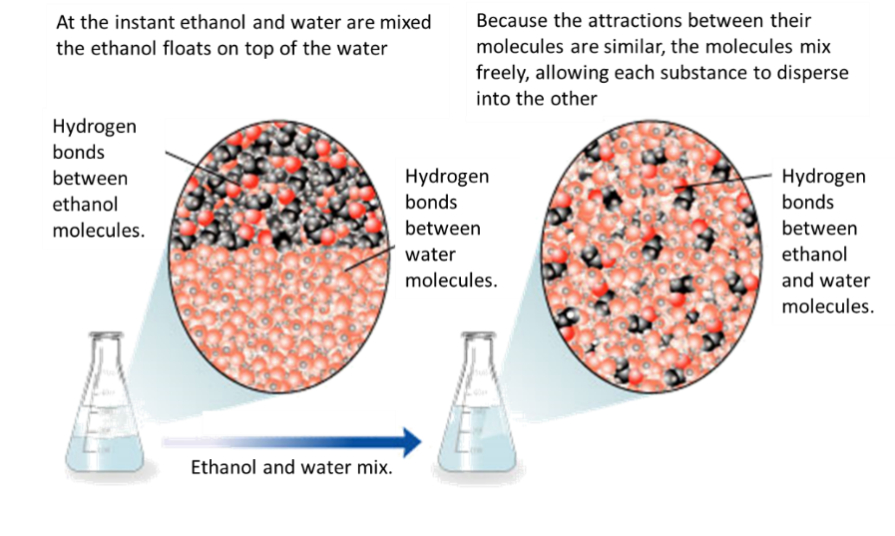

**Boiling points**

Alcohols: The boiling point trend is similar to both alkanes and alkenes where the larger the number of C atoms in the chain the higher the boiling point.

The boiling point is higher than both alkanes and alkenes as the intermolecular bonding is stronger due to being a polar molecule– which creates a positive and negative end and hold the individual alcohol molecules together stronger and thus needs more energy to break them (heat energy). Even small chain alcohols are liquid at room temperature

**Amines**

Functional group is the amino group –NH3

Amines are named as substituents e.g. aminomethane, CH3NH2. These may be classed as primary, secondary or tertiary, but their classification depends on the number of C atoms attached to the N atom. Primary RNH2, secondary R2NH, tertiary R3N.

Amines have an unpleasant “ammonia” smell. The smaller amines, up to C5, are soluble in water but larger amino alkanes are insoluble, as the size of the non-polar hydrocarbon chain cancels out the effect of the polar amino (mainly due to lone pair of electrons on the N) functional group.

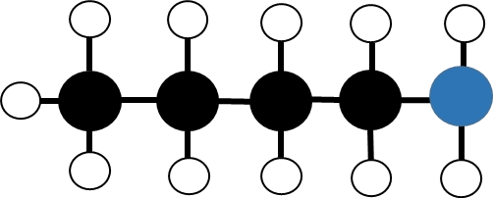

**Naming Primary Amines**

1. Identify the longest C chain - Identify any branches
2. Number the C atoms in longest chain so number Carbon 1 attached to amino group (NH2)
3. Write the name
   1. Location of branch
   2. Name of branch
   3. Amino-
   4. Prefix of long chain
   5. -ane

e.g. 1-aminobutane (4C)

**Bonding and physical properties**

**Intermolecular bonding** results from hydrogen bonding between the N-H groups as well as ID-ID attractions from the molecule, which means they have a higher melting and boiling point than similar length alkanes.

They act as weak bases and turn red litmus blue, often used as an identification test.

**States**

* aminomethane and aminoethane are **gases**.
* aminopropane and aminobutane are volatile **liquids** with fishy smells.
* Heavier aminoalkanes are **solids**.

**Solubility in water**

Lower molecular mass aminoalkanes are soluble in water due to hydrogen bonding. Solubility in water decreases as hydrocarbon portion increases.

**Carboxylic Acids**

Functional group is the carboxyl group –COOH

**Naming carboxylic acids**

1. Longest –C chain with -COOH
2. Identify branches
3. No. 1 C is the C in -COOH
4. Location of branches
5. Name branch
6. Prefix
7. -anoic acid

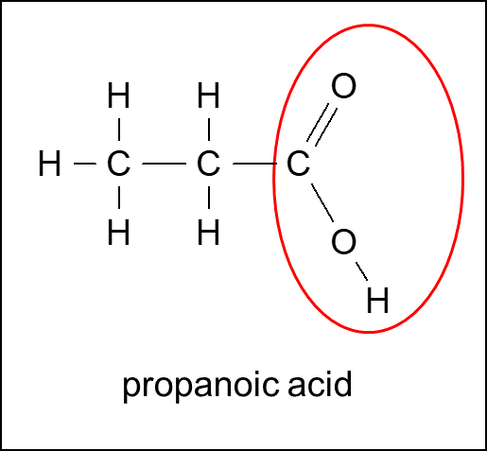

**Properties**

* polar molecules as short chains ~ non-polar molecules as long chains
* boiling points and melting points decrease with chain length
* turn blue litmus red (weakly acidic)
* conduct electricity
* react with metal to form salt and H2
* react with metal oxides to form salt and H2O
* react with metal carbonates to form salt and H2O and CO2

All the simple, straight-chain carboxylic acids up to ten carbons are liquids at room temperature. The liquids have sharp pungent odours and all have high boiling points.

Smaller molecules, less than 10 carbons, are completely miscible in water due to the formation of hydrogen bonds with the water.

The highly polar carboxylic acids dimerise (bond two molecules) in the liquid phase (bond in pairs) and in non-aqueous solvents (CCl4) and form two hydrogen bonds between each pair.

This extra degree of hydrogen bonding causes carboxylic acids to have higher boiling points compared to their corresponding alcohols.

**Aldehydes**

Functional group is the group – RCHO

Aldehydes are a class of organic compounds that are important in the manufacture of plastics, dyes, food additives, and other chemical compounds. Aldehydes have the general formula -RCHO

Where R is either a hydrogen atom, as in the case of formaldehyde, or an aromatic hydrocarbon group.

Formaldehyde is used extensively in the chemical industry in the synthesis of organic compounds. Its most important use is in the manufacture of synthetic resins. Recent tests have indicated that it is a carcinogen.

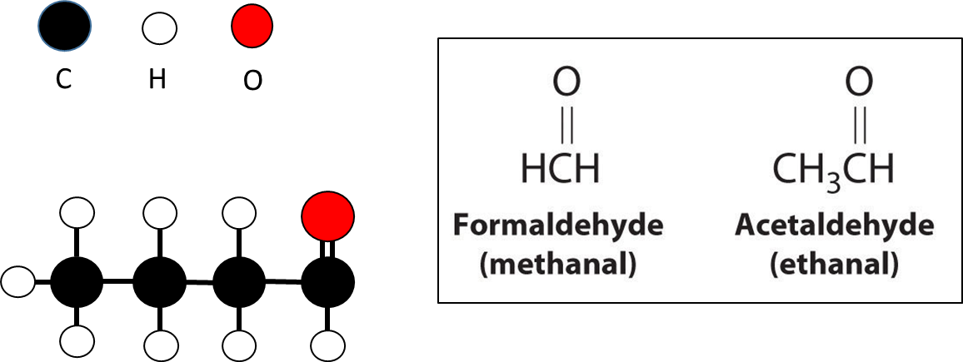

**Aldehydes Naming**

**Aldehydes are named by changing “-e” at the end of the alkane to “-al”.**

The aldehyde group does not need to be numbered when naming an aldehyde as it **must always be on the end carbon** (carbon number 1). If there are other substituents in the molecule, then numbering is always from the aldehyde end of the chain.

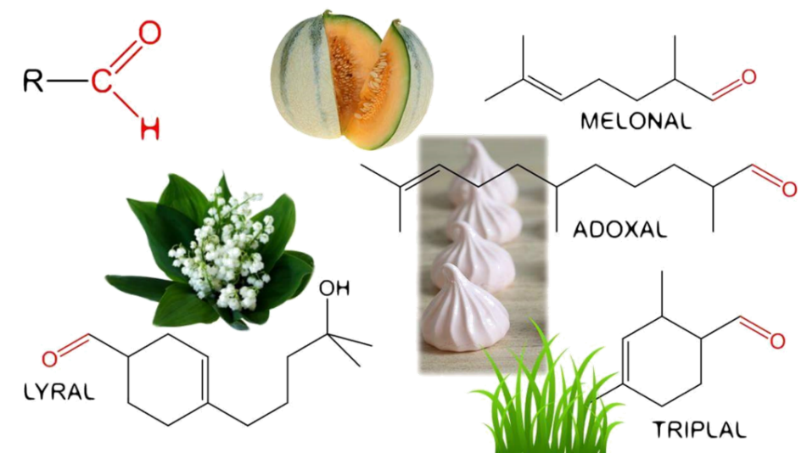

**Ketones**

Functional group is the group – **(alkanones - RCOR')** Ketones are named by changing “-e” on alkanes to “-one”. Ketones (apart from prop none and butanone where there are no isomers) need a number to indicate the position of the carbonyl (C=O) group.

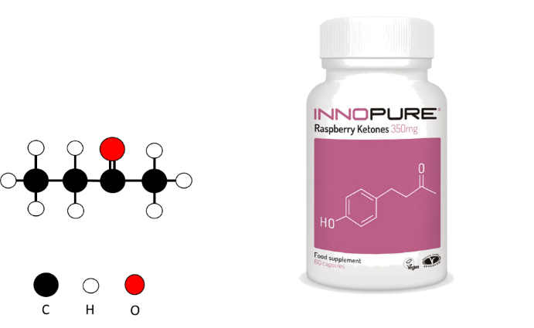

Ketones are a class of organic compounds of the general structure RCOR’, in which R and R’ represent organic radicals. The simplest ketone is acetone (CH3COCH3). Acetone is a product of the metabolism of fats, but under ordinary conditions, it oxidizes quickly to water and carbon dioxide. In diabetes mellitus, however, acetone accumulates in the body. Other ketones are camphor, many steroids, some fragrances, and some sugars. Ketones are relatively reactive organic compounds and thus are invaluable in synthesizing other compounds; they are also important intermediates in cell metabolism.

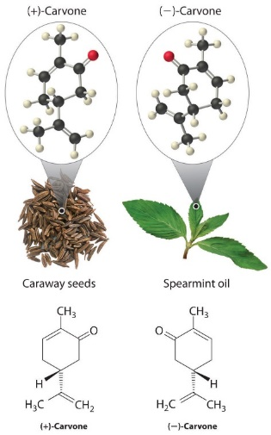

**Ketone Optical Isomers**

Carvone is a ketone that forms two optical isomers or enantiomers: (–) carvone smells like spearmint. Its mirror image, (+) carvone, smells like caraway. Humans have olfactory receptors in their noses, which can distinguish between the chiral ketones, allowing them to notice significant differences in smell between spearmint and caraway.

**Alcohols, aldehydes, ketones and carboxylic acids**

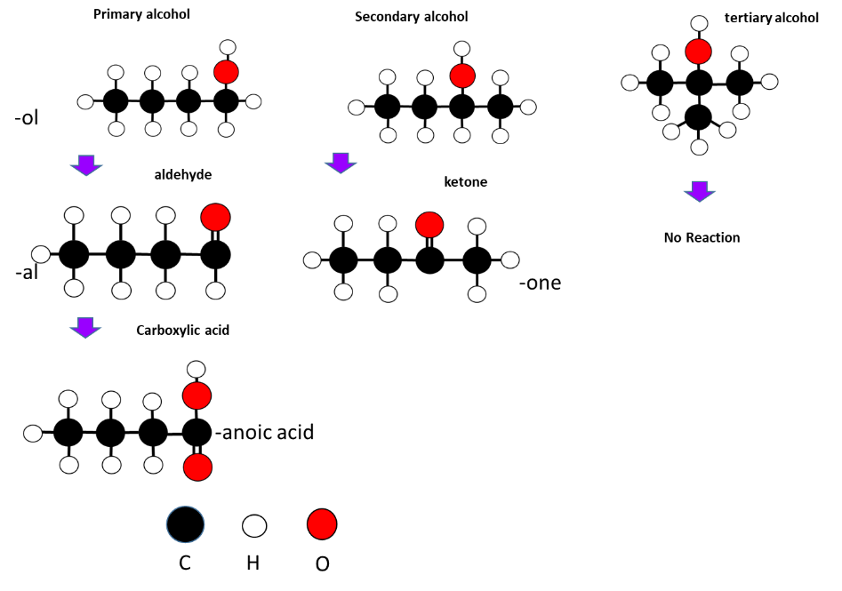

**Acid Chlorides (acyl chlorides)**

Formed from carboxylic acids, with a -Cl replacing the –OH Functional Group –COCl

**Naming**

* suffix is “-oyl chloride”
* prefix is alkyl group including the carbon on the -COCl group e.g. “ethan”

**Physical and Chemical Properties**

* low MPs and BPs as there is no H bonding on the functional group.
* liquids which fume in moist air and have an irritating smell (due to rapid hydrolysis reaction)
* Substances in this functional groups are highly reactive

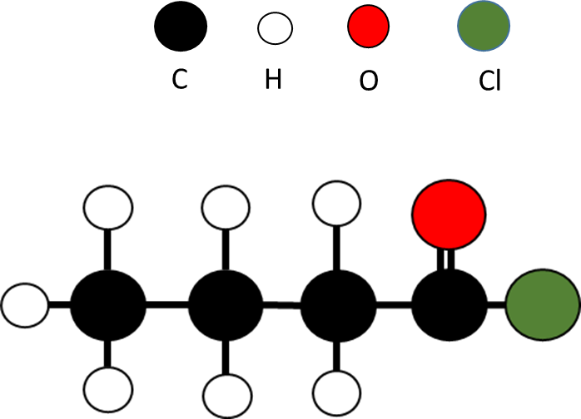

**Amides**

Functional Group -CONH2

Formed from carboxylic acids with a –NH2 substituting the -OH.

**Physical and Chemical Properties**

* methanamide is liquid, the rest are odourless solids. (Impure ethanamide smells like mice)
* The higher melting points are due to dimerisation caused by hydrogen bonding.
* A **dimer** is a chemical entity consisting of two structurally similar subunits called monomers joined by bonds that can be either strong or weak

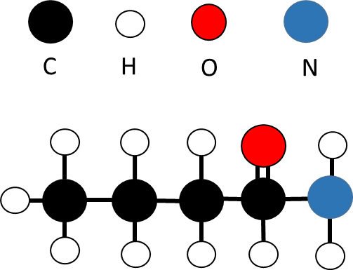

**Amide naming (Primary only)**

1. The carbon attached to the ONH2 will be carbon 1
2. Number and name any branches
3. Name the longest C chain
4. Suffix – anamide

**Esters**

Functional group is –COO-

Esters often have fruity or distinctive smells and they are prepared by the process of esterification

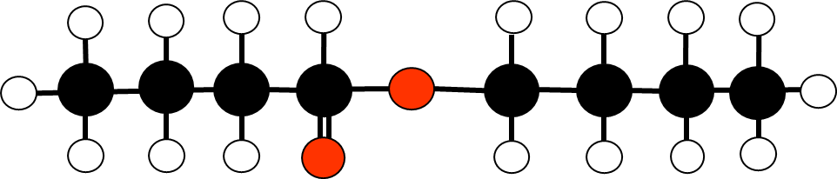

**Naming esters (**for example butyl butanoate above)

1. Split between C-O bond
2. Identify name for side with –O-
3. Prefix of C chain
4. -yl
5. Identify name for side with C=O
6. Prefix of C chain
7. –anoate

**Ester Properties**

Esters are chemical compounds responsible for the fruity smells present in processed food. Many natural flavours and smells are due to the presence of esters in flowers and fruits.

The higher the molecular weight, the weaker the odours they carry are.

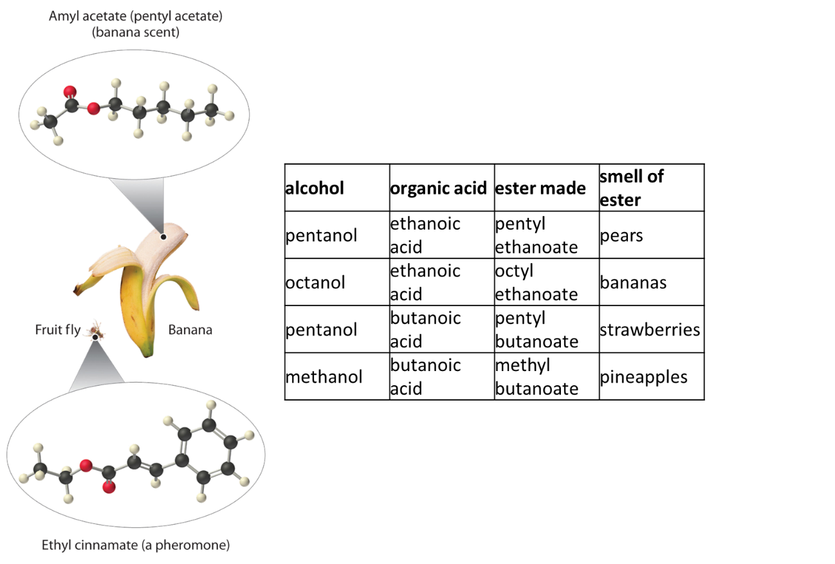

**Geometric Isomers**

Alkenes can exist as **geometrical** or ***cis-trans* isomers,** a form of stereoisomerism. A simple example is but-2-ene. To exist as geometrical isomers the C atoms at **both** ends of the non-rotatable double bond must each have **two different groups (or atoms) attached**. It is impossible for a 1-alkene to have geometric isomers since the first C atom in the chain has two identical H atoms.

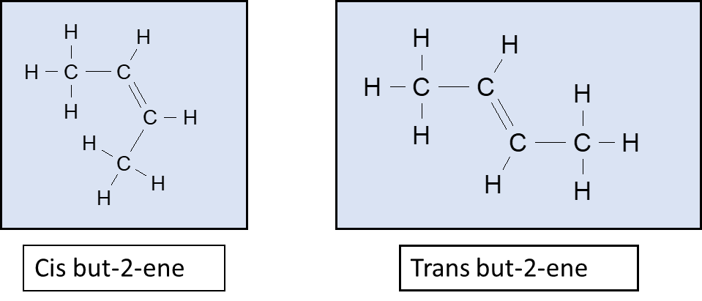

**NOTE:**

(i) The *cis* or *trans* prefix must be included when naming these alkenes. (ii) Bond angles around a double bonded C are 120o; and the shape is trigonal planar

**Optical isomers (enantiomers)**

Optical isomers (like geometric isomers) are examples of stereoisomers. The enantiomer and its mirror image are non-identical. All amino acids, (except the simplest amino acid, glycine), are optically active. This means they contain an **asymmetric**, or **chiral**, carbon atom. This is a carbon atom, which has four different groups attached. To show the different enantiomers of a molecule it is necessary to draw a 3-dimensional structure. For any enantiomer, the structure of the mirror image can be drawn by swapping **any two** groups.

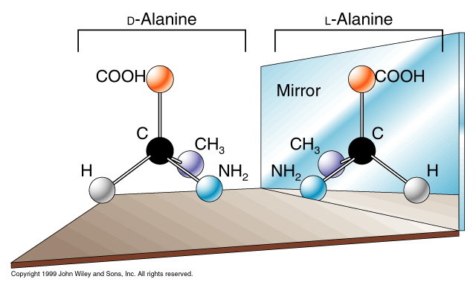

A chiral molecule is a type of molecule that lacks an internal plane of symmetry and has a non-superimposable mirror image. The feature that is most often the cause of chirality in molecules is the presence of an asymmetric carbon atom.

The term chiral (pronounced in general is used to describe an object that is non-super imposable on its mirror image.

Optical isomers cannot be superimposed. If two of the groups are the same around the chiral carbon then the molecule can be turned 180° and be superimposed therefore it is not an optical isomer.

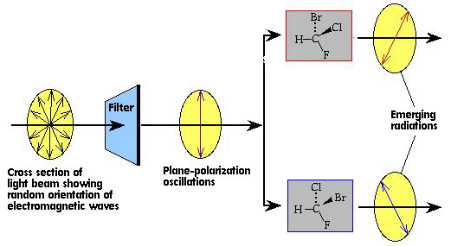

 Enantiomers have identical physical properties (melting point, solubility etc.) BUT differ in that they **rotate** plane polarised light in opposite directions.

**Reaction types**

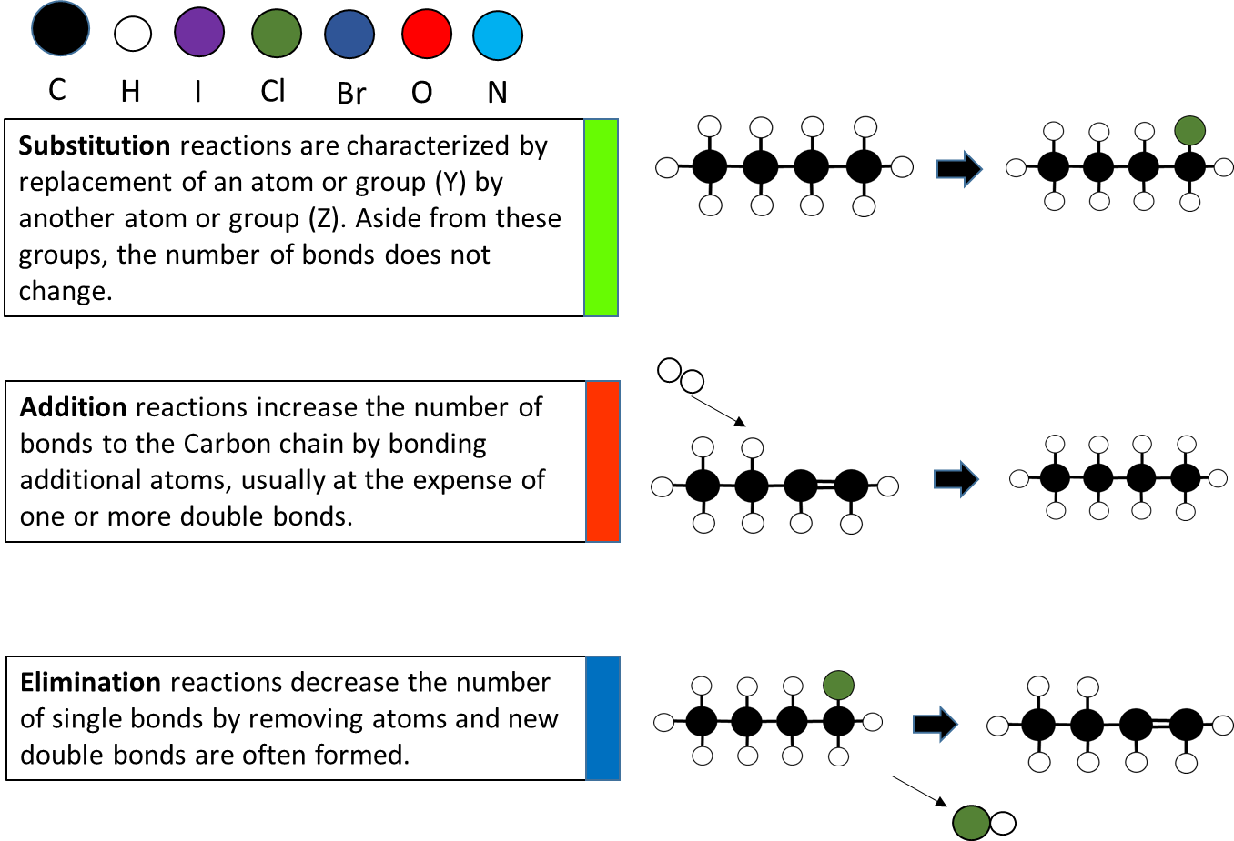

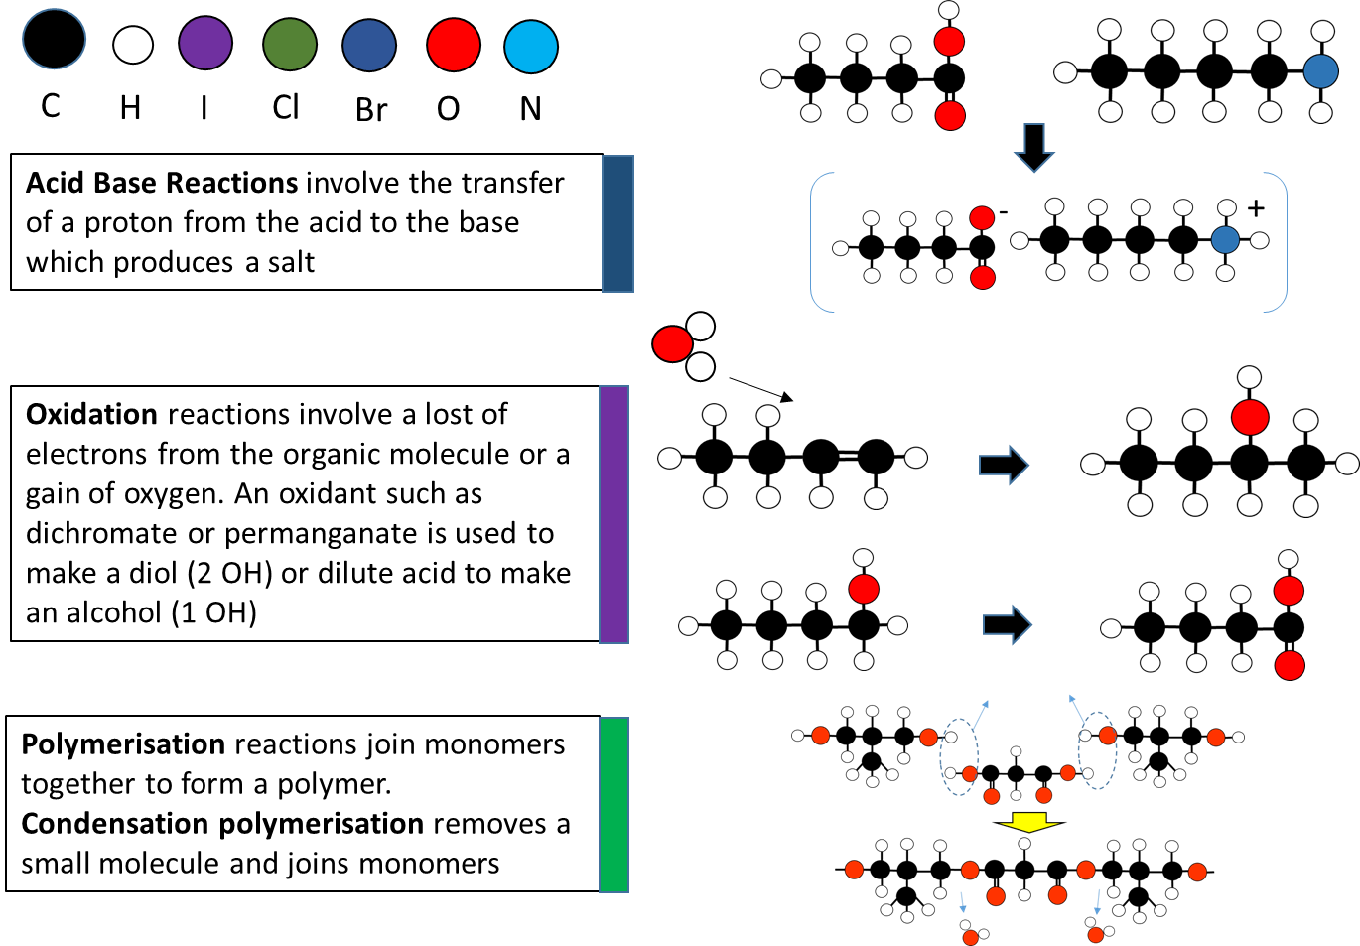

**Alkene reactions**

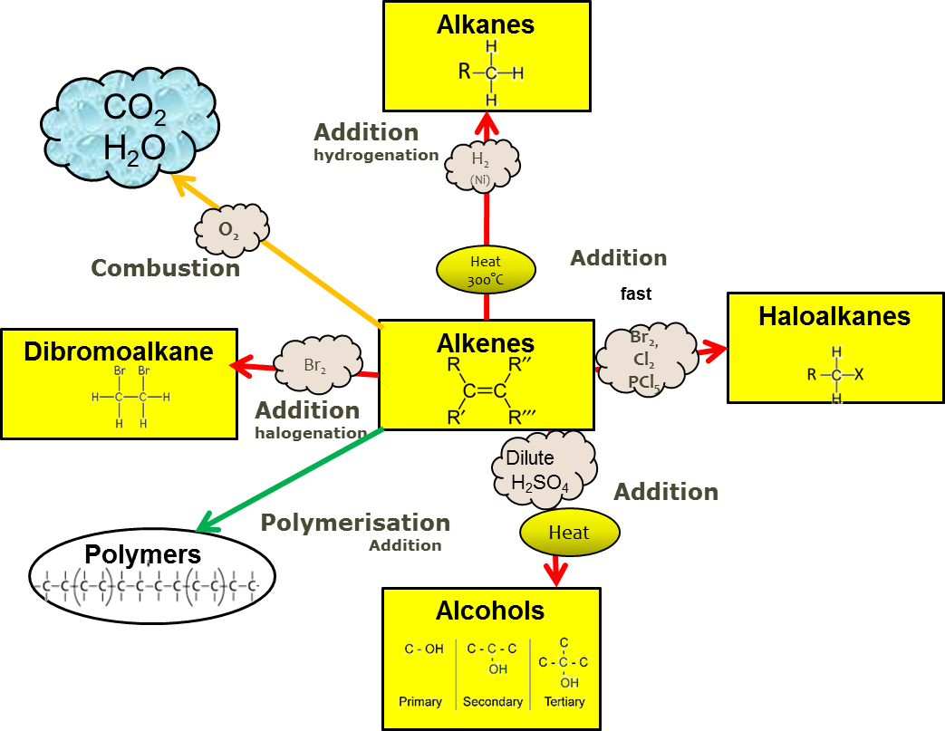

**Addition Reactions**

Alkenes are **unsaturated** molecules, where not every carbon atom has the maximum amount of atoms bonded to it because it has one or more double bonds. If another atom is added to an alkene, the double bond can be broken down to a single bond and another atom can occupy the available site.

This reaction is known as an **addition** reaction. This reaction has a lower activation energy requirement than substitution, therefore it requires less energy to break a double bond than break a C-H bond, and it can proceed easier than a substitution reaction.

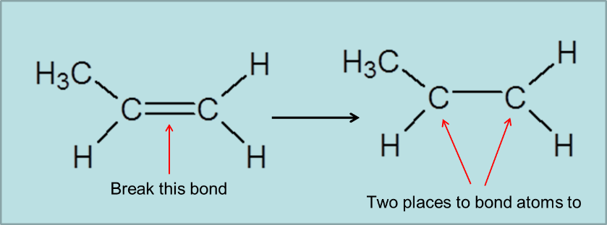

**Markovnikov’s Rule** - sometimes called the “rich get richer” rule

The **major** product is the one in which the H atom of HBr attaches to the C atom with the **most H atoms** already **Asymmetric** molecules such as HCl and H2O can also be added to alkenes resulting in the formation of **two** possible products.

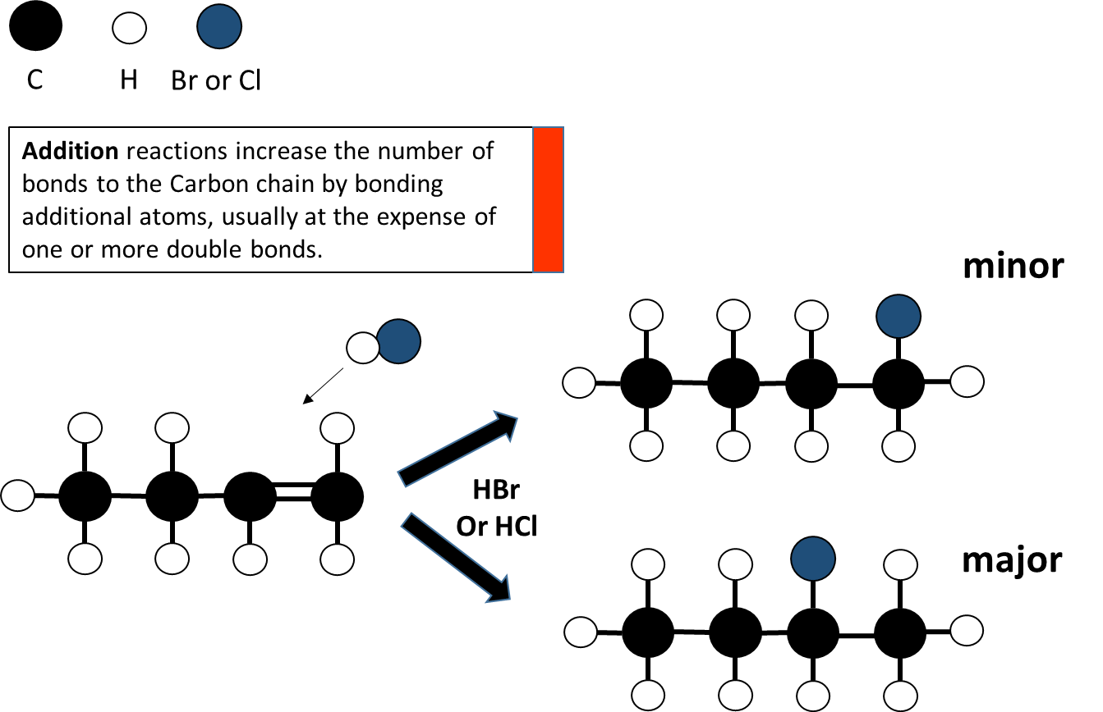

**Testing for alkanes and alkenes**

Alkenes and alkynes undergo **addition** reactions - this means they can undergo addition of a halogen across the double (or triple) bond to form a di-haloalkane (or tetra-haloalkane).

The common test for an unsaturated hydrocarbon is therefore the **rapid** decolourisation of an orange solution of bromine. This occurs in both the presence or absence of sunlight (c.f. reaction of alkanes that requires UV light and is much slower).

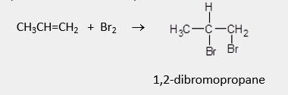

An alternative test to distinguish alkenes from alkanes is the reaction of alkenes with potassium permanganate. In acid solution the purple permanganate ion, MnO4*−*, is reduced to colourless manganese ion, Mn2+, while in neutral solution it is reduced to brown manganese dioxide, MnO2. Alkanes have no reaction with potassium permanganate so the solution remains purple.

**Oxidation reactions with alkenes**

Alkenes can also undergo an **oxidation** reaction (this could also be classified as an addition reaction).

The reagent is an oxidant, potassium permanganate (acidified), MnO4-/H+, performed under reflux conditions. The reaction creates a diol. Two hydroxyl groups join onto the carbons on either end of the broken double bond.

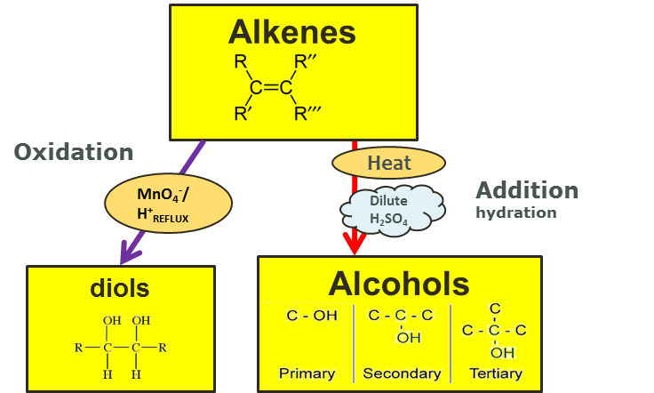

Compare this to the **addition reaction** that which occurs with dilute acid added to an alkene. Only a single hydroxyl group is added to make an alcohol.

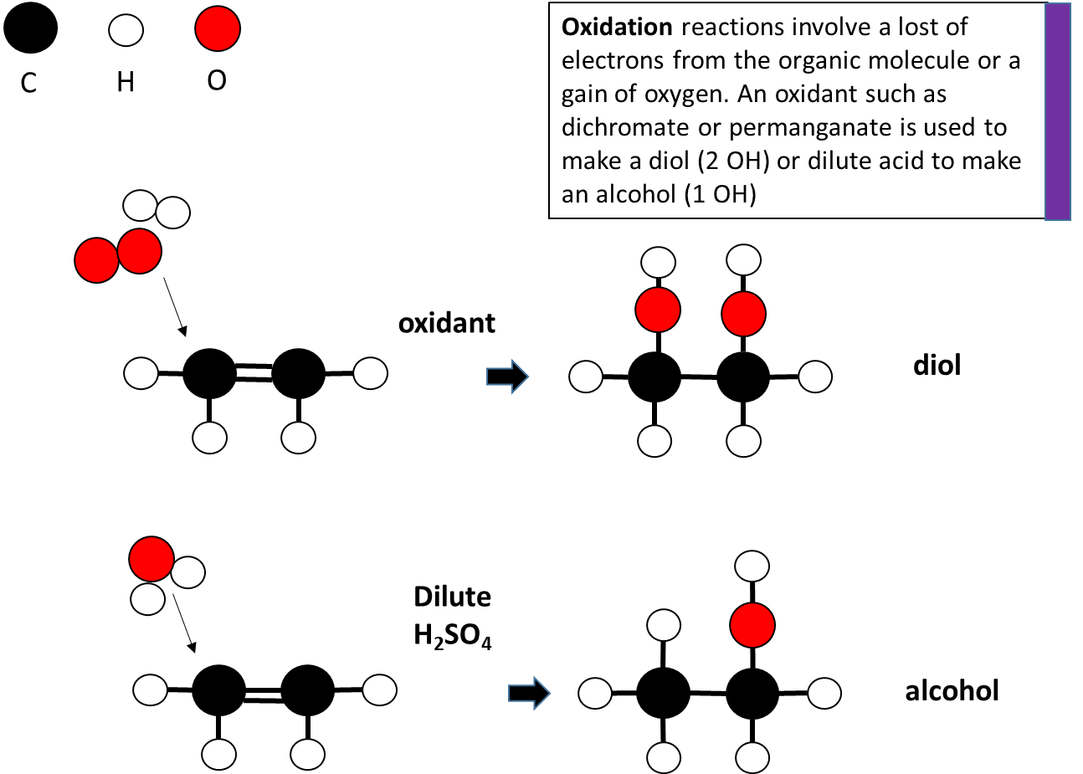

**Haloalkane Reactions**

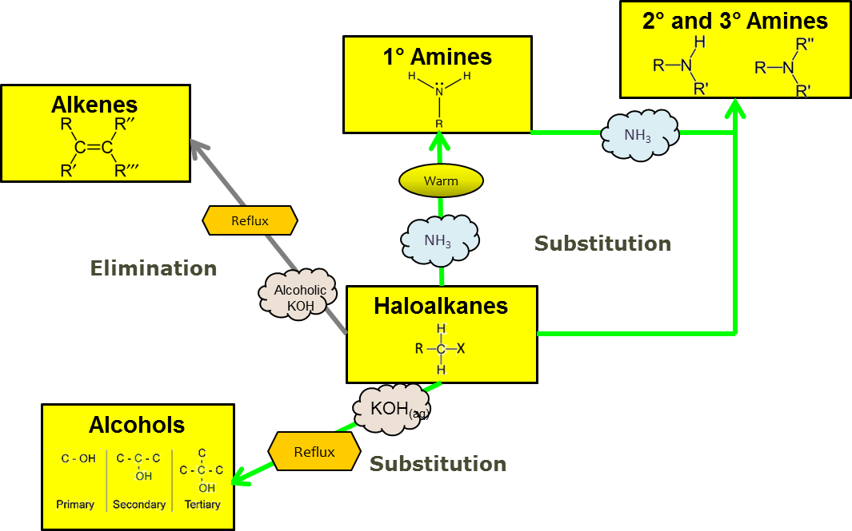

**Elimination Reactions**

Elimination reactions decrease the number of single bonds by removing atoms and new double bonds are often formed.

The Halogen atom is removed and a double bond forms between the two carbon atoms.

Elimination of Haloalkanes isfavoured when the solvent used is less polar e.g. **alcoholic** (rather than aqueous) **KOH.** The reagent may be referred to as either ethanolic KOH, KOH / CH3CH2OH or OH- in alcohol. The reaction also occurs more favourably with tertiary haloalkanes rather than primary.

**Elimination** - Saytzeff’s rule (poor get poorer)

When an elimination reaction occurs on a **secondary haloalkane** (with more than 3 carbons in the longest chain) then the H removed along with the halogen (Cl/Br) can come from either side. This produces 2 types of products; major or minor.

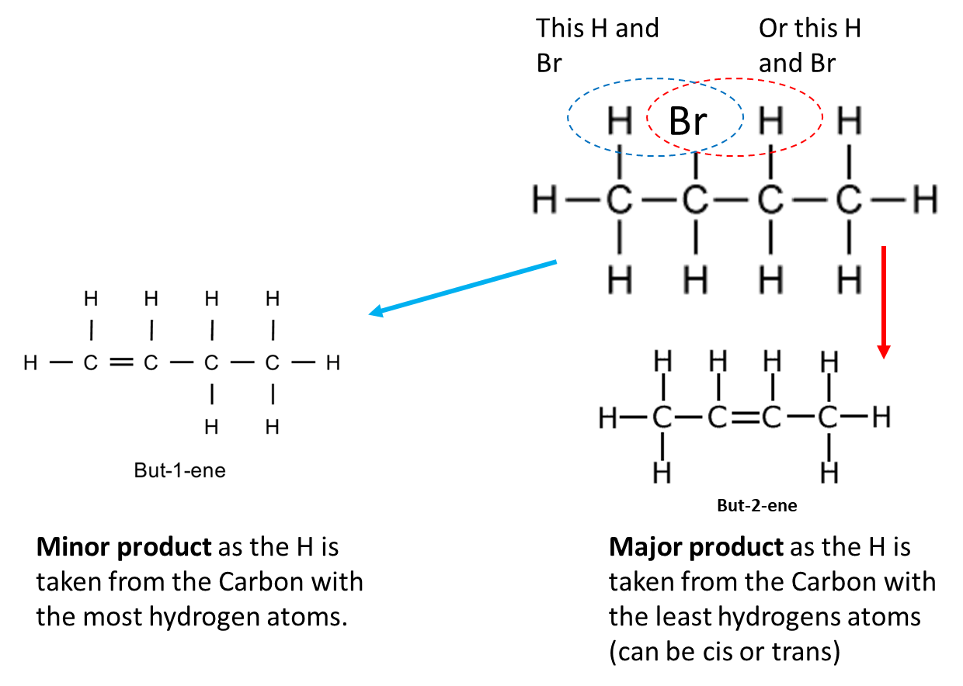

**Elimination – major and minor products**

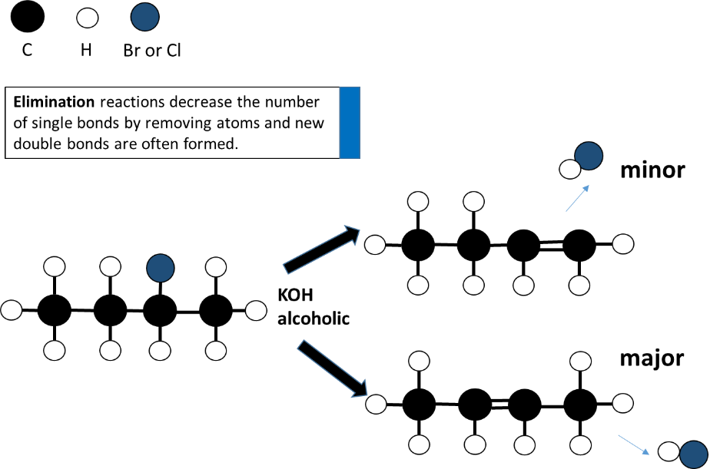

**Substitution Reactions**

Substitution reactions do not change the number of single bonds. The Halogen atom is removed and a hydroxyl (OH) group is substituted.

Substitution of Haloalkanes isfavoured when the solvent used is polar e.g. **aqueous** (rather than alcoholic) **KOH.**

The OH bonds with the **same** carbon that the halogen is removed from.

A primary halogen will become a primary alcohol and a secondary halogen will become a secondary alcohol

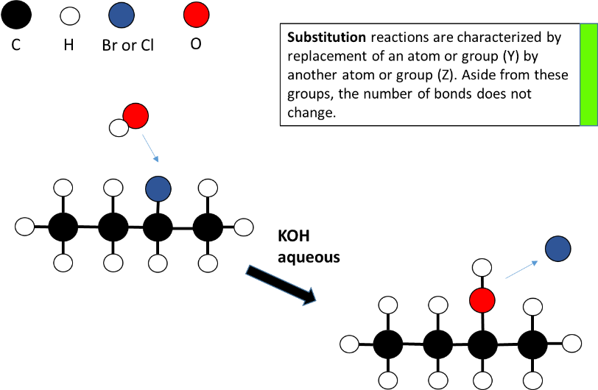

**Halo alkane preparation**

Haloalkanes are formed when alkanes undergo a substitution reaction. Hydrogen atoms are substituted (replaced) by a group 17 halogen atom.

For example, methane undergoes a series of substitution reactions with chlorine gas (Cl2) in the presence of ultraviolet light.

Haloalkanes are relatively nonpolar overall (despite the polarity of the C-X bond) and are insoluble in water. A monohaloalkane e.g. 2-bromopropane can be formed by

a) **substitution** of propane using Br2. (forming two products, the bromoalkane and HBr)

b) **addition** of HBr to propene (forming only one product)

c) **Substitution** of the OH on an alcohol using e.g. PCl3, PCl5, SOCl2 or conc HCl/ZnCl2

**Alcohol reactions**

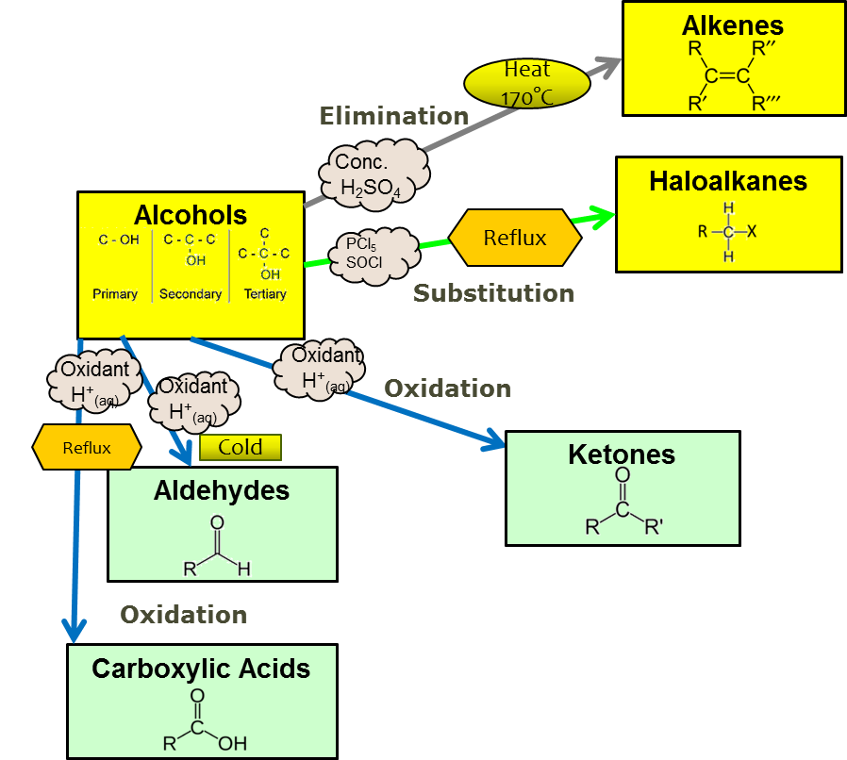

**Alcohol Reactions - Elimination**

**Elimination** reactions occur when the hydroxyl group (OH) plus a hydrogen from an adjacent (beside) carbon atom is removed. The OH and the H removed form a water molecule. The two carbons with the OH and H taken off join to form a double one. A concentrated sulphuric acid is used as the reagent. This type of elimination reaction is also known as a dehydration reaction because water is removed.

**Elimination – major and minor products** - (poor get poorer)

When an elimination reaction occurs on an **asymmetrical** **secondary** alcohol (with more than 3 carbons in the longest chain) then the H removed along with the OH can come from either side. This produces 2 types of products; major or minor.

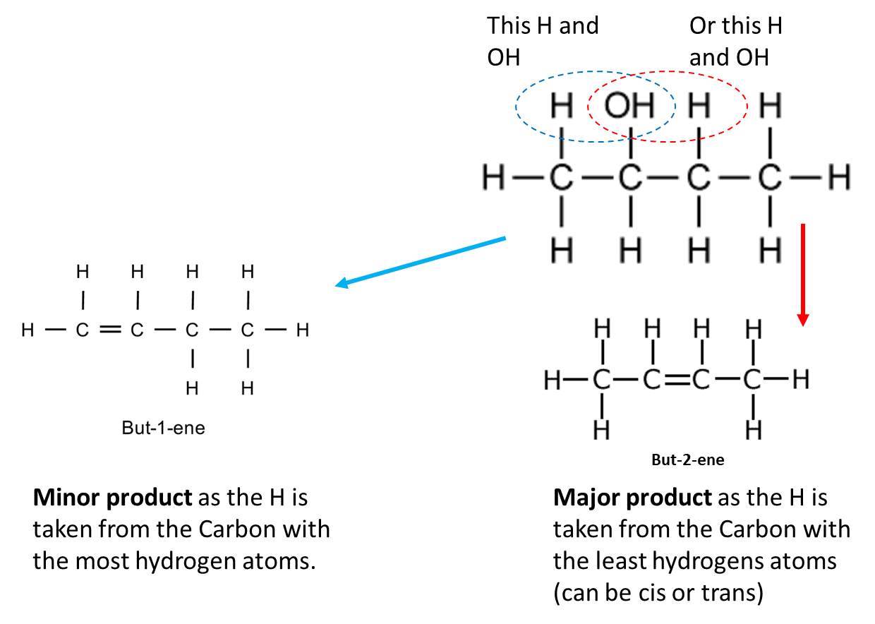

**Elimination in a Secondary Alcohol**

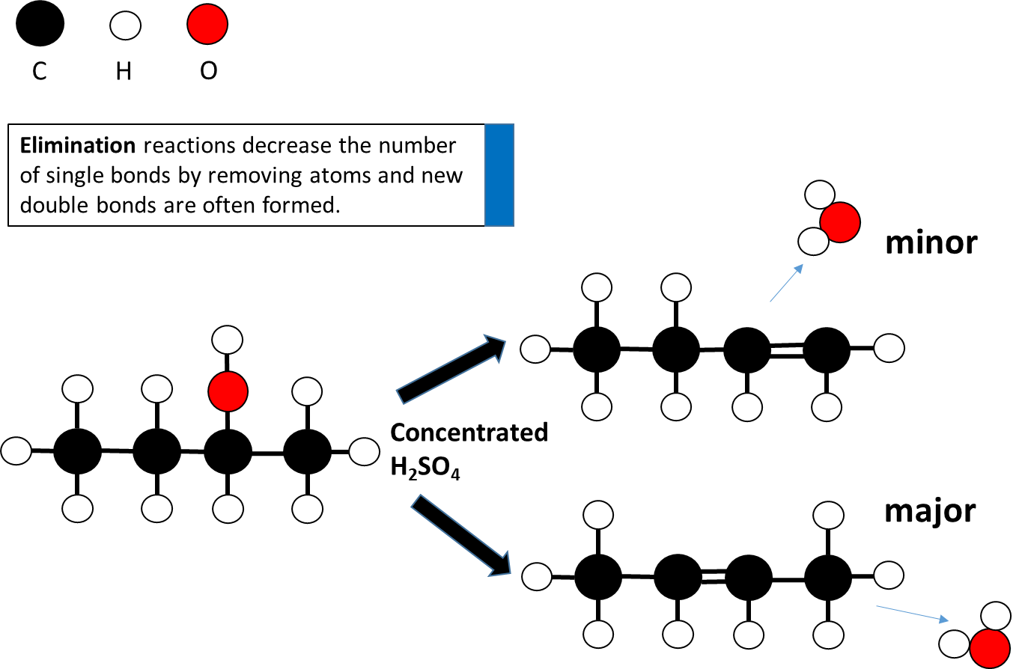

**Alcohol Reactions – Oxidation**

The type of product formed depends on whether the alcohol used in the oxidation reaction is primary or secondary.

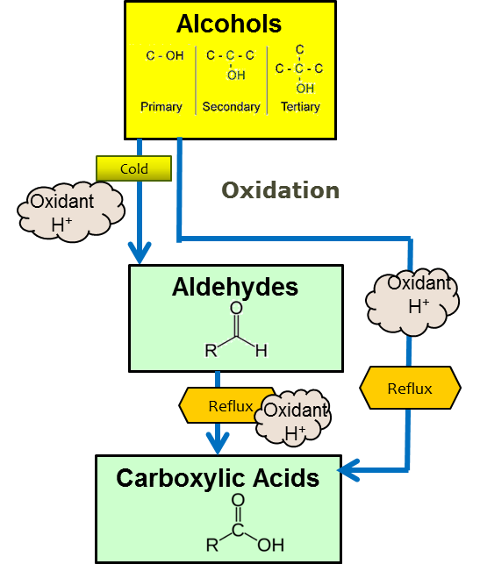

**Oxidation of primary alcohols -** using acidified KMnO4 or acidified K2Cr2O7

Aldehydes must always be prepared from Primary alcohols. Primary alcohols can be oxidized by mild oxidizing agents, such as potassium dichromate (K2Cr2O7), or potassium permanganate (KMnO4) to yield aldehydes.

Conditions are warm only with use of distillation to collect evaporated aldehyde as it has a lower boiling point than the alcohol (which has hydrogen bonding)

**Primary alcohols** are oxidised to form **aldehydes,** which are then easily oxidised further to form **carboxylic acids.**

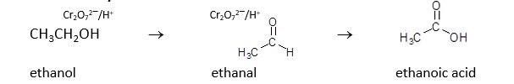

When using acidified dichromate in this redox reaction, the Cr2O72− is reduced to Cr3+, and the colour changes from orange to green. This colour change was the basis for the chemical reaction in the old “blow in the bag” breathalyser test.

When using acidified permanganate in this redox reaction, the MnO4− is reduced to Mn2+, and the colour changes from purple to colourless.

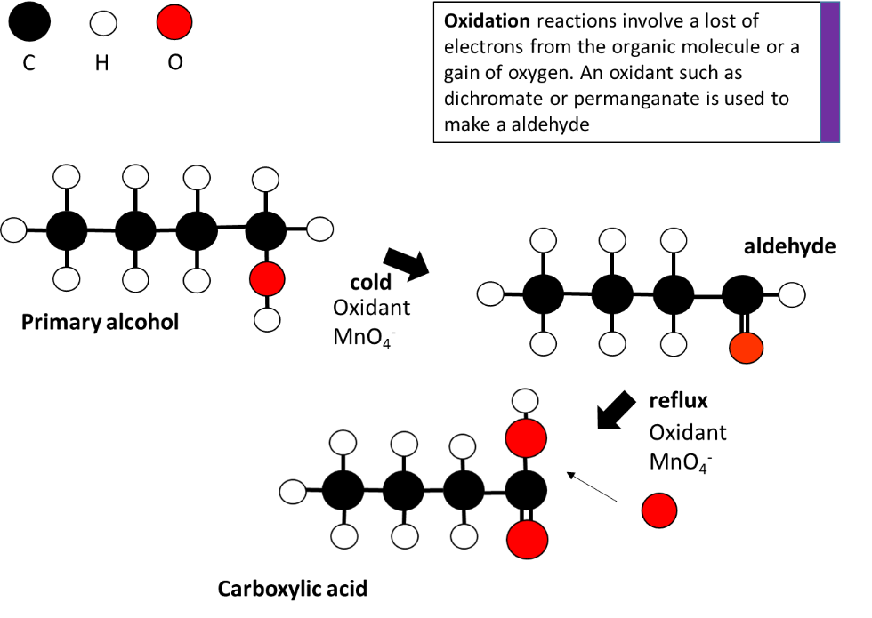

**Distillation**

A primary alcohol is oxidised to an aldehyde. The aldehyde can be further oxidised by exactly the same reagent to a carboxylic acid, so it is important to remove it from the reaction vessel immediately.

This is possible as the aldehyde has a much lower boiling point than both the alcohol and carboxylic acid. The reaction is performed in a distillation flask above the boiling point of the aldehyde and below the boiling point of the other compounds and the aldehyde is allowed to distil off as it is formed.

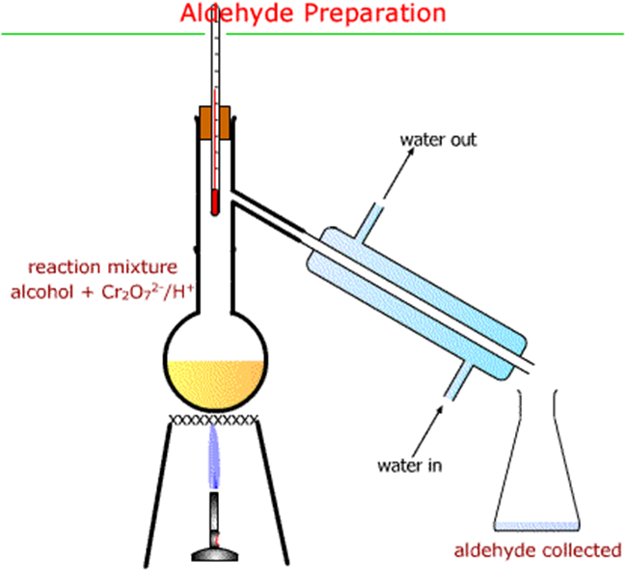

**Oxidation in secondary alcohols -** using acidified KMnO4 or acidified K2Cr2O7

**Secondary alcohols** are oxidised to form **ketones, which** do not oxidise further

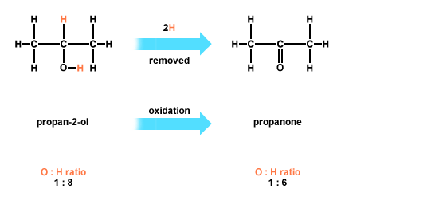

Tertiary alcohols do not oxidise

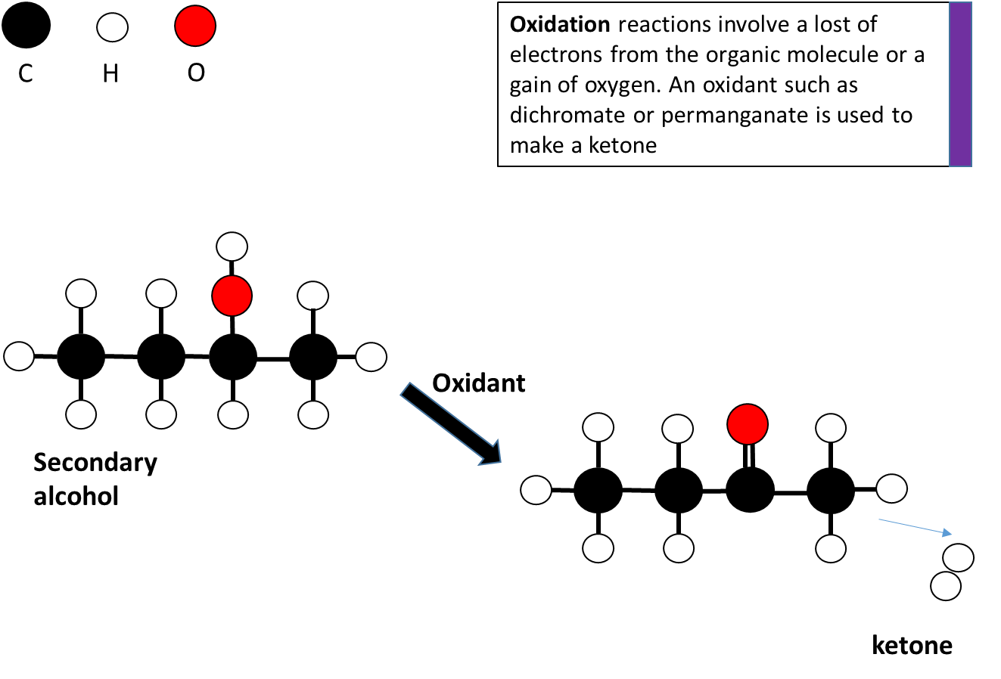

**Reflux**

An Aldehyde can be further oxidised to produce Carboxylic acid. (The Carboxylic acid can also be prepared directly from the primary alcohol). The process requires the use of **reflux** apparatus. The aldehyde (or alcohol solution) is heated until it forms the carboxylic acid but the water jacket condenser prevents the aldehyde escaping as vapour – which has a lower boiling point than the Carboxylic acid that has Hydrogen bonding.

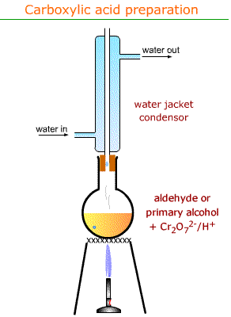

**Alcohol reactions – Substitution** **-** of the OH− by a Cl*−* to form a chloroalkane.

This substitution removes the hydroxyl group (plus one hydrogen to form water) and replaces the two bonding sites on the carbons with a H and Cl (from HCl). This is called a **nucleophilic** substitution as the Br is attracted to the nucleus of the carbon atom

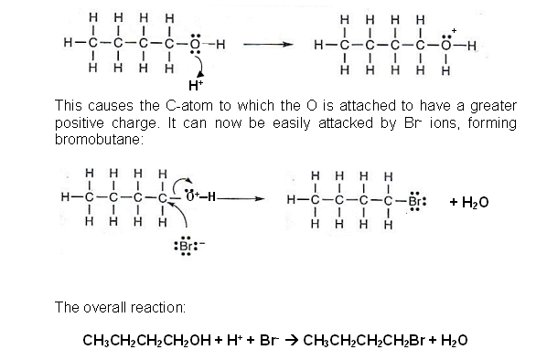

The haloalkane formed is nonpolar and insoluble in the aqueous solution so forms a cloudy emulsion that separates out as two layers.

For **secondary alcohols** - solution slowly goes cloudy as the chloroalkane slowly forms and separates.

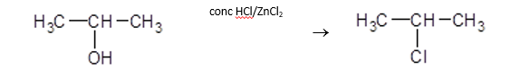

For **primary alcohols** - reaction is so slow a single layer containing unreacted alcohol remains.

Substitution of alcohols can also be carried out using **PCl5, PCl3 and SOCl2.**

**Lucas’ Reagent and substitution**

**Lucas' reagent** is a solution of zinc chloride in concentrated HCl, used to classify alcohols of low molecular weight. The reaction is a substitution in which the chlorine replaces the hydroxyl (OH) group.

The reagent dissolves the alcohol, removing the OH group, forming a carbocation. The speed of this reaction is proportional to the energy required to form the carbocation, so tertiary alcohols react quickly, while smaller, less substituted, alcohols react more slowly. The cloudiness observed is caused by the carbocation immediately reacting with the chloride ion creating an insoluble chloroalkane.

We can use these to identify whether an alcohol is primary, secondary or tertiary

The time taken for turbidity to appear is a measure of the reactivity of the class of alcohol with Lucas reagent, and this is used to differentiate between the three classes of alcohols:

* No visible reaction: **primary alcohol**

* Solution turns cloudy in 3-5 minutes: **secondary alcohol**

* Solution turns cloudy immediately: **tertiary alcohol**

**Amine reactions**

Amines behave like ammonia due to a non-bonding pair of e- proton acceptors (i.e. bases)

Like ammonia itself, water-soluble amines form alkaline solutions. They react with water by proton transfer to form OH- ions. This means aqueous solutions of amines turn litmus blue.

RNH2 + H2O → RNH3+ + OH-

Amines also react with acids to form salts.

CH3NH2 + HCl → CH3NH3+ Cl-

aminomethane methyl ammonium chloride

The formation of an ionic salt increases the solubility of the amine in acidic solutions (compared to their solubility in water). This change in solubility can be used to separate amines from other organic compounds. The formation of the salt also results in the disappearance of the obnoxious smell of the amine, which explains why lemon juice is often provided with fish meals.

Amines are made by the substitution reaction between NH3 and haloalkanes, but the reaction is carried out using alcohol as a solvent rather than water.

***Reaction with water***

CH3NH2 + H2O → CH3NH3+ + OH-

Aminomethane methylammonium hydroxide

***Reaction with acid to form salts***

CH3NH2  + HCl → CH3NH3+ + Cl

aminomethane hydrochloric acid methylammonium chloride

This reaction can occur in solution, or in the air as vapours given off solutions of both chemicals meet and combine to form a smoke. This smoke is made of the salt in solid form.

**Amine (ammonium) ion + Carboxylic ion reactions** (Naming salts.)

The amine ion effectively becomes an **ammonium ion** – and acts as the cation in forming the ionic salt. The organic group attached to it becomes a “branch” and is named as such. i.e. CH3NH3+ becomes methyl ammonium. The **carboxylate ion** becomes the anion and takes on the suffix –anoate. i.e. CH3COO- becomes methanoate, therefore a salt made of the 2 ions CH3NH3+ CH3COO- is called methyl ammonium methanoate

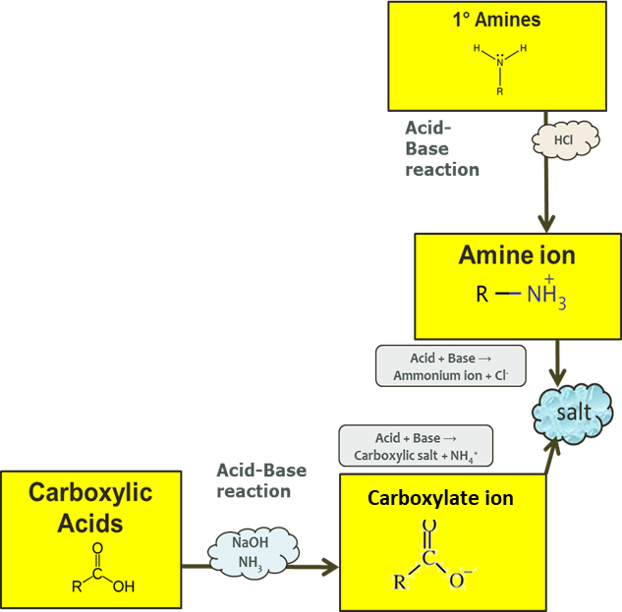

**Carboxylic Acid Reactions**

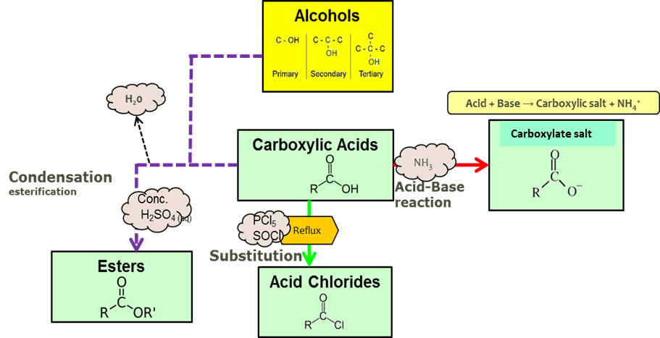

**Carboxylic Acid Reactions - Acid/base**

Carboxylic acids act as a weak acid by partially dissociating and neutralising bases:

For example

RCOOH + NaOH 🡺 RCOONa + H2O

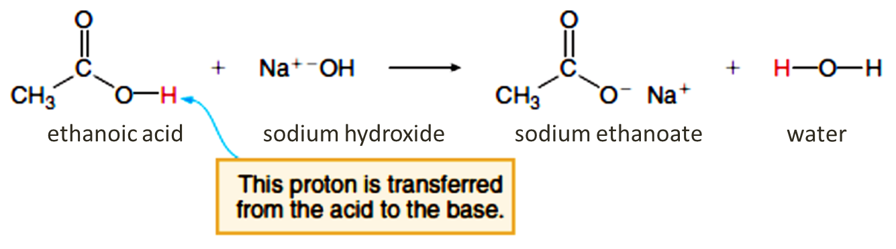

Carboxylic acid also have similar reactions to other acids:

React with **magnesium** to give hydrogen gas (a useful test)

CH3COOH + Mg 🡺 Mg(CH3COO)2 + H2(g)

 React with calcium **carbonate** to give CO2(g) (a useful test)

CH3COOH + CaCO3 🡺 Ca(CH3COO)2 + CO2(g) + H2O

**Carboxylic Acid Reactions - Substitution**

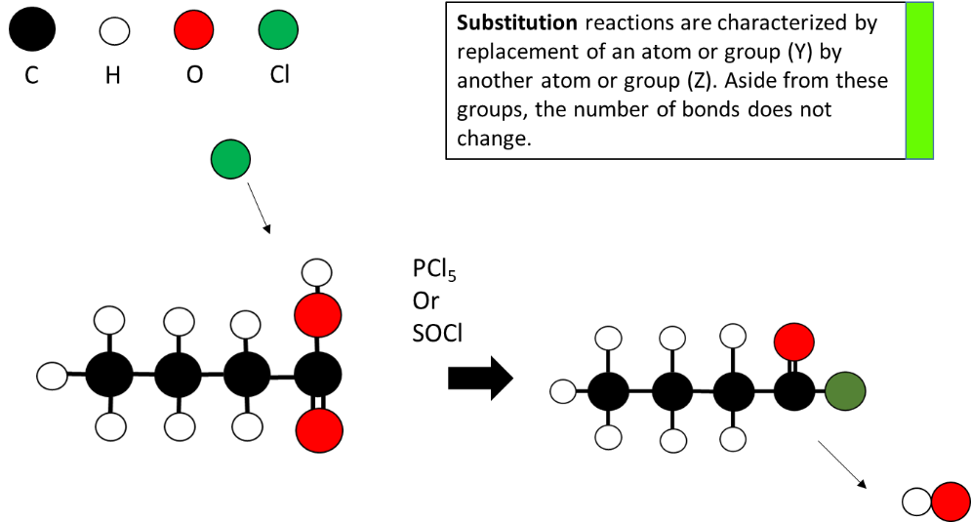

**Substitution reaction to form acid chlorides**

Using PCl3, PCl5 or SOCl2 (not conc HCl), carboxylic acids undergo a **substitution reaction**

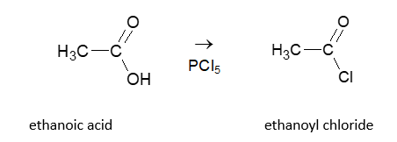

The acid chloride is named using the name of the parent alkane, but changing the final “-e” to “-oyl chloride”. The acid chloride formed reacts violently with water to produce the corresponding carboxylic acid. It is for this reason that conc HCl cannot be used to make an acid chloride because the concentrated acid consists of at least 60% water.

**Carboxylic Acid Reactions – Esterification**

Esterification is a **condensation** reaction that combines a carboxylic acid and an alcohol, where a water molecule is removed. The carboxylic acid and alcohol are **refluxed** with concentrated sulphuric acid.

After reflux, **sodium carbonate** is added to neutralise any excess acid and **anhydrous magnesium sulfate** MgSO4 is added to remove water.

Because of the volatility of esters, they are then readily separated from the reaction mixture by fractional distillation.

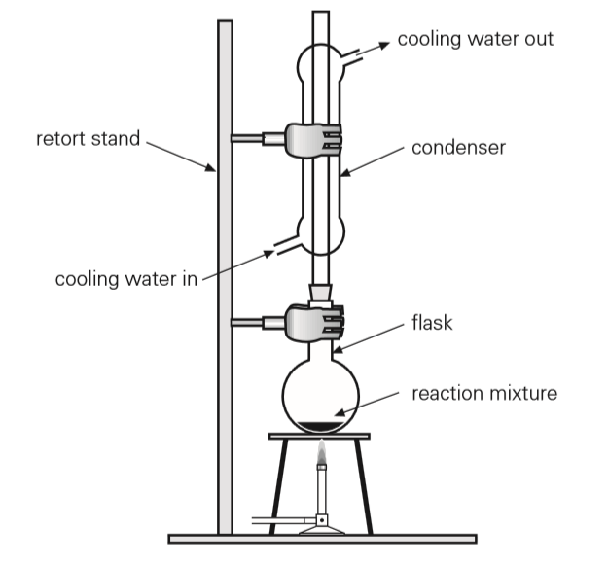

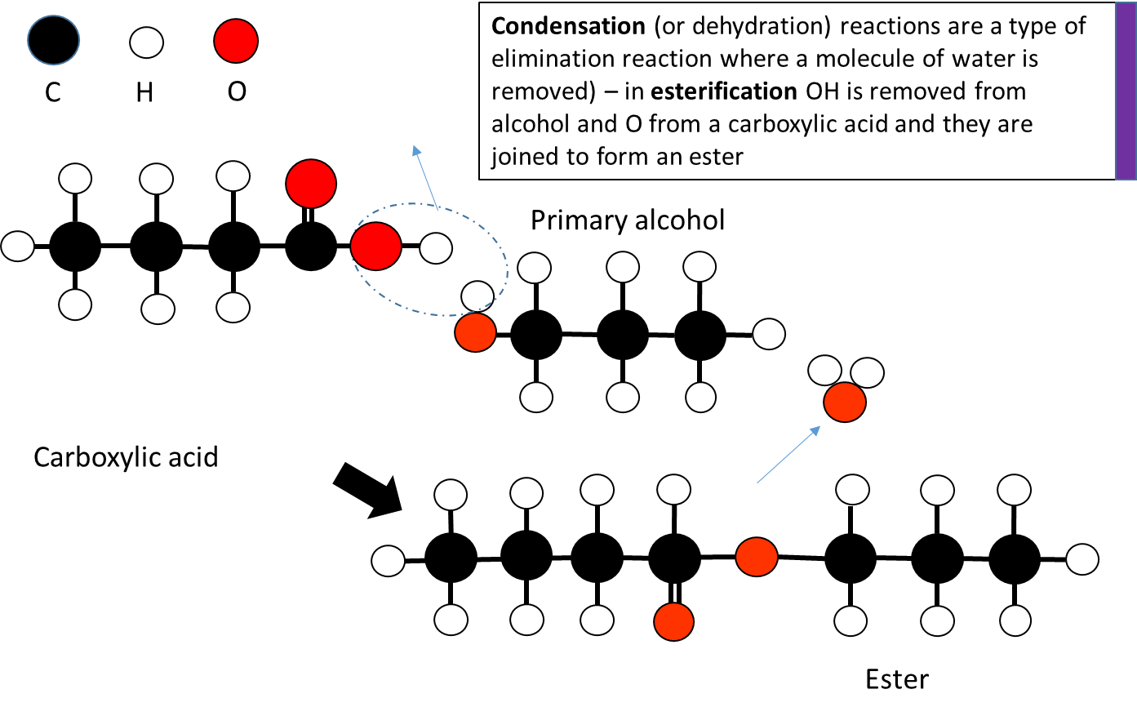

**Aldehyde/Ketone Reactions - Reduction**

**Reduction of Aldehydes and Ketones**- NaBH4 (sodium borohydride)- reduce aldehydes to primary alcohols and ketones to secondary alcohols. This is considered a reduction reaction because the amount of Hydrogen increases.

Sometimes LiAlH4 (lithium aluminium hydride) can also be used as a reductant

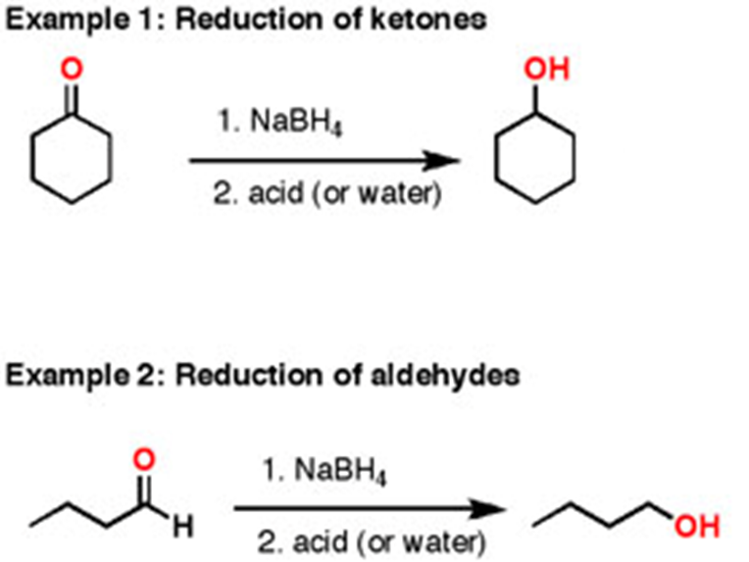

**Reduction of Aldehydes and Ketones** with NaBH4

In this Reduction reaction, we are breaking a C-O bond and replacing it with a C-H bond. This is what helps us classify the reaction as a reduction.

Note that we also form an O-H bond. In order to make the alcohol, the oxygen needs to pick up a proton (H+) (called pronation) from either water or acid that is added after the reaction is complete.

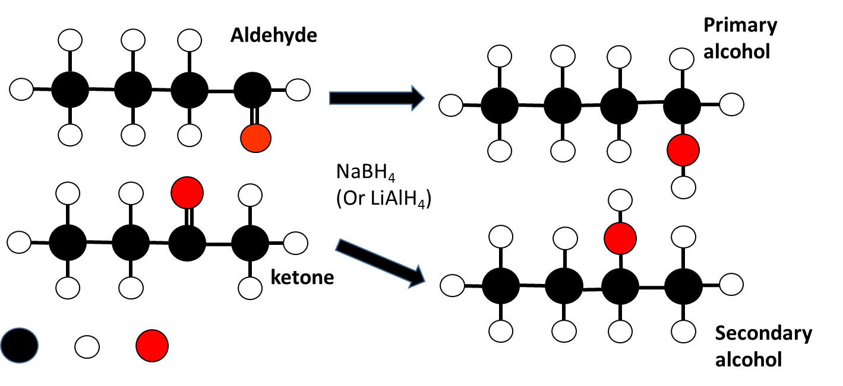

**Tollens’ test**

If Tollens’ reagent (a colourless solution [Ag(NH3)2]+ ) is heated with an aldehyde a redox reaction occurs, which produces a silver mirror on the inner surface of the test tube. The aldehyde is oxidised to a carboxylic acid.

The reduction half-equation is

Ag+*(aq)* + e− → Ag*(s)*

If Tollens’ reagent is heated with a ketone or an alcohol, no reaction occurs. This means there would be no observed colour change and no formation of a silver mirror.

Aldehydes are readily oxidised by even mild oxidising agents such as Ag+ and Cu2+, which are too weak to oxidise alcohols. Like alcohols, they are also oxidised by acidified potassium dichromate and acidified potassium permanganate.

In contrast, ketones are not oxidised, and this means that they can readily be distinguished by observing the reaction with an oxidising agent.

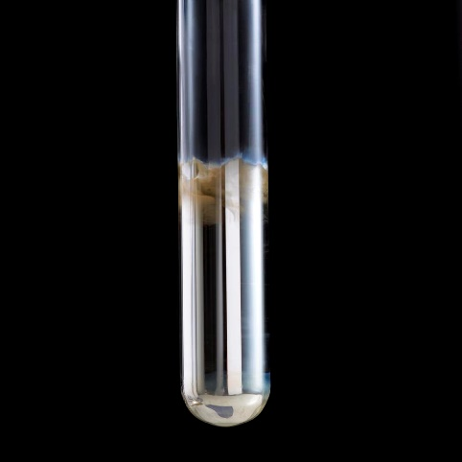

**Benedict's test** - Benedict’s reagent is an alkaline solution containing a copper(II) citrate complex ion. When Benedict’s solution is heated with an aldehyde the Cu2+ complex ion acts as an oxidising agent, and the blue complex of Cu2+ is reduced to a **brick** **red precipitate of Cu2O**.

When heated with a ketone (or an alcohol), Benedict’s solution does not react and remains blue.

**Fehling's test** - Fehling's solution is an alkaline solution containing a deep blue complex ion of Cu2+ (copper (II) tartrate complex ion). It is also reduced to red Cu2O when heated with an aldehyde, but has no reaction with ketones (or alcohols).

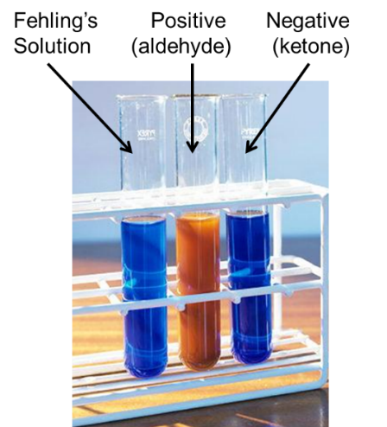

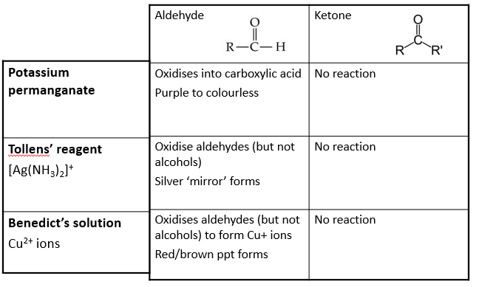

**Acid Chloride reactions**

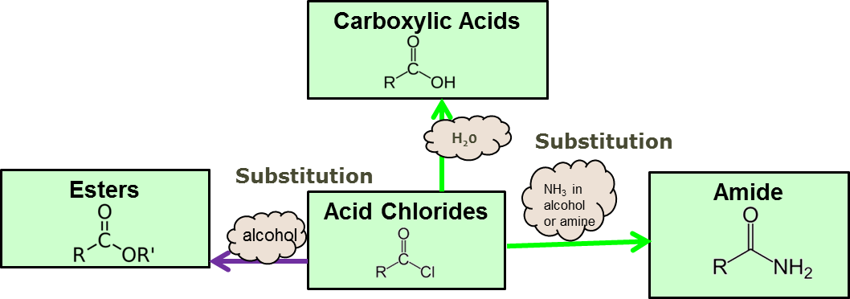

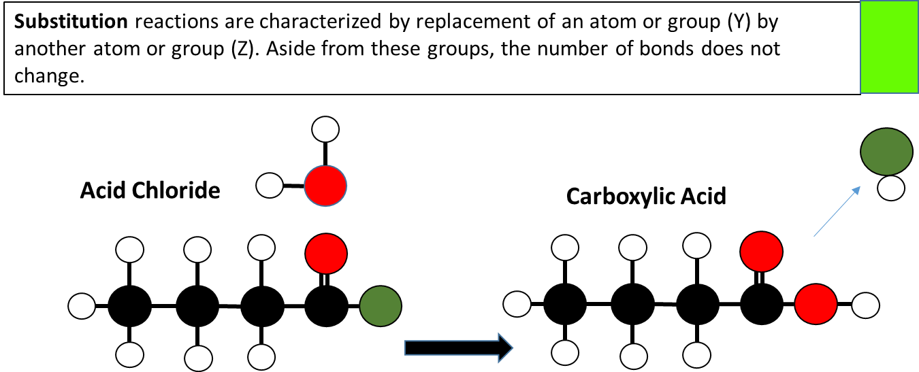

**Reactivity**

The C-Cl bond is polar. The carbon is δ+ and is readily attacked by nucleophiles causing substitution of the Cl. For this reason, acyl chlorides are useful for producing many chemicals.

Addition of water to acyl chlorides results in a vigorous exothermic reaction.

RCOCl + H2O → RCOOH + HCl

**Choice of chlorinating agent.** By choosing the correct chlorinating agent, the products will be easier to separate by fractional distillation. e.g. If PCl5 was used to chlorinate butanoic acid, the products butanoyl chloride (B.P. 102oC) and phosphorous oxychloride POCl3 (B.P. 103oC) would be difficult to separate.

**Acid Chloride reactions - Esterification**

React readily with alcohols to produce esters

RCOCl + R’OH → RCOOR’ + HCl

The acid chloride is dropped into pure alcohol, (in fume cupboard, because HCl(g) is produced). Reaction is fast, yield is high, no heat or catalyst required.

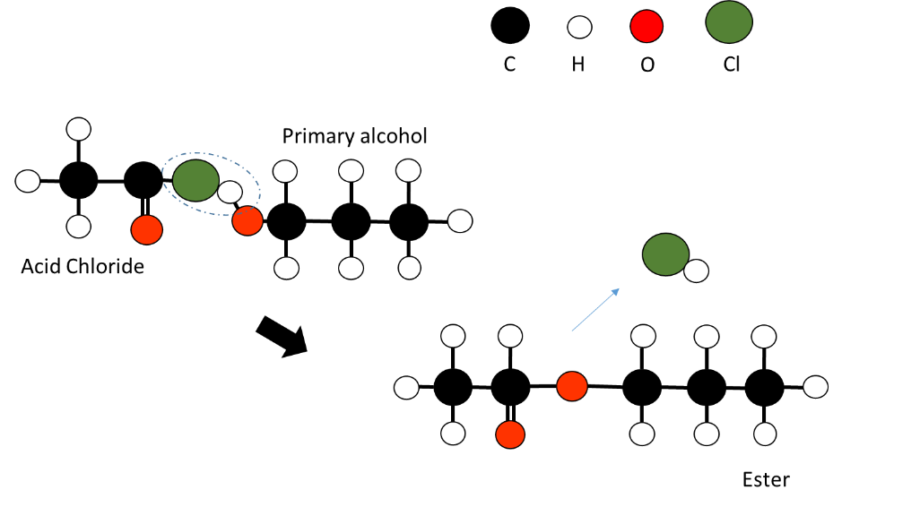

**Acid Chloride reactions – Substitution with ammonia**

React readily with Ammonia to form Amides (primary)

RCOCl + NH3 → RCONH2 + HCl

ammonia 1o amide

As HCl is produced in the reaction, it reacts with unreacted NH3

HCl + NH3 → NH4Cl

Adding these two we find the overall reaction.

RCOCl + 2NH3 → RCONH2 + NH4Cl

acyl chloride ammonia 1o amide

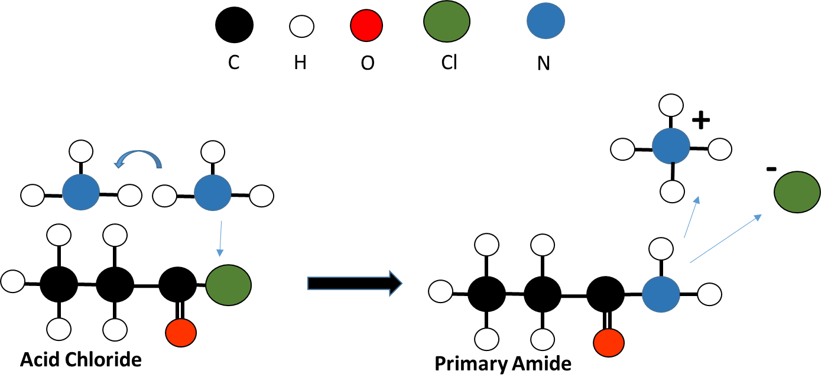

**Acid Chloride reactions – Substitution with primary amines**

Acyl chlorides react readily with 1o amines to produce 2o amides

RCOCl + R’NH2 → RCONHR’ + HCl

acyl chloride 1°amine 2o amide

As HCl is produced in the reaction it reacts with unreacted amine.

HCl + R’NH2 → R’NH3Cl

Adding these two reactions together, we find the overall reaction.

RCOCl + 2R’NH2 → RCONHR’ + R’NH3+Cl-

acyl chloride 2o amide

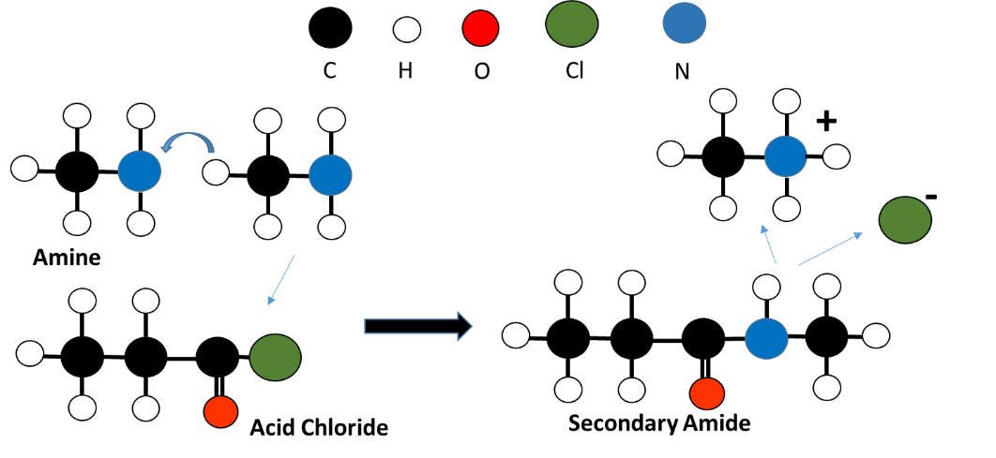

**Hydrolysis Reactions of Amides**

**Acid hydrolysis** produces the carboxylic acid and ammonium ions.

RCONH2 + H3O+ → RCOOH + NH4+

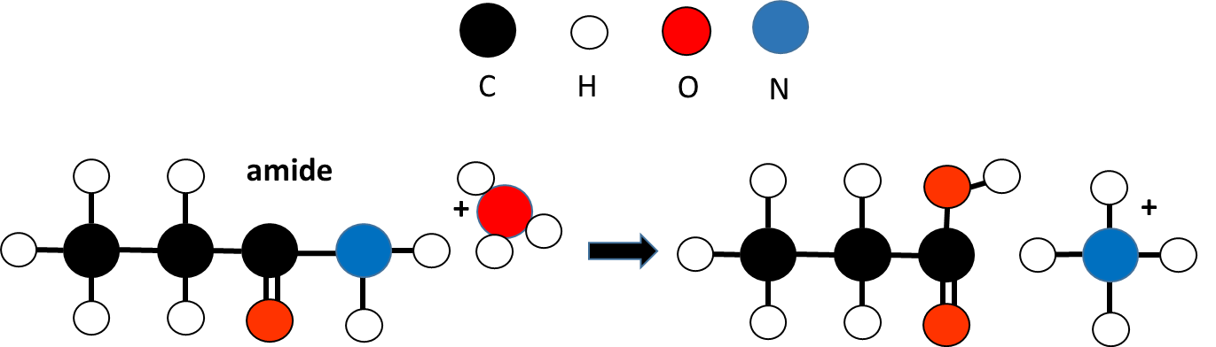

**Basic hydrolysis** produces the carboylate ion and ammonia

RCONH2 + OH1- → RCOO1- + NH3

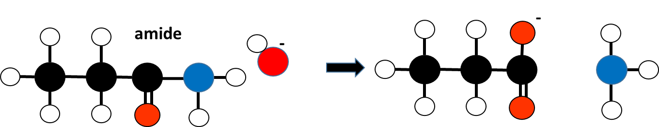

**Ester Reactions - Esterification (Acid)**

Carboxylic Acid + alcohol → Ester + water

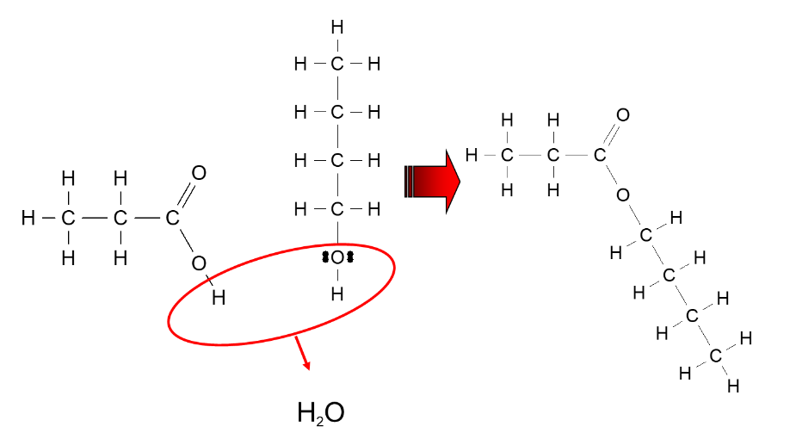

**Triglycerides**

Glycerol + 3 long carboxylic acids (fatty acids) → triglyceride

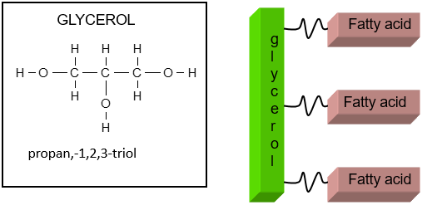

**Ester hydrolysis**

The ester link is hydrolysed in both acid and basic conditions. Both produce an alcohol.

Acidic hydrolysis produces an acid and basic hydrolysis produces a base or salt / following hydrolysis in sodium hydroxide, an acid-base reaction occurs to form the sodium salt and water. (No further reaction occurs in acid.)

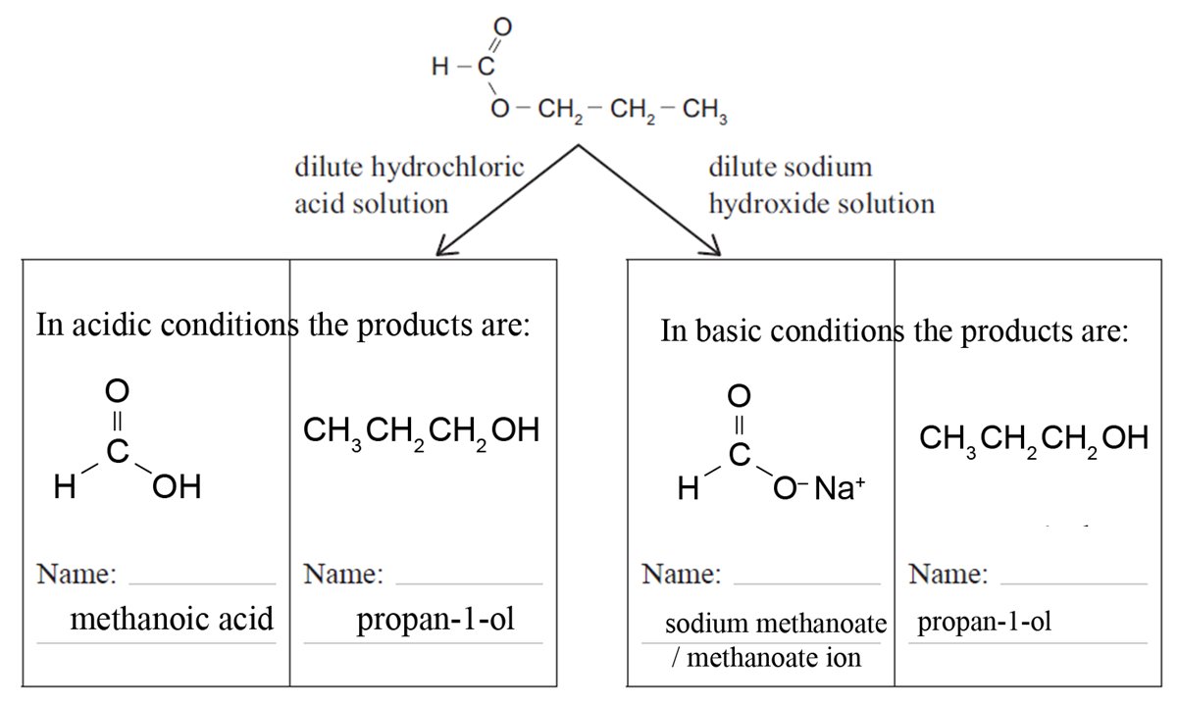

**Alkaline hydrolysis of fats and oils, producing soaps**

Fats and oils are “triesters” **e.g. glycerol tristearate** a saturated fat found in many animal and vegetable fats such as tallow (animal fat).

**Reflux** is used for hydrolysis of the triglyceride as it increases the rate of reaction; (Condensing) prevents volatile chemicals from being lost to the environment, (The mixture refluxed to increase reaction rate without loss of product through evaporation).

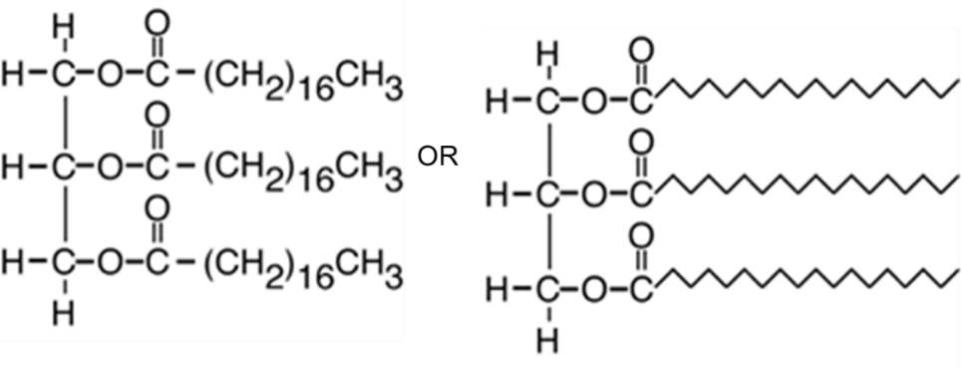

Hydrolysis of fats or oils with ethanolic aqueous sodium hydroxide produces glycerol and the sodium salt of the fatty acid.

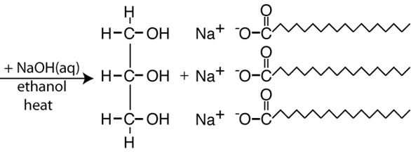

**Condensation polymerisation**

Condensation reactions involve the elimination of water (or small molecule). Polymerisation involves smaller units called monomers joining to form larger molecules or chains called polymers.

There are two main types of condensation polymers –

**Polyesters** - the monomers consist of a di – carboxylic acid (a COOH at each end) and a diol (an –OH at each end). These monomers join at each end to form an ester bond. The CA and the alcohol then continue joining in repeating patterns.

**Polyamide** –the monomers consist of an amide and a di – carboxylic acid.

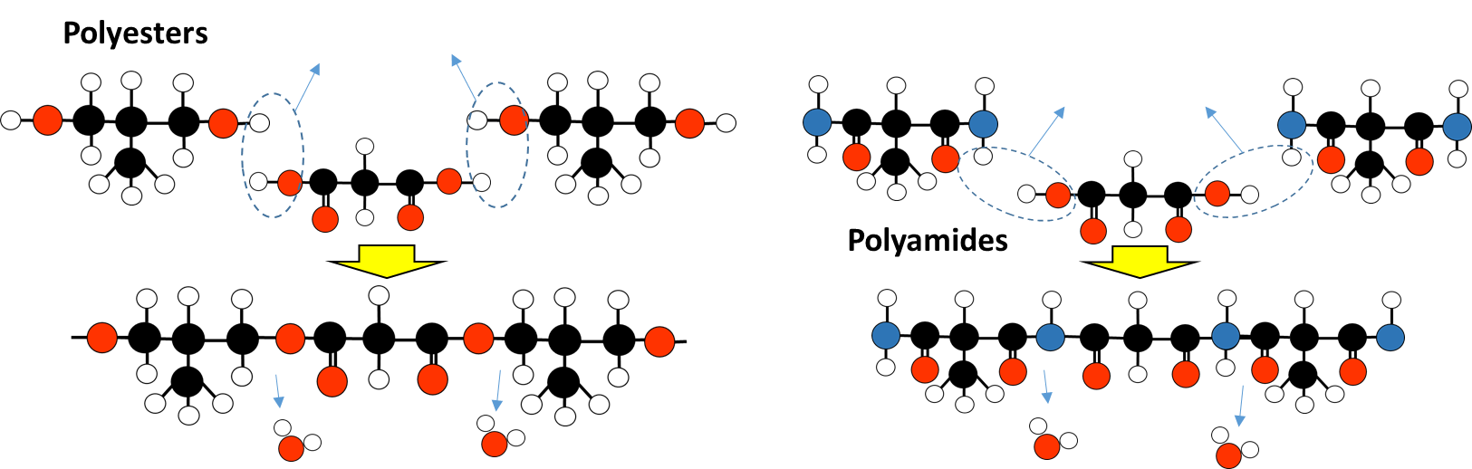

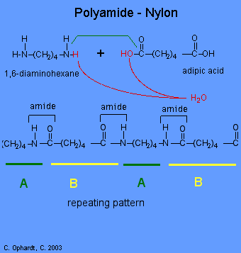

**Polyamides**

A carboxyl group (carbon with a double bonded oxygen such as carboxylic acid) and an amino group (with a NH2 attached to the carbon chain such as an amide or amine) can react together to form an amide or **peptide** link (-CONH) through condensation polymerisation – as a water molecule is released to form each link.

E.g. Nylon-6,6

**Preparation:** Condensation polymerisation of a diamine and a dicarboxylic acid

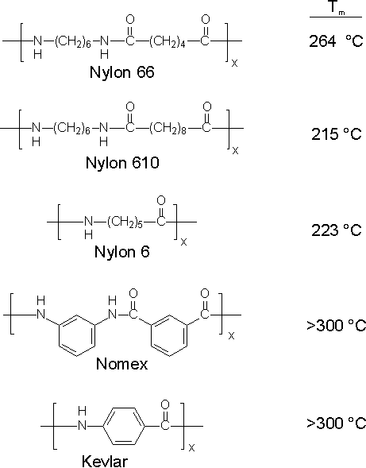

**Polyamide Products**

A polyamide is a polymer containing monomers of amides joined by peptide bonds. They can occur both naturally and artificially, examples being proteins, such as wool and silk, and can be made artificially through step-growth polymerization or solid-phase synthesis, examples being nylons, aramids, and sodium poly(aspartate). Polyamides are commonly used in textiles, automotives, carpet and sportswear due to their extreme durability and strength

**Polyesters**

These are formed by repeated condensation of a di-acid and a di-alcohol.

E.g. Preparation of Terylene

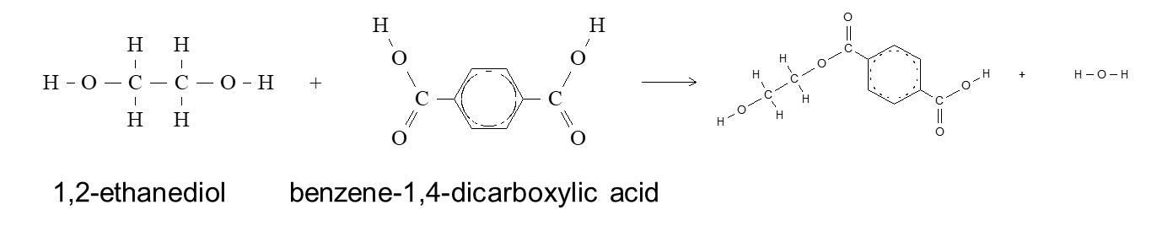

Repeated condensation reactions at either end produces the polymer Terylene [-CH2CH2OOCPhCOO-]n

**Amino acids**

Amino acids have both the basic amino, NH2, and acidic carboxylic acid, CO2H, groups. In acidic solutions, the basic NH2 group is protonated to form a positively charged amino acid. Human protein is made from about 20 different amino acids.

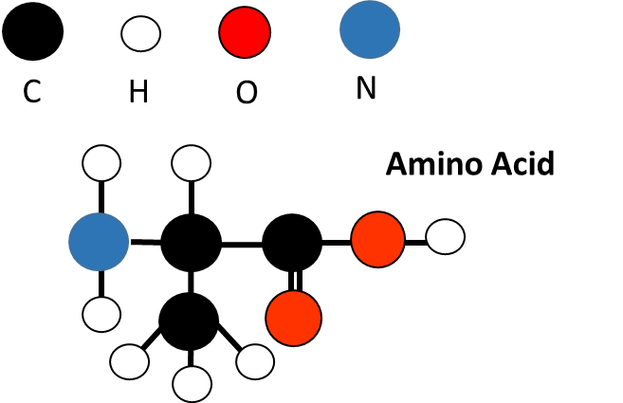

Polypeptide chains can be made from condensation polymerisation of amino acids. Two simple amino acids that can form polymers are glycine and alanine. Alanine has optical isomers. Most Amino Acids form optical isomers (or enantiomers) because they have a chiral carbon with four different groups off it. Our bodies only use one type of optical isomer for each amino acid.

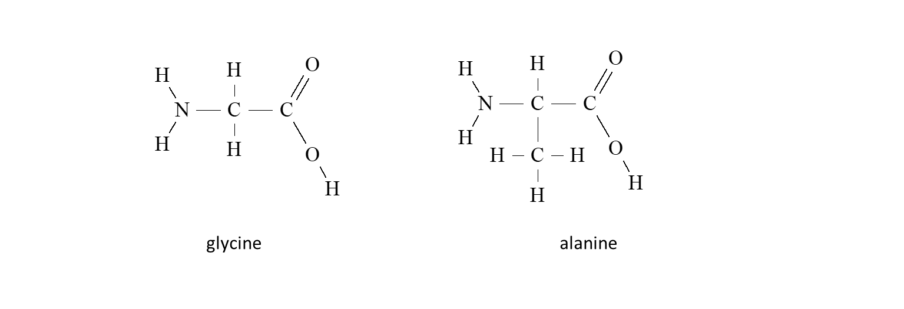

**Peptide bond -** The linking bond between two amino acids. –CONH- (same as an amide link) to form a dipeptide or peptide chain

