Chemistry AS 91392
C3.6 Aqueous Systems

Demonstrate understanding of equilibrium principles in aqueous systems
Aqueous systems are limited to those involving sparingly soluble ionic solids
Equilibrium principles in aqueous systems are limited to qualitative descriptions and/or calculations involving:
- relative concentrations of dissolved species
- sparingly soluble ionic solids
    - relating solubility to K_{s}
    - solubility of solids in water and in solutions already containing one of the ions A or B (a common ion) or due to the formation of a complex ion, or the reaction of a basic anion with added acid
    - predicting precipitation or dissolution

Sparingly soluble ionic solids are limited to AB, A₂B and AB₂ types where neither of the ions A nor B reacts further with water.
Aqueous systems are limited to those involving acidic and basic solutions (in which proton transfer occurs).
- acidic and basic solutions (includes buffers)
    - acid/base strength, K_{a} (pK_{a})
    - concentration of species present in weak acidic and/or basic solutions (includes buffers)
    - relating concentration of species to pH and conductivity
    - Titration curves to represent an acid-base system including selection of indicators (titrations of weak acids with weak bases are excluded).

Acidic and basic solutions are monoprotic acids, bases, salts, and buffers (those in which the extent of reaction is small so that the equilibrium concentration of a dissolved weak acid or base can be approximated by the initial concentration).
Candidates are expected to recognise common strong acids (HCl, HBr, HNO₃, H₂SO₄); strong bases (KOH, NaOH); weak acids (HF, CH₃COOH, and NH₄⁺); weak bases (NH₃, CH₃NH₂, and CH₃COO–). Less familiar weak acids and bases may be included in the context of appropriate resource information. Values of K_{b} or pK_{b} will not be provided, but may be derived and used in calculations. Knowledge of specific complex ions covered in Chemistry Level 2 AS91162 will be assumed. Less familiar complex ions may be included in the context of appropriate resource information.

Equilibrium
Equilibrium is a state of dynamic balance where the rates of formation of product = equals the rate of formation of reactants
At equilibrium, the concentrations of reactants and products are constant. However, both the forward and reverse reactions are continuing
Some reactions go to completion
Reaction stops when one of the reactants is used up
Other reactions are reversible
Products are also forming reactants. Reaction continues
Solubility
The solubility of a substance is the amount of that substance that will dissolve in a given amount of solvent. Solubility is a quantitative term. Solubility varies depending on the solvent and the solute. The terms soluble and insoluble are relative. Some substances can be sparingly soluble where only a very small percentage dissolves. For a solute to dissolve the attraction to the solvent molecules must be stronger than the bonds holding the atoms/molecules of the solute together.

Equilibrium of solutions
A system reaches equilibrium when the rate the solid dissociates into ions matches the rate that the ions precipitate into solids. The equilibrium can be changed permanently by adjusting the system temperature (or temporarily - pressure or adding/removing reactants/product).
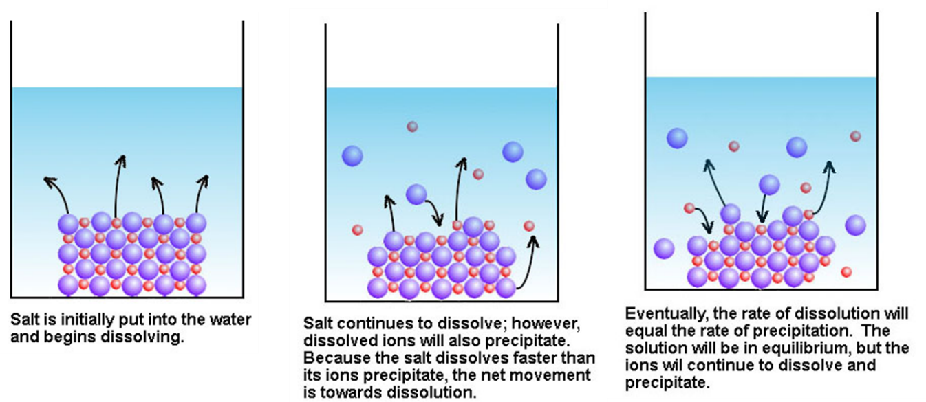

Sparingly Solubility
Many ionic salts are sparingly soluble in water. Even those that are commonly classified as insoluble still have a small amount of the solid dissolved in an aqueous solution so that when the solution is saturated an equilibrium exists between the dissolved ions and the insoluble solid.

The solubility of a salt is often measured in grams per litre, g L⁻¹, or moles per litre, mol L⁻¹. This is the number of grams or moles of the solid that will dissolve to make up 1 litre of a saturated solution at that temperature. If the solubility of a pure salt is given then it is possible to calculate the concentration of both the cation and anion in the solution.
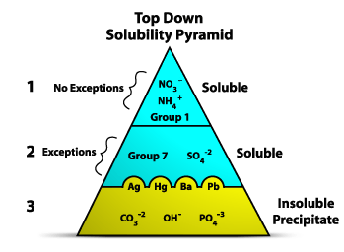
Sparingly Soluble Equilibrium Equations
When sparingly soluble ionic salts dissolve in water to form aqueous solutions, a small percentage of the salt dissociates into individual ions (anion and cation) in the same ratio that they exist as a solid salt.
Once the aqueous solution reaches equilibrium, the rate that the solid salt dissociates into the ions (breaking bonds holding solid together) is matched by the rate the ions reform ionic bonds and “reassemble” as an ionic solid in the solution.
NOTE: although we use an equation, dissolving is a physical change rather than a chemical reaction.
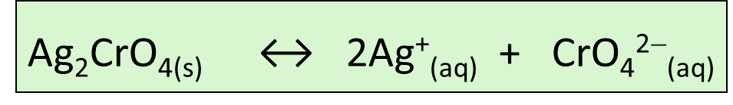
Water is not included in the equation because the very large concentration before and after
means there is negligible change.
Solubility [s] and Concentration
[ ] indicates concentration
At room temperature the solubility of silver chromate, Ag₂CrO₄, is 6.5 x 10⁻⁵ mol L⁻¹.
What is the concentration of Ag⁺ and CrO₄²⁻ ions [s] in 500 mL of a saturated solution?
Start with the equation for the dissolving process.
Ag₂CrO_{4(s)} ⇋ 2Ag⁺_{(aq)} + CrO₄²⁻_{(aq)}
The equation shows that for every mole of dissolved solid there are 2 moles of Ag⁺ ions and 1 mole of CrO₄²⁻ ions. Therefore
[Ag⁺] = 2 x 6.5 x 10⁻⁵ = 1.3 x 10⁻⁻⁹ mol L⁻¹
[CrO₄²⁻] = 6.5 x 10⁻⁵ mol L⁻¹
Note: that because the calculation involves concentration it does not matter that the sample is a 500 mL sample rather than a litre sample since the concentration in any volume of saturated solution is always 6.5 x 10⁻⁵ mol L⁻¹ (at room temperature).
Solubility from molL⁻¹ to gL⁻¹
Example question: What is the solubility [s] of Ag₂CrO₄ in g L⁻¹?
To convert from moles per litre to grams per litre it is necessary to use the molar mass M(Ag₂CrO₄) = 332 g mol⁻¹ and the relationship m = n x M.
s= 6.5 x 10⁻⁵ mol L⁻¹.
Since there is 6.5 x 10⁻⁵ moles in 1 litre the number of grams in 1 litre would be
mass = 6.5 x 10⁻⁵ x 332 = 0.0216 grams and the concentration is 0.0216 g L⁻¹.
Equilibrium Constant: K_{C}
The size of K calculated gives information as to how far a reaction has proceeded
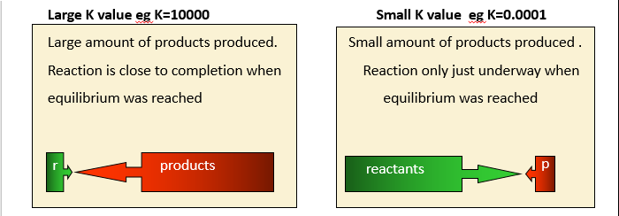
Note: equilibrium does not mean there are equal amounts of reactants and products present
An equilibrium equation can be written as an expression (K_{c}) in which concentrations of products and reactants can be placed in to give us a value. The value will indication the proportion of reactants to products in any given reaction.
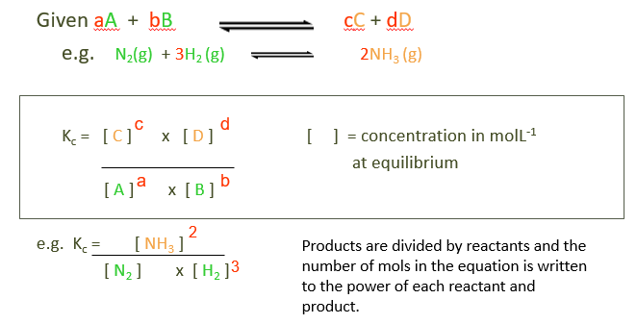
Note: only reactants and products in gas state or aqueous can be placed into an equilibrium expression. Do not place solids or liquids into the expression.
Solubility product K_{s}
The solubility product is the equilibrium constant for the equilibrium between an undissolved salt and its ions in a saturated solution. It is very similar to any other equilibrium constant and, for any particular salt, the value of K_{s} only changes if temperature changes.
Consider a saturated solution of Ca(OH)₂. For this equilibrium, we have the solubility product expression:
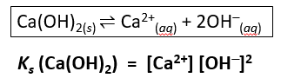
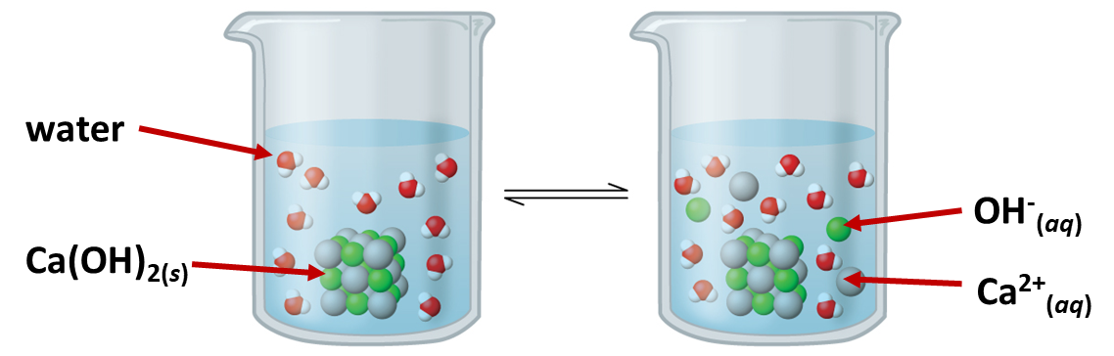
Remember: Water is not included in the equation or expression because the very large concentration before and after means there is negligible change.

Calculating K_{s:} ratio of cation to anion 1:1
Since the solubility can be used to calculate the concentration of ions in a saturated solution of a sparingly soluble salt, then these concentrations can be used to calculate the value of K_{s}.
1. AB type of salt (ratio of cation to anion = 1:1)
The solubility of BaSO₄ is given as 1.05 x 10⁻⁵ mol L⁻¹ at 25ºC. Calculate the value of K_{s}.
BaSO₄(s) ⇌ Ba²⁺ (aq) + SO₄²⁻ (aq)
From this equation [Ba²⁺] = [SO₄²⁻] = solubility, s
K_{s} (BaSO₄) = [Ba²⁺] x [SO₄²⁻] = s² = (1.05 x 10⁻⁵)² = 1.10 x 10⁻¹⁰
NOTE: This equality is only true if there are no other sources of Ba²⁺ and SO₄²⁻ present in the solution ie if all the Ba²⁺ and SO₄²⁻ ions come from the dissolved solid
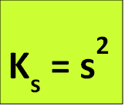
Determining K_{s} : ratio of cation to anion 2:1 or 1:2
AB₂ (or A₂B) type of salt (ratio cation to anion = 1:2 OR 2:1)
Calculate the solubility product for PbI₂ at 25 ºC, given the solubility at 25 ºC is 1.52 x 10⁻³ mol L⁻¹.
PbI₂(s) ⇌ Pb²⁺(aq) + 2I⁻ (aq)
This tells us that [Pb²⁺] = solubility, s = 1.52 x 10⁻³ mol L⁻¹
And [I⁻] = 2 x solubility = 2s = 2 x 1.52 x 10⁻³ = 3.04 x 10⁻³ mol L⁻¹
The expression for K_{s} is K_{s} (PbI₂) = [Pb²⁺] x [I⁻]²
and substituting for solubility we get
K_{s} (PbI₂) = (1.52 x 10⁻³) x (3.04 x 10⁻³)² = 1.40 x 10⁻⁸
NOTE: because [2s]² means everything inside the brackets is squared then expanding it out becomes 2² + s² = 4s². The other ion [s] then is multiplied so the whole expression becomes 4s³ (cubed)
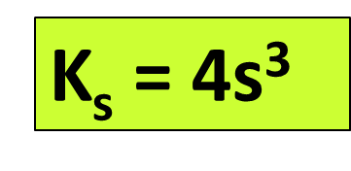
Determining S from K_{s} (1:1)
It is possible to use the value of K_{s} at any particular temperature to calculate the solubility of the salt [s] at that temperature and to calculate the concentration of ions in the saturated solution.
Example
- Calculate the solubility of iron(II) sulfide at 25ºC given that
FeS(s) ⇌ Fe²⁺(aq) + S²⁻(aq)
K_{s} (FeS) = [Fe²⁺] x [S²⁻] = 6.3 x 10⁻¹⁸
From the equation it can be seen that, since the only source of ions is from the dissolving of FeS
Then [Fe²⁺] = [S²⁻] = solubility, s
- K_{s} (FeS) = s² and s = = = 2.51 x 10⁻⁹ mol L⁻¹
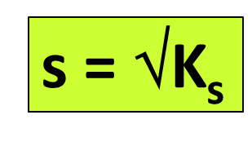
Determining S from K_{s} (2:1)
Calculate the solubility of zinc hydroxide at 25 ºC given K_{s} (Zn(OH)₂) = 2.0 x 10⁻¹⁷
The dissolving equation is Zn(OH)_{2(s)} ⇌ Zn²⁺_{(aq)} + 2OH⁻ _{(aq)}
This means that [Zn²⁺] = solubility = s and [OH⁻] = 2 x solubility = 2s
The expression for K_{s} is K_{s} (Zn(OH)₂) = [Zn²⁺] x [OH⁻]²
OR K_{s} (Zn(OH)₂) = (s) x (2s)² = 4s³
It is therefore possible to use this expression to solve for the solubility, s.
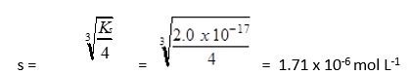

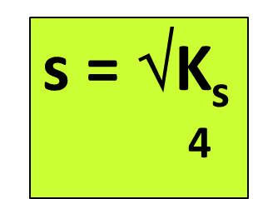
Effects of Acid on Solubility
If the salt contains a carbonate i.e. Ag₂CO₃ which is sparingly soluble, it will dissociate into its ions – one ion being a cation and the other the anion carbonate.
Ag₂CO₃ ⇌ Ag⁺ + CO₃²⁻
If acid is added to this system then it will react with the carbonate ion effectively reducing the concentration of this in the solution. Acid neutralises carbonates
Accordingly, to the principals of equilibrium if a product is removed (carbonate) the reaction will increase in the forward direction to replace the depleted product – hence more salt will dissolve and the overall solubility of the system will increase.
Acids increase solubility if the salt contains a carbonate.
Effects of Base on Solubility
If a sparingly soluble salt contains an cation i.e. AgCl containing Ag⁺ which reacts with NH₃ or OH- to produce a complex ion such as [Ag(NH₃)₂]⁺
Then when a base is added to this system then it will react with the cation effectively reducing the concentration of this in the solution. Base “locks up” many cations into complex ions.
Accordingly, to the principals of equilibrium if a product is removed (silver ions) the reaction will increase in the forward direction to replace the depleted product – hence more salt will dissolve and the overall solubility of the system will increase.
Bases increase solubility if the salt contains a cation that forms a complex ion when pH is above10
Effects of adding hydroxide on Solubility
Decrease SOLUBILITY
If a sparingly soluble salt contains hydroxide i.e. Zn(OH)₂ , a small amount of OH- added will decrease solubility as the reaction is shifted to the left to remove added product and produce more reactant (the solid salt)
This occurs when pH is above 4 but below 10
Increase SOLUBILITY
Then when excess hydroxide is added to this system then it will react with the cation to produce a complex ion, effectively reducing the concentration of this in the solution.
Accordingly, to the principals of equilibrium if a product is removed (silver ions) the reaction will increase in the forward direction to replace the depleted product – hence more salt will dissolve and the overall solubility of the system will increase.
Bases increase solubility if the salt contains a cation that forms a complex ion, when pH is above 10 only.
Ionic product
In any solution, whether it is saturated or not, such as AgCl the product formed [Ag⁺][Cl⁻] is called the ionic product and cannot exceed the K_{s}. If either Ag⁺ ions or Cl⁻ ions are added from another source, such as by adding NaCl, and the new concentrations of ions exceed the K_{s} then a precipitate will form.
Example
What is the minimum concentration of Cl⁻ ions to give a precipitate of AgCl?
c(AgNO₃) = 0.01molL⁻¹ K_{s} = 2 x10⁻¹⁰
If IP > Ks then precipitate will form
- AgCl_{(s)} ⇌ Ag⁺_{(aq)} + Cl⁻_{(aq)}
- K_{s} = [Ag⁺] [Cl⁻] K_{s} = [0.01] [Cl⁻]
- Rearrange K_{s} = [Ag⁺] [Cl⁻]
[Cl⁻] = K_{s} = 2 x 10⁻¹⁰ = 2 x 10⁻⁸
[0.01] 0.01
A precipitate will form if the concentration of Cl⁻ ions exceeds 2 x 10⁻⁸ molL⁻¹
The ratio of the concentrations of products and reactants is called Q.
K_{s} is the maximum concentration of ions the solution can hold (at a given temperature)
Common ion effect
K_{s} is used to calculate the solubility of sparingly soluble salts in pure water. If a solution being added contains either one of the ions already present in the solution then this will reduce the solubility of the salt since the presence of the common ion will move the equilibrium towards the side of precipitated salt. For example, the equation for the dissolving of AgCl is
AgCl(s) ⇌ Ag⁺(aq) + Cl⁻(aq)
AgCl would be less soluble in sea water than in pure water because the presence of the Cl⁻ dissolved in the sea water means [Cl⁻] is higher which must reduce the concentration of [Ag⁺] at equilibrium (as the value of K_{s} cannot change). This reduces the amount of solid AgCl that can dissolve.
Common Ion effect an example of Le Chatelier’s principle. It is possible to calculate the solubility of any salt in a solution containing a common ion, provided the concentration of the ion in the solution and the K_{s} is known.
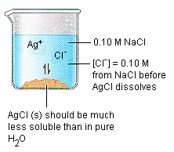
Example
What is the solubility of AgCl in a 0.0025 mol L⁻¹ solution of NaCl?
Ks (AgCl) = [Ag⁺] x [Cl⁻] = 1.6 x 10⁻¹⁰
[Ag⁺] = solubility, s of the AgCl since the only source of silver ions is from dissolved AgCl.
[Cl⁻] = 0.0025 + s since the final concentration of Cl⁻ ions is given by the concentration originally in the solution PLUS the extra dissolved to make a saturated solution.
Assume s is much less than 0.0025 and therefore [Cl⁻] = 0.0025
Ks (AgCl) = s x 0.0025 = 1.6 x 10⁻¹⁰
and s = 1.6 x 10 ⁻¹⁰
0.0025 = 6.4 x 10⁻⁸ mol L⁻¹.
NOTE :(a) This solubility of AgCl in a solution containing Cl⁻ ion is much less than (in this case by more than 1000x) the solubility in pure water of 1.26 x 10⁻⁵ mol L⁻¹. (b) The assumption made that [Cl⁻] = 0.0025 is valid since 6.4 x 10⁻⁸ is much less than 0.0025.

Solubility Key concepts

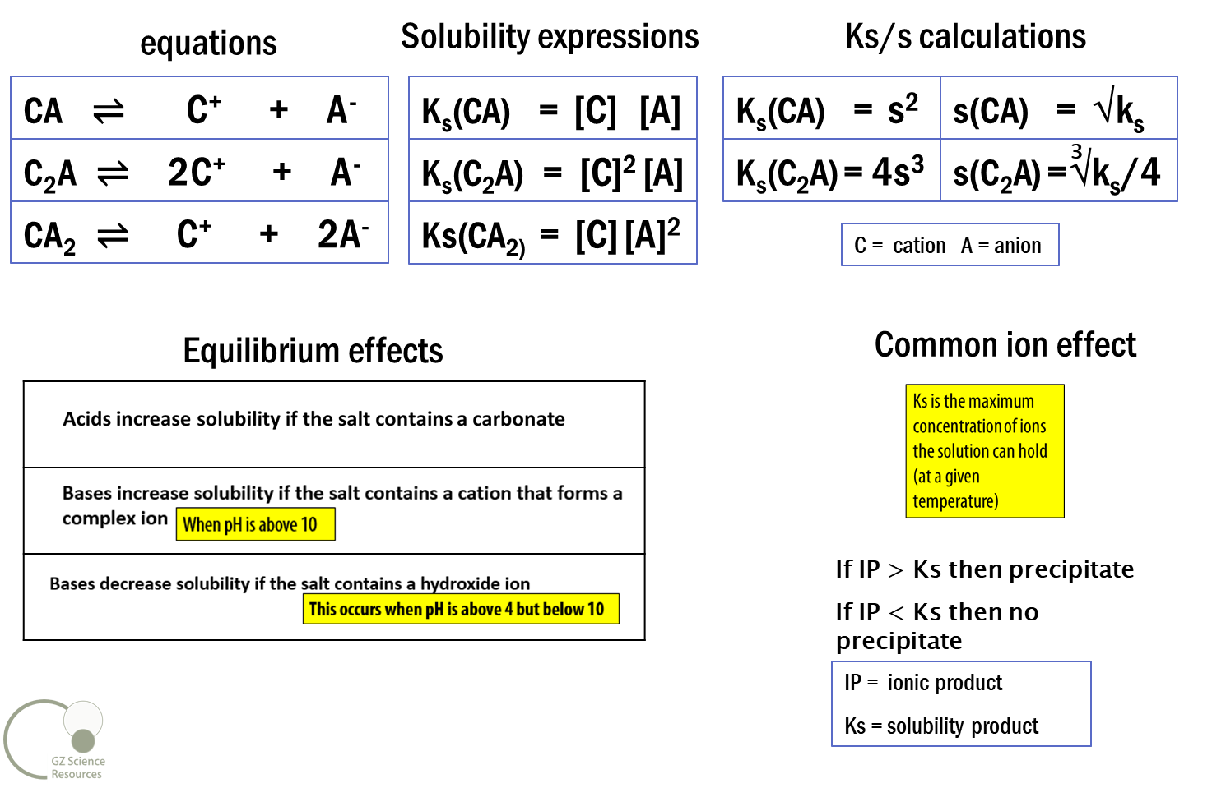

Acids – their characteristics
An Acid donates its Hydrogen ion (H⁺), which is really just a proton - the electron remains behind.
Common acids (that you need to know) include:
Strong acids: HNO₃ - nitric acid, HCl - hydrochloric acid, H₂SO₄ – sulfuric acid, HBr - Hydrobromic acid
Weak acids: CH₃COOH – ethanoic acid, HF - Hydrofluoric acid, and NH₄⁺ - ammonium
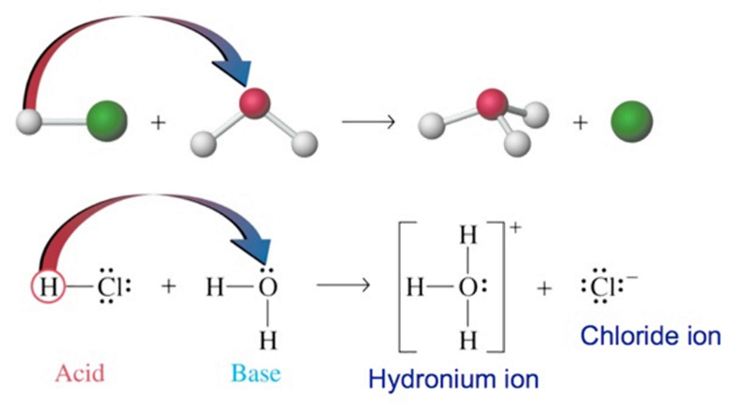
Bases – their characteristics
A Base accepts a Hydrogen ion that have been donated from an Acid.
Common bases (that you need to know) include:
Strong bases: NaOH – sodium hydroxide, KOH – potassium hydroxide
Weak bases: NH₃ – ammonia, CH₃NH₂ - methylamine and CH₃COO– - ethanoate ion
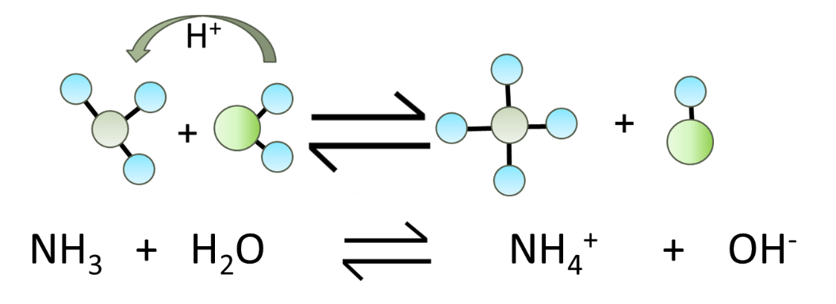
Some substances such as water are amphiprotic and can act as both an acid and a base depending on what other substance the water is with.
Brønsted–Lowry theory of Acid and Base reactions
Acid-Base reactions involve the transfer of Hydrogen ions, H⁺. A hydrogen ion, H⁺ is simply a lone proton (an H with the electron removed). In water (or aqueous solutions), H⁺ ions exist as an H₃O⁺ ion, called hydronium.
Acids are substances that donate protons (H⁺) in solution
HCl_{(g)} + H₂O_{(l)} → H₃O⁺_{(aq)} + Cl⁻_{(aq)}
HCl gas dissolved in water
HCl has donated an H⁺ so is acting as an acid
H₂O has accepted an H⁺ so it is acting as a base
Solution becomes acidic since H₃O⁺ ions form
Bases are substances that accept protons (H⁺) in solution
NH_{3(g)} + H₂O_{(l) ⇋} NH₄⁺_{(aq)} + OH⁻_{(aq)}
NH₃ gas dissolved in water
NH₃ has accepted an H⁺ so it is acting as a base
H₂O has donated an H⁺ so is acting as an acid
Solution becomes basic since OH⁻ ions form.
Brønsted–Lowry acids and bases summary
Proton donation to a water molecule forms H₃O⁺ (hydronium) ions.
HA(aq) + H₂O(l) ⇋ H₃O⁺(aq) + A⁻(aq)
acid base acid base
proton donor proton acceptor
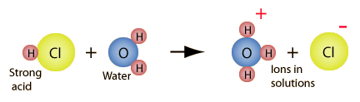
Similarly, proton donation from water to a base produces OH⁻ ions.
B(aq) + H₂O(l) ⇋ BH⁺(aq) + OH⁻(aq)
base acid acid base
proton acceptor proton donor
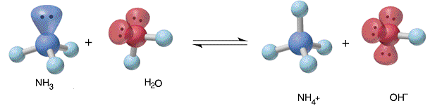
Amphiprotic substances
An amphiprotic substance is a substance that can donate or accept a proton, H⁺
For a substance to be amphiprotic it must
- Contain a hydrogen atom, which is able to be donated to another chemical species.
- Be able to accept a hydrogen ion from another species.
Examples of amphiprotic species include, H₂O, HCO₃⁻ , HSO₄⁻ , HPO₄²⁻ and H₂PO₄⁻
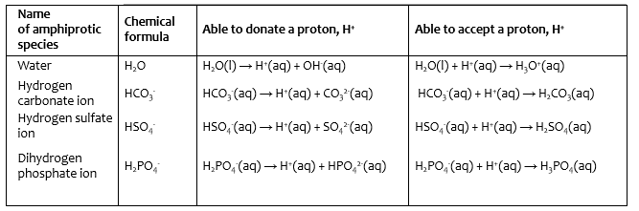
Strong and Weak Acids
The strength of an acid is determined by how readily it will donate its H⁺ ions. Strong acids will have a low pH (0-3) and include HNO₃ , HCl , H₂SO₄ , and HBr
Weak acids will have a higher pH (4-6). They are mostly organic acids and include CH₃COOH, HF and NH₄⁺
Strong acids
Donate protons (H⁺) in aqueous solution to become completely dissociated.
HCl_{(g)} + H₂O_{(l)} → H₃O⁺_{(aq)} + Cl⁻_{(aq)}
HCl gas dissolved in water
HCl has donated an H⁺ so is acting as an acid
H₂O has accepted an H⁺ so it is acting as a base
Solution contains virtually no intact HCl molecules after reaction.
Weak acids
Donate protons (H⁺) in aqueous solution to become partially dissociated.
CH₃COOH_{(l)} + H₂O_{(l)} ⇋ CH₃COO⁻_{(aq)} + H₃O⁺_{(aq)}
CH₃COOH dissolved in water
Only some of the acetic acid molecules dissociate into acetate ions (CH₃COO⁻)
Because the acetate ion is a strong base (conjugate pairs), it will readily accept H⁺ (from H₃O⁺) and become acetic acid.
Solution contains mostly intact CH₃COOH molecules.
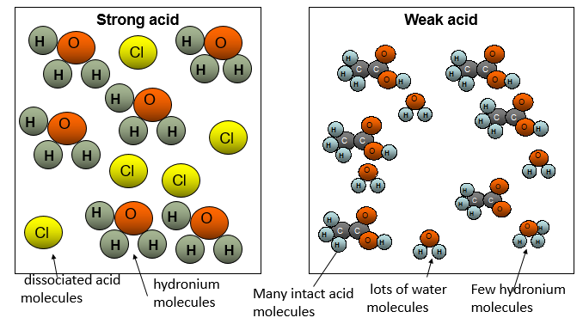

Strong and Weak Bases
The strength of a base is determined by how readily it will accept H⁺ ions. Strong bases will have a high pH (12-14) and include NaOH and KOH. Weak acids will have a lower pH (8-11). They include NH_{3,} CH₃NH₂ and CH₃COO–
Strong Bases
Completely accept protons (H⁺) in aqueous solution
NaOH_{(s)} → Na⁺_{(aq)} + OH⁻_{(aq)}
NaOH completely dissociates
The OH- ions will readily accept H⁺ ions.
Solution contains very few intact NaOH molecules after reaction.
Weak Bases
Partially accept protons (H⁺) in aqueous solution
NH_{3(g)} + H₂O ⇋ NH₄⁺_{(aq)} + OH⁻_{(aq)}
Only some of the ammonia molecules dissociate into ammonium ions (NH₄⁺)
Because ammonium is a reasonably strong acid (conjugate pairs), it will readily donate H⁺ and become ammonia.
Solution contains mostly intact NH₃ molecules.
Conjugate pairs
If two species differ by just one proton, they are classed as a conjugate acid-base pair.
Examples of acid-base pairs are H₂SO₄/HSO₄⁻ and NH₄⁺/NH₃.
The acid is always the species with the additional proton.
It can also be said that NH₃ is the conjugate base of NH₄⁺.
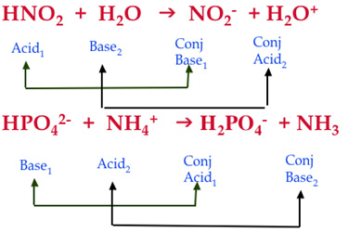
When a base accepts a proton, it becomes an acid because it now has a proton that it can donate. In addition, when an acid donates a proton it becomes a base, because it now has room to accept a proton.
These are what we call conjugate pairs of acids and bases.
When an acid gives up its proton, what remains is called the conjugate base of that acid. When a base accepts a proton, the resulting chemical is called the conjugate acid of that original base.
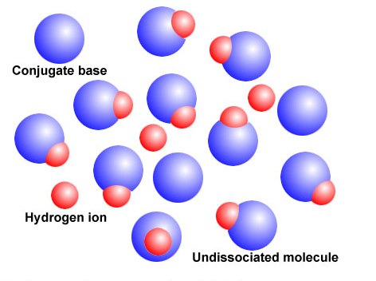
Conjugate Acid and Base pairs (Strong Acid)
HX is a symbol used for a strong acid. A conjugate acid can be seen as the chemical substance that releases a proton in the backward chemical reaction.
The base produced, X−, is called the conjugate base and it absorbs a proton in the backward chemical reaction.
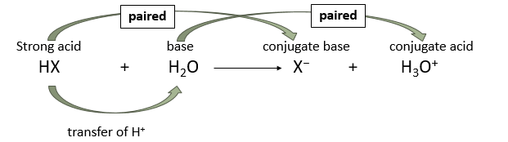
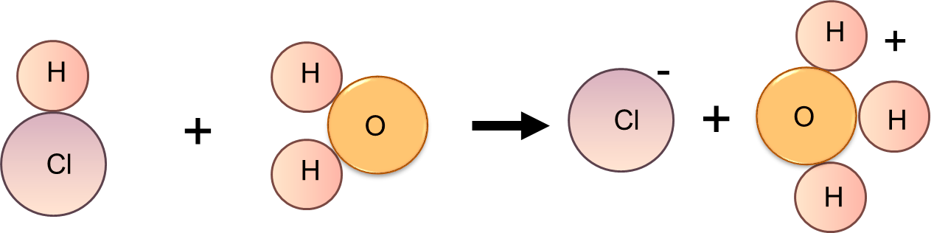
Where c(HX) = [H₃0⁺]
Initial concentration of HX is equal to final concentration of H₃0⁺
so pH= -log c(HX)

Conjugate Acid and Base pairs (weak acid)
HA is a symbol used for weak acid. Note the use of the double arrow. Because the weak acid only partially dissociates, in an equilibrium, a reaction occurs with a fixed amount of an acid and its conjugate remains in solution.
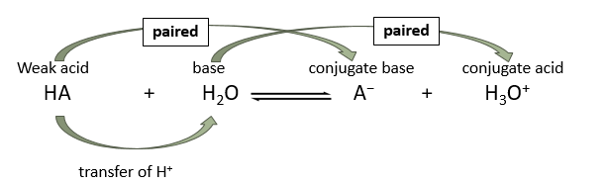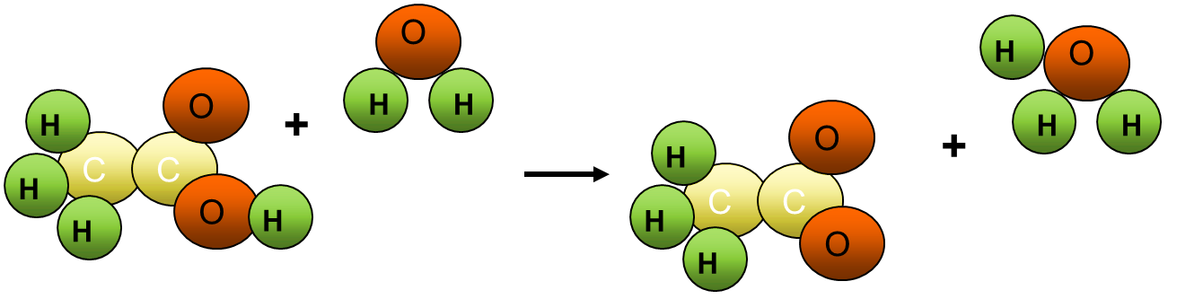

Conjugate Acid and Base pairs (Base)
B is a symbol used for a base. The base now accepts the hydrogen ion from the water. The hydroxide ion, OH⁻, is the paired conjugate of the water once the H⁺ has been removed. Strong bases use a single direction arrow and weak bases use a double arrow.
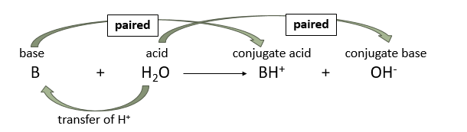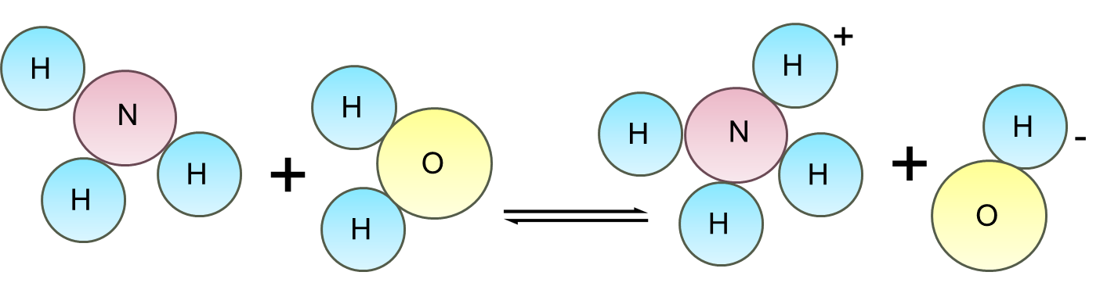

Conjugate Acid and Base pairs
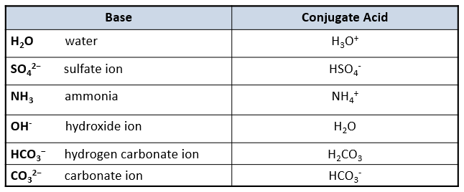
The stronger an acid, normally the weaker its conjugate base, and, conversely, the stronger a base, the weaker its conjugate acid.
A strong acid like HCl donates its proton so readily that there is essentially no tendency for the conjugate base Cl– to reaccept a proton. Consequently, Cl– is a very weak base. A strong base like the H– ion accepts a proton and holds it so firmly that there is no tendency for the conjugate acid H₂ to donate a proton. Hence, H₂ is a very weak acid.

Species in solution
A solution is formed by mixing a solute (a dissolved substance) into a solvent (the solution that dissolves the solute.
In Aqueous Chemistry, the solvent is water, and the solute can be an acid, base or ionic salt.
A solute dissolves by bonds being broken between solute particles (endothermic) and new bonds being formed between solute and solvent (exothermic).
A small amount of H₃O⁺ and OH⁻ will always be present in water due to Kw = [OH⁻] [H₃O⁺] = 1 x 10⁻¹⁴
Water will always be present in large concentrations.
Concentration of species in solution
The relative concentration of the species in solution at equilibrium will depend upon the type of substances dissolved into water initially.
- In aqueous solutions, water will almost always be present in the highest concentration.
- Small quantities of H₃O⁺ and OH⁻ will also be present, according to the K_{w} = [H₃O⁺] [OH⁻] = 1 x 10⁻¹⁴
- Information on relative concentration can often be presented in a bar graph.
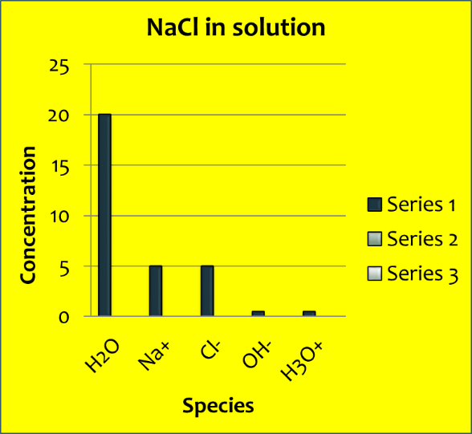
Weak and strong acids
In a strong acid there will be no original acid seen in the final solution. Equal quantities of conjugate base and hydronium are formed.
In a weak acid there will be mostly the original acid seen in the final solution. Equal quantities of conjugate base and hydronium are formed, but in small amounts.
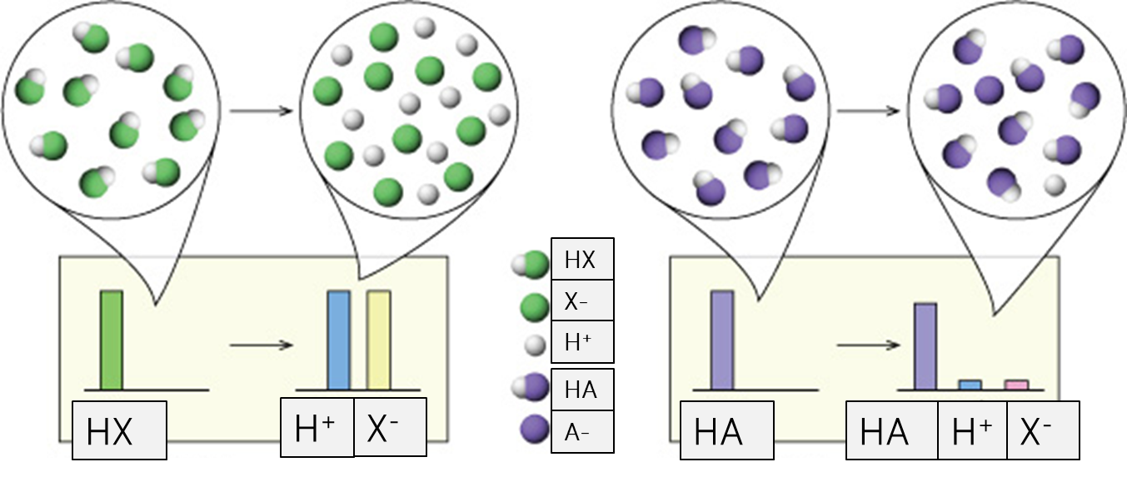
Concentration of ions in solution – Strong Acid
Strong Acid i.e. HCl reacting with water
[Cl⁻] = [H₃O⁺] > [OH⁻]
Strong acids will provide good conductivity and pH 1-2 due to the high presence of H₃O⁺ ions
No strong acid will be left in the final mixture.
H₃O⁺ and Cl⁻ are produced in equal concentrations – in the same concentration as the original strong acid.
A small amount of OH⁻ is present as water dissociates into H₃O⁺ and OH⁻

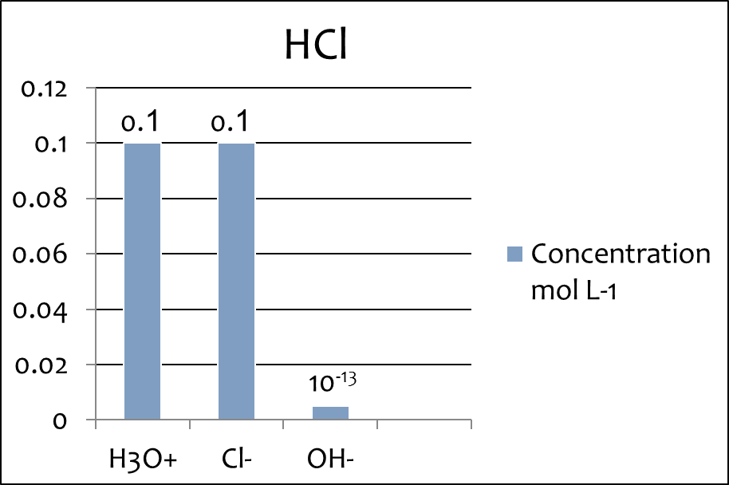

Concentration of ions in solution – Weak Acid
Weak Acid i.e. CH₃COOH reacting with water
[CH₃COOH] > [CH₃COO⁻] ≈ [H₃O⁺] > [OH⁻ ]
Weak acids will provide poor conductivity and pH 3-6 due to the low presence of H₃O⁺ ions (but still higher than OH⁻ ions)
Most weak acid will be left in the final mixture.
H₃O⁺ and CH₃COO⁻ are produced in equal concentrations – a small amount of the weak acid had dissociated.
A small amount of OH⁻ is present as water dissociates into H₃O⁺ and OH⁻

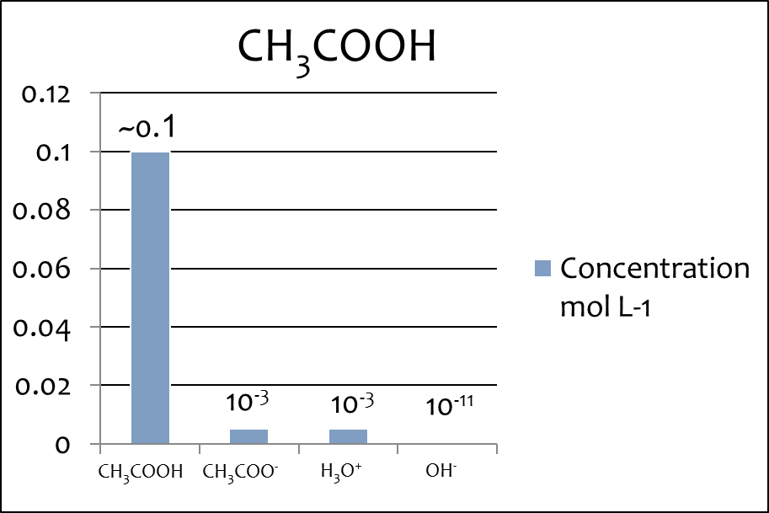
Concentration of ions in solution – Strong Base
Strong Base i.e. NaOH reacting with water
[OH⁻] >= [Na⁺] > [H₃O⁺]
Strong bases will provide good conductivity and pH 12 – 14 due to the high presence of OH⁻ ions
No strong base will be left in the final mixture.
OH⁻ and Na⁺ are produced in equal concentrations – in the same concentration as the original strong base.
A small amount of H₃O⁺ is present as water dissociates into H₃O⁺ and OH⁻
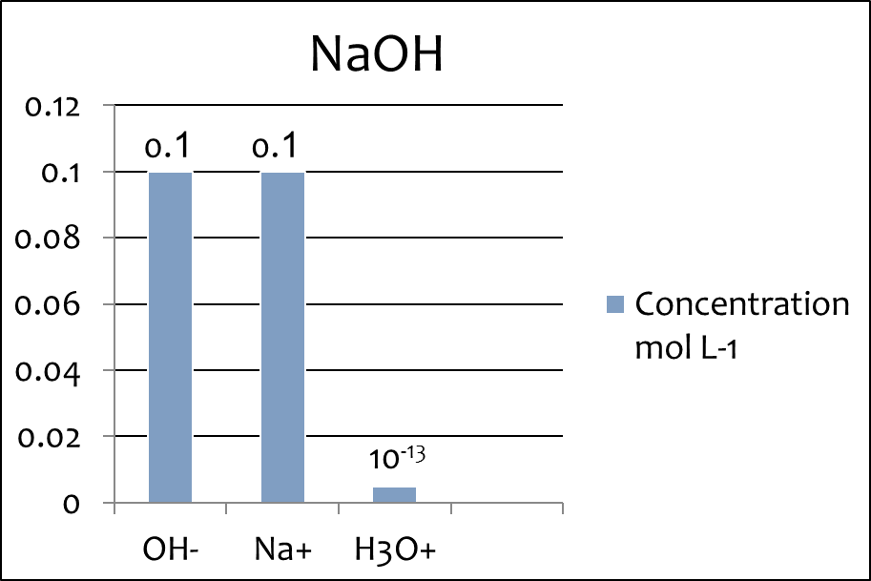
Concentration of ions in solution – Weak Base
Weak Base i.e. NH₃
[NH₃] > [OH-] > [NH₄⁺] > [H₃O⁺]
Weak bases will provide poor conductivity and pH 8 – 11 due to the low presence of OH⁻ ions (but still higher than H₃O⁺ ions)
Most weak base will be left in the final mixture.
OH⁻ and NH₄⁺ are produced in equal concentrations – a small amount of the weak base had dissociated.
A small amount of H₃O⁺ is present as water dissociates into H₃O⁺ and OH⁻
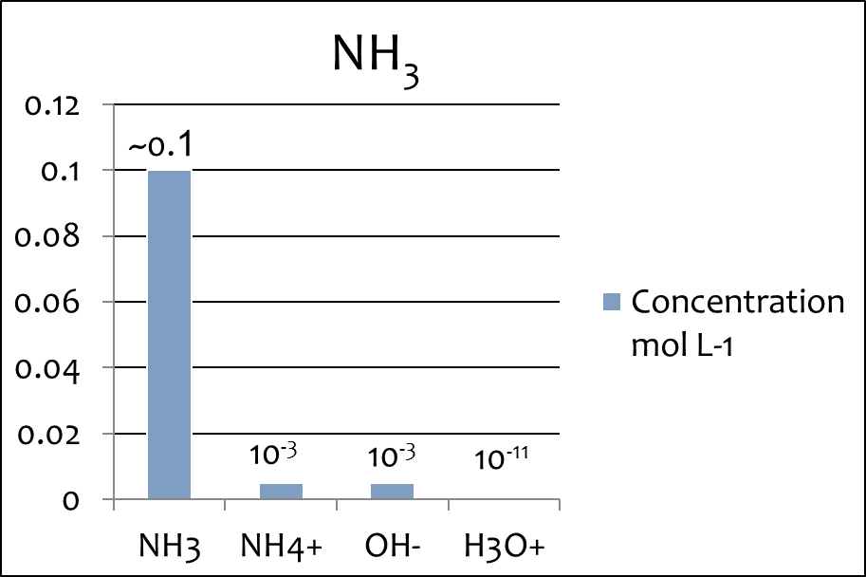
Concentration of ions in solution – acid salt
Acid Salt i.e. NH₄Cl
[Cl⁻] > [NH₄⁺ ] > [H₃O⁺] = [NH₃] > [OH⁻]
Acid salts will provide good conductivity and pH < 7 due to the high presence of ions from dissolving and to a lesser extent H₃O⁺ ions
The spectator ion will be left in the highest concentration followed by the weak acid.
H₃O⁺ and NH₃ are produced in equal concentrations – a small amount of the weak acid had dissociated.
A small amount of OH⁻ is present as water dissociates into H₃O⁺ and OH⁻
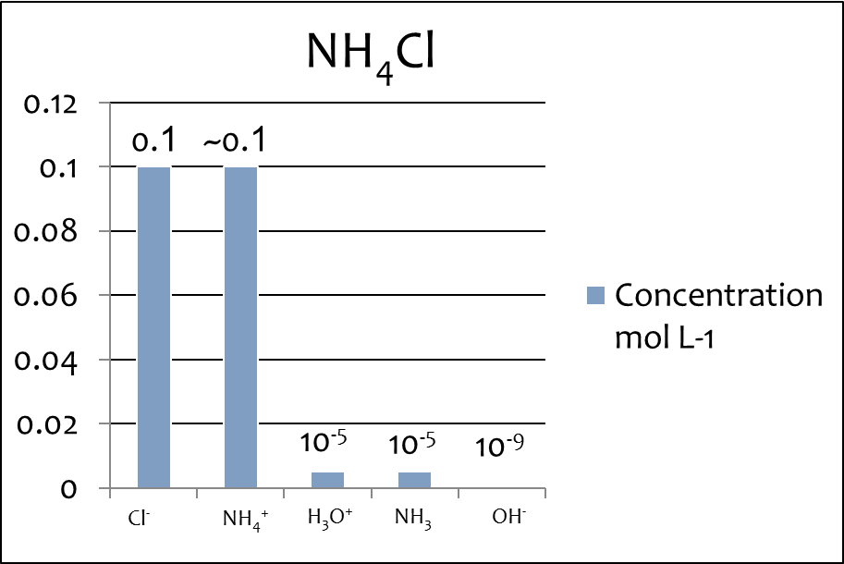
Concentration of ions in solution – base salt
Base Salt i.e. CH₃COONa
[Na⁺] ≈ [CH₃COO⁻] > [CH₃COOH] = [OH⁻ ] > [H₃O⁺]
Base salts will provide good conductivity and pH > 7 due to the high presence of ions from dissolving and to a lesser extent OH⁻ ions
The spectator ion will be left in the highest concentration followed by the weak base.
OH⁻ and CH₃COOH are produced in equal concentrations – a small amount of the weak base had dissociated.
A small amount of H₃O⁺ is present as water dissociates into H₃O⁺ and OH⁻
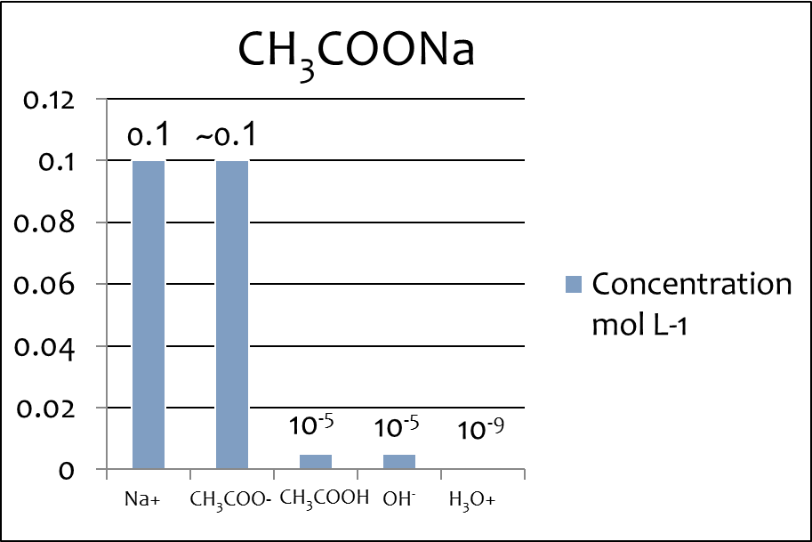
pH of salt solutions
All cations that are the conjugate acids of weak bases act as weak acids and lower the pH of the solution. This means that a salt solution containing this cation could be acidic. For example, a solution of ammonium chloride, NH₄Cl, contains the cation NH₄⁺ and the anion Cl⁻. The Cl⁻ ion acts as a neutral species and does not affect the pH (as it is the conjugate base of a strong acid and is so weakly basic that it effectively has no reaction with water). The NH₄⁺ ion is the conjugate acid of the weak base NH₃ and so itself is a weak acid.

The ionic salt will first dissolve into its two ions. This equation needs to be shown.
There will then be a further equation as the ion acting as a weak acid or base undergoes an acid/base reaction with water.
The non-reacting ion is left off as the spectator.
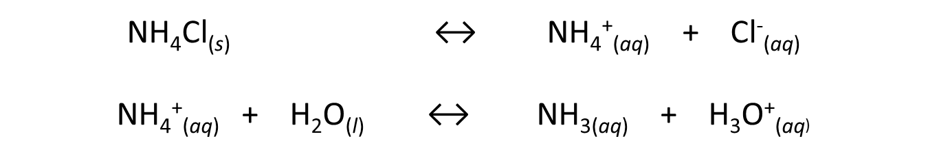
Conductivity of solutions
Conductivity is related to the availability of free moving charged particles.
The presence of ions in solution and the concentration of them determine conductivity.
High conductivity
A strong electrolyte (solution containing ions) is created when a strong acid /strong base is added to water and fully dissociates. An ionic salt added to water also produces a strong electrolyte when both anions and cations are formed.
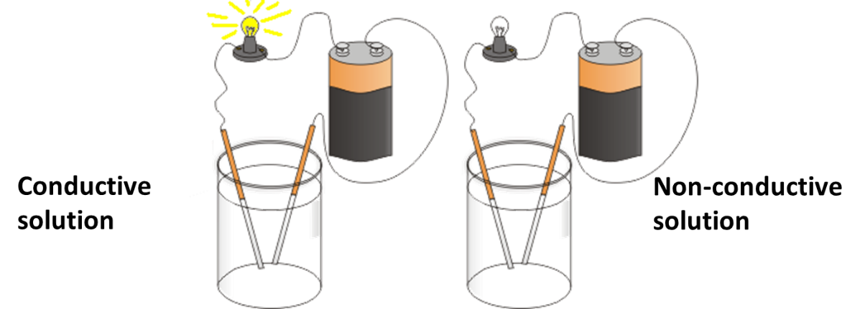
Low Conductivity
A weak electrolyte is formed from a weak acid or base that only partially dissociates. Only a small concentration of ions are created to carry charge. (Such as acetic acid)
No Conductivity
Polar molecular solids that dissolve in water have no free charge particles (such as glucose or alcohols) and therefore cannot conduct charge.

Kw – the ionic product for water
K_{w} is ionic product for water and an equilibrium constant based on the reaction of water molecules transferring H⁺ in an acid base reaction to create OH⁻ and H₃O⁺ in equal quantities. The rate of reaction from reactants to products is the same as products to reactants once equilibrium is reached.
K_{c} = [H₃0⁺] [OH⁻] from: 2H₂0_{(l)} ⇋ H₃0⁺_{(aq)} + OH⁻ _{(aq)}
[H₂0]² (Δ_{r}H =+ve)
Or K_{c} x [H₂0]² = [H₃0⁺] [OH⁻]
Because the concentration of water is so large it does not change → considered constant
So K_{c} x [H₂0]² is also constant – called K_{w}
As [H₃0⁺] x [OH⁻] always equals 1 x 10⁻¹⁴ then so does K_{w}
Temperature increase causes an increase in Kw as the reaction is endothermic this favours the forward reaction (Le Chatelier’s Principle)
Acidity constant
An acid dissociation constant, Ka, (also known as acidity constant) is a quantitative measure of the strength of an acid in solution.
It is the equilibrium constant for a chemical reaction known as dissociation in the context of acid-base reactions.
The equilibrium can be written symbolically as:
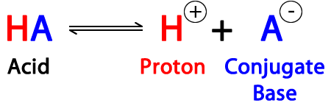
The chemical species HA, A− and H+ are said to be in equilibrium when their concentrations do not change with the passing of time.
Weak acids dissociate only slightly therefore in a solution mostly reactants will be found and the K value will be small
Strong acids completely (or nearly completely) dissociate therefore in a solution only a small amount of reactants will be found and the K value will be large
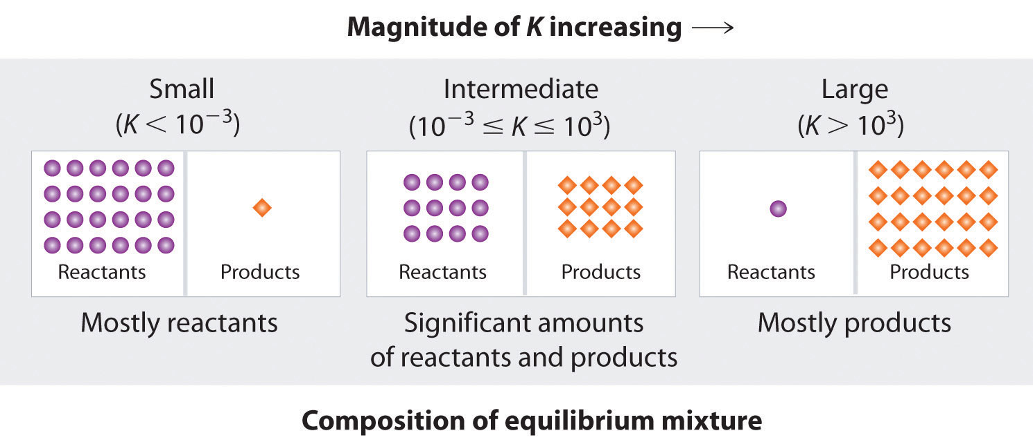
From the equation:
HA + H₂O ↔ A⁻ + H₃O⁺
The equilibrium constant for a weak acid can be written as:
K_{a} = [H₃O⁺] [A⁻]
[HA]
We can also assume that the concentration of H₃O⁺ and A⁻ are the same, as one mole of H₃O⁺ forms every time one mole of A⁻ is created.
In a weak acid we can assume that the [HA] concentration at equilibrium is no different from the starting concentration c (HA) due to very limited dissociation.
We do not include H₂O because in an aqueous solution it is in such high concentrations that the difference before and after dissociation is negligible.
Acidity constant - assumptions
Acidity constant = K_{a}
[H₃0⁺] = [A⁻] hydronium concentration = conjugate base concentration
K_{a} = [H₃0⁺]²
[HA]
→ if K_{a} small then [H₃0⁺] much smaller than [HA] – very little dissociation
[HA] can then be assumed to be equal to c(HA)
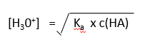
pH calculations – Weak acid
1. Convert pK_{a} to K_{a} (if required)
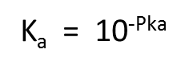
2. Calculate [H₃O⁺]
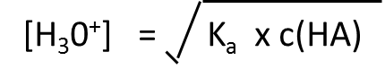
3. Calculate pH (start here if strong acid)
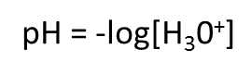
Use when
→ given Ka (acid dissociation constant)
→ given c(HA) – initial concentration of acid, as concentration at equilibrium [HA] and at the start c(HA)
is the same
→ Weak acid, HA
HA + H₂O ⇋ A⁻ + H₃O⁺ Use this equation to compare number of mols.
NOTE: As weak acids are diluted they become “stronger” as degree of dissociation (a = [H⁺]/c_{HA}) increases. (At infinite dilution, a weak acid is 100% dissociated) This is because in the equilibrium HA + H₂O ⇋ H₃O⁺ + A⁻, adding water dilutes all concentrations equally in the expression K_{a} = [H₃O⁺] x [A⁻]/HA so to keep K constant, the equilibrium position needs to shift to the right.
Pk_{a}
pK_{a} = -log K_{a} K_{a} = 10^{-Pka}
→ negative for strong acids (HX)
→ gets larger (3 – 13) as acids get weaker – less dissociation
Weaker acid = stronger conjugate base
HA + H₂O ⇋ H₃)⁺ + A⁻
reactants products
→ larger pKa more reactants

Bases
B_{(aq)} + H₂0 ⇋ BH⁺ + OH⁻
Base water conjugate acid hydroxide
Strong base – completely dissociates (accepts all H⁺ ions)
pH = -log[H₃0⁺] [H₃0⁺] = 1 x 10⁻¹⁴/[OH⁻]
Strong bases will have a conjugate weak acid
Weak base – partly dissociates (accepts few H⁺ ions)
[B] assumed to be same as c(B) – initial concentration
K_{b} – base dissociation constant
K_{b} = 1 x10⁻¹⁴ / K_{a}
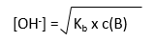
K_{b} is small if K_{a} is large – weak base and strong acid
K_{b} is large if K_{a} is small – strong base and weak acid
Use when
→ given Ka of conjugate acid (acid dissociation constant)
→ given concentration of reactant
→ Weak base, B (replace [A⁻])
BH⁺ + H₂O ⇋ B + H₃O⁺
Use this equation to compare number of mols.
pH calculations – Weak base
1. Convert K_{a} to K_{b}
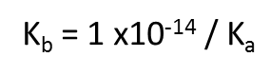
2. Calculate [OH⁻]
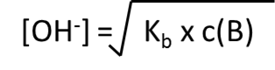
3. Convert [OH⁻] to [H₃O⁺] (start here if Strong Base)
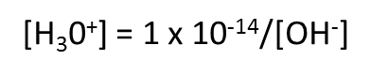
4. Calculate pH

Acid – base titration curves
A plot of the pH of an acid solution against the volume of added base (or vice-versa) produces what is called a pH titration curve. The example below shows how the pH (measured using a pH meter) changes when a strong acid is added to a strong base. There are characteristic points on the curve that can be identified. One of these is the equivalence point, the midpoint of the section where the pH of the solution rises (or falls) sharply. The equivalence points for titrations between a strong acid and a strong base have a pH of 7. Both before and after this section the pH only changes slowly.
Because the pH rises so sharply at the equivalence point of a strong acid/strong base titration a range of indicators can be used to determine the end-point of the titration. If the indicator has a pKa value equal to a pH value within the steep rise in the curve then it will change colour at the equivalence point for this titration.
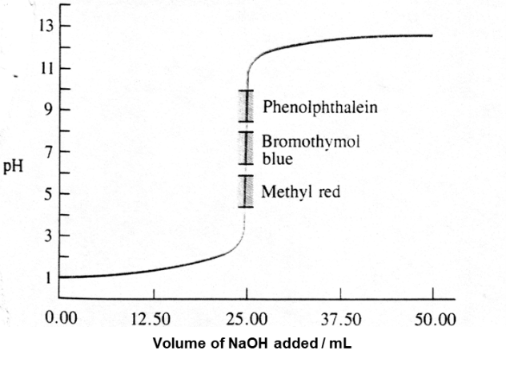
The pH curve below shows a typical shape for the titration of a weak acid with a strong base e.g. methanoic acid with sodium hydroxide.
Note that the equivalence point has a pH > 7 since at this point, it is a solution of sodium methanoate and the methanoate ion is a weak base since it is the conjugate of the weak acid methanoic acid. At the equivalence point the HCOO⁻ formed reacts with water:
HCOO⁻ + H₂O ⇋ HCOOH + OH⁻
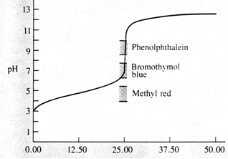
The equivalence point is at a pH greater than 7 so only indicators with a pK_{a} about 8-9 will change colour at the correct pH and be useful.
Neutralisation of acids
Acids are neutralised by bases. The amount of base needed to neutralise an acid depends only on the concentration and volume and is independent of the acid strength. The concentration of an acid solution is found by carrying out a titration with a base of accurately known concentration (called a standard solution). Such a titration is also called a volumetric analysis. Given the titration data, it is possible to calculate the acid concentration. To determine the amount of base needed to neutralise an acid we normally use an appropriate acid-base indicator and stop the titration at the point when the indicator changes colour. This is called the end-point of the titration. This is the point when the amount of added base is exactly equal to the initial amount of acid in the solution.

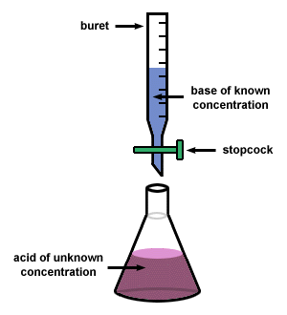
The pH of the equivalence point will determine the choice of indicator used.
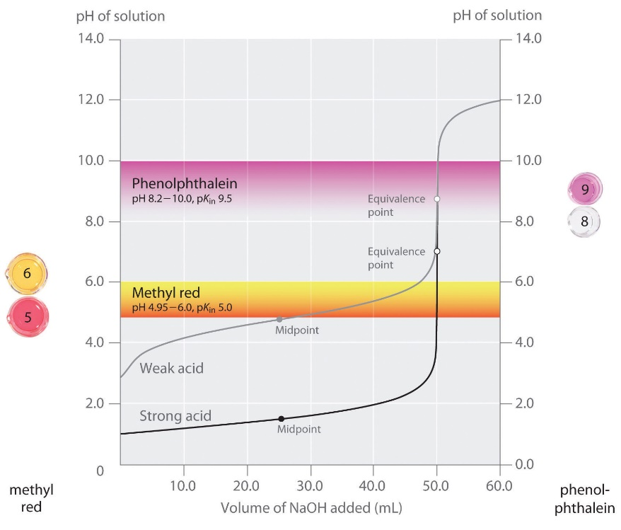
Features of a titration curve – strong base/weak acid
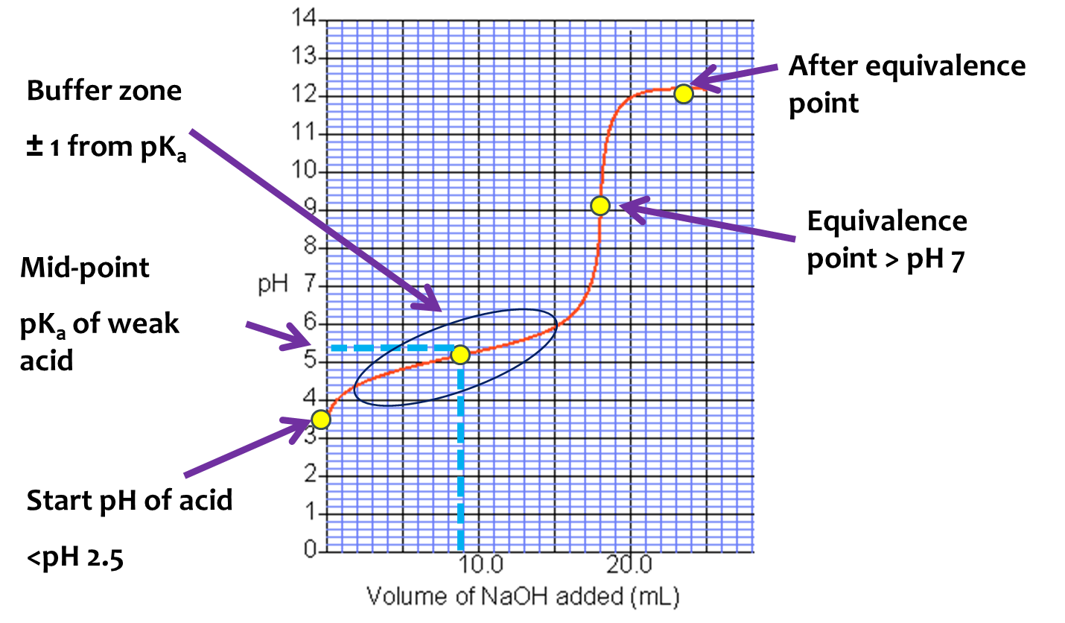
- Start pH of acid - The initial pH of the solution is due to the starting acid or base in the flask. This is where your titration curve begins
- Equivalence point - This is the point when all of the weak acid has reacted with the base being added. This will be the most vertical point on the graph.
- Mid-point – This will be exactly half way in volume to the equivalence point. The pk_{a} will be the pH of the midpoint.
- Buffer Zone – This will be an area 1 pH either side of the mid - point. It can be plotted on the graph as a circled area
- After the equivalence point – The pH depends on the concentration of the solution being added from the burette.
Strong Base added to Strong Acid  Characteristics:  Start point below pH 3  Equivalence point at 7  End of titration below pH12  Symmetrical shape  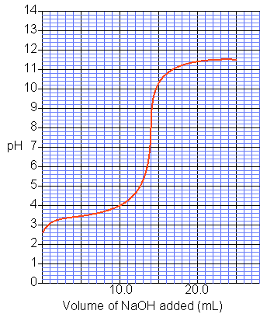 | Strong Base added to Weak Acid  Characteristics:  Start point above pH 3  Equivalence point above 7  End of titration above pH12  Unsymmetrical shape  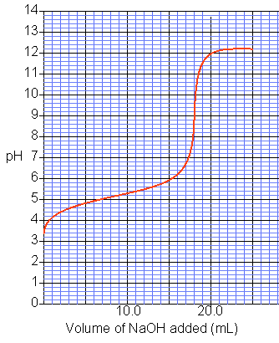
Strong Acid added to Weak Base
Characteristics:
Start point below pH 12
Equivalence point below 7
End of titration below pH3
Unsymmetrical shape
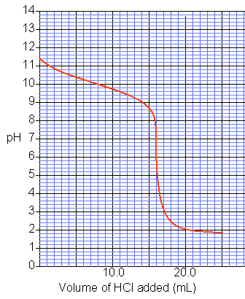

Drawing titration curves
Step One: Calculate the start pH (in flask)  Weak acid [H₃O⁺] = √ K_{a} x c(HA)  Weak base [OH⁻] = √ K_{b} x c(B)  Assumptions:  [HA] = c(HA)  H₂O concentration is the same before and after [H₃O⁺] = [conjugate base] | 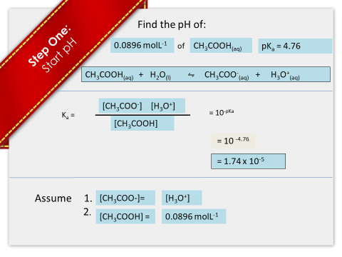
 | 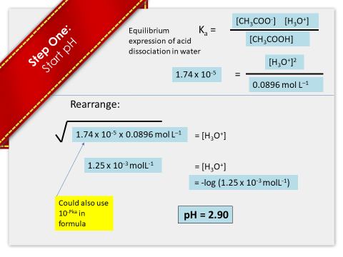
Step Two: Calculate the volume at equivalence point  - Calculate the number of moles of known acid or base (the substance where the concentration has been given) n = c x v  - Multiply the number of moles by U/K  - Rearrange equation to calculate volume v = n / c  v = volume (L) c = concentration (molL⁻¹) | 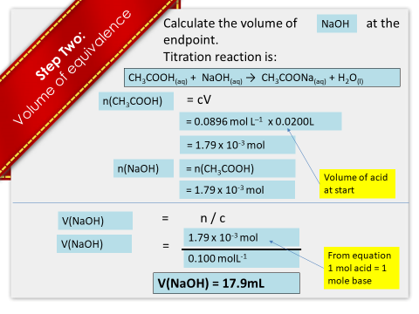

Step Three: Calculate the midpoint Volume of the buffer zone  - Volume ( x axis) = equivalence point volume / 2  - pH ( y axis) = pK_{a} of the Weak Acid ( or conjugate acid of Weak base)  The buffer zone is 1 pH either side of the mid-point | 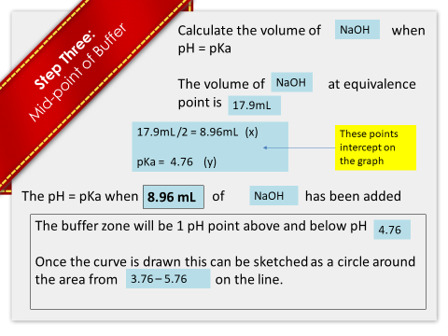

Step Four: Calculate pH of the equivalence point (end point)  a) Use the number of moles (n) of base (as calculated in step two) required to completely react with n of acid present to reach equivalence.  Each 1 mole of base required to react with acid produces 1 mole of conjugate base.  Example  HCOOH_{(aq)} + NaOH_{(aq)} ⇋ HCOONa_{(aq)} + H₂O_{(l)}  b) Calculate c(conjugate base) using c = n/v  V = initial volume in flask + volume added during titration to reach equivalence  c) Use pH equations  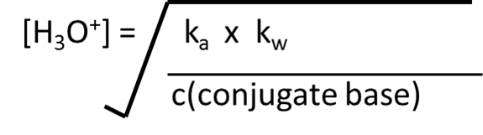 | 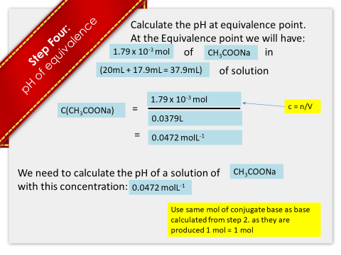
 | 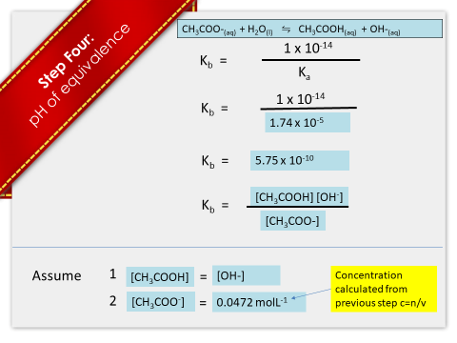
 | 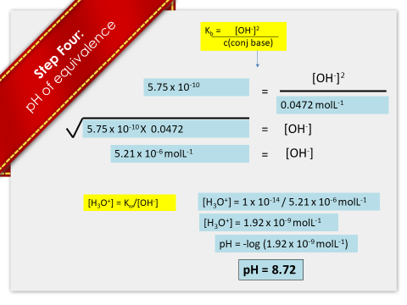

Step Five: Calculate pH after the equivalence point  [OH⁻] = start concentration x volume added after equivalence  total volume acid + base  Plot all of these points on the graph and join with a curved line.  If the acid or base is weak the curve will be gentle, if the acid or base is strong the curve will be sharp. | 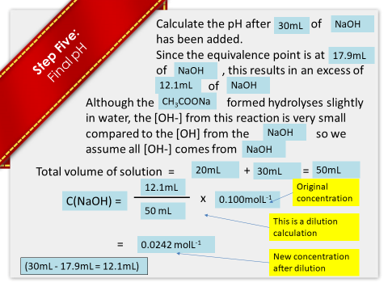
 | 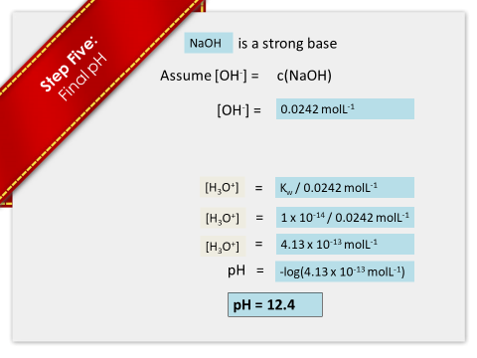
 | 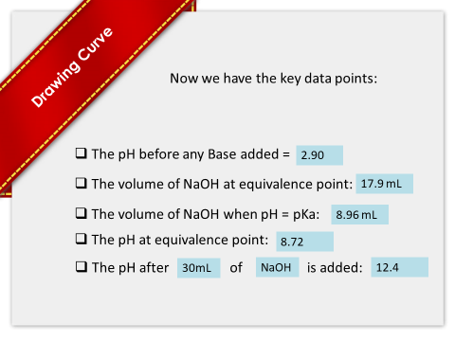
 | 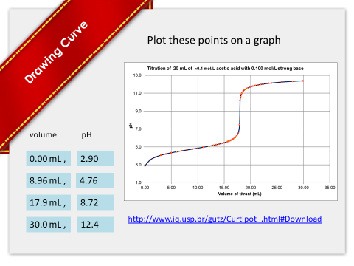

Why is pKa = pH at mid-point of the buffer?
At this point, half of the weak acid has reacted with the base to form equal quantities of conjugate. Acid + water ⇋ conjugate base + H₃O⁺
So K_{a} = [conjugate base] [H₃O⁺]
[acid]
If they are equal concentration they are cancelled and K_{a} = [H₃O⁺]
Therefore pK_{a} = pH as pK_{a} = -log K_{a} and pH = -log [H₃O⁺]
Calculating pH after an amount of base (or acid) is added
Sample question: 20.0 mL of 0.0896 mol L^{–1} ethanoic acid is titrated with 0.100 mol L^{–1} sodium hydroxide.
pKa (CH₃COOH) = 4.76
Calculate the pH of the titration mixture after 5.00 mL of NaOH has been added.
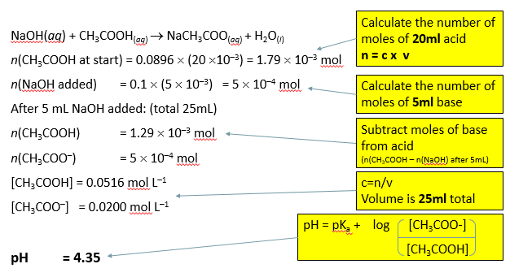
Buffer solutions
The transfer of protons between ions and water molecules controls the pH of aqueous solutions. The pH of blood, for example, is normally 7.4, and if it falls more than 0.4 from this value (because of disease or shock, both of which generate acidic conditions) then you could die. You could also die if your blood plasma pH rises to 7.8, as could happen during the early stages of recovery from severe burns. To survive, your blood system is buffered to maintain a constant pH.
A buffer solution consists of a weak acid (to supply protons to any added strong base) and its conjugate weak base (to receive protons from any added strong acid). A buffer solution is a solution that resists changes in pH when small amounts of acid or base are added.

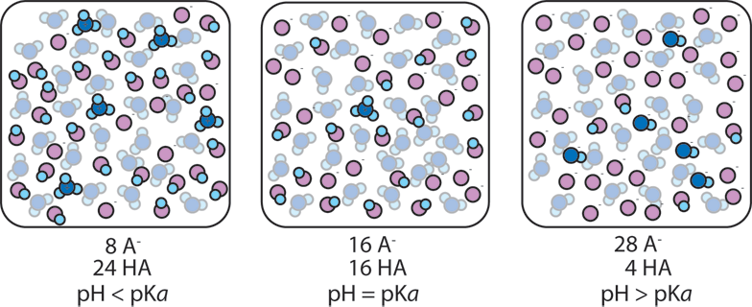
Buffer solutions
An example of a buffer solution would be one containing a mixture of ethanoic acid and sodium ethanoate. If base (OH⁻) ions are added, they will react with the ethanoic acid.

CH₃COOH(aq) + OH⁻(aq) ↔ CH₃COO⁻(aq) + H₂O(l)
If acid (H₃O⁺) ions are added, they will react with the ethanoate ions.
CH₃COO⁻(aq) + H₃O⁺(aq) ↔ CH₃COOH(aq) + H₂O(l)
These reactions show that any added acid (H₃O⁺) or base (OH⁻) are largely consumed and the pH of the solution therefore hardly changes.
Buffers make use of equilibrium principles that “stabilize” the ratio of reactants to products and resist change of this
If there is a higher concentration of weak acid then the buffer will work better at neutralising acid and vice versa

Buffer calculations for monoprotic acids
Calculate pH of buffer given: k_{a} or Pk_{a} + conc of [HA] and [A⁻]
Rearrange formula
HA + H₂0 ↔ H₃0⁺ + A⁻
K_{a} ⁼ [H₃O⁺][A⁻] to [H₃O⁺] = K_{a} x [HA]
[HA] [A⁻]
Convert to pH = pK_{a} - log [HA] or pH = pK_{a} + log [A⁻]
[A⁻] [HA]

Note: in a buffer solution [H₃O⁺] does not equal [A⁻] since the A⁻ has not been produced by the dissociation of the acid HA alone

Buffer calculations
[H₃O⁺] = Ka x [weak acid] OR pH = pKa + log [A-]
[conjugate base] [HA]
[Weak acid or conjugate base] = original concentration x original volume
final volume
Note: because the buffer solution contains a higher concentration of acid than base the pH is lower (more acidic) than the pKa

Buffer capacity
The effectiveness of a buffer in maintaining pH depends on the relative concentrations of acid and base in the solution.
A buffer solution with a high concentration of acid and base can neutralise more added base and acid than one with low concentrations.
If [weak base] = [weak acid] in a buffer solution, then pH = pKa.
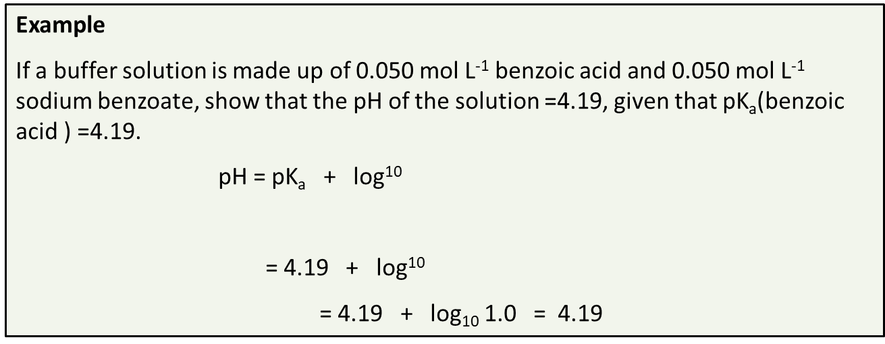

Buffer Key Questions
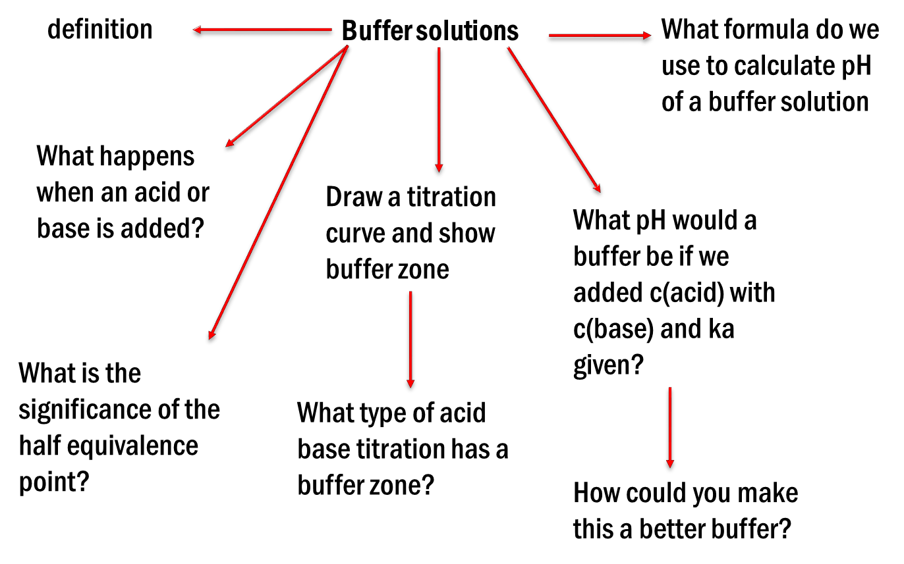

Acid/Base Key concepts
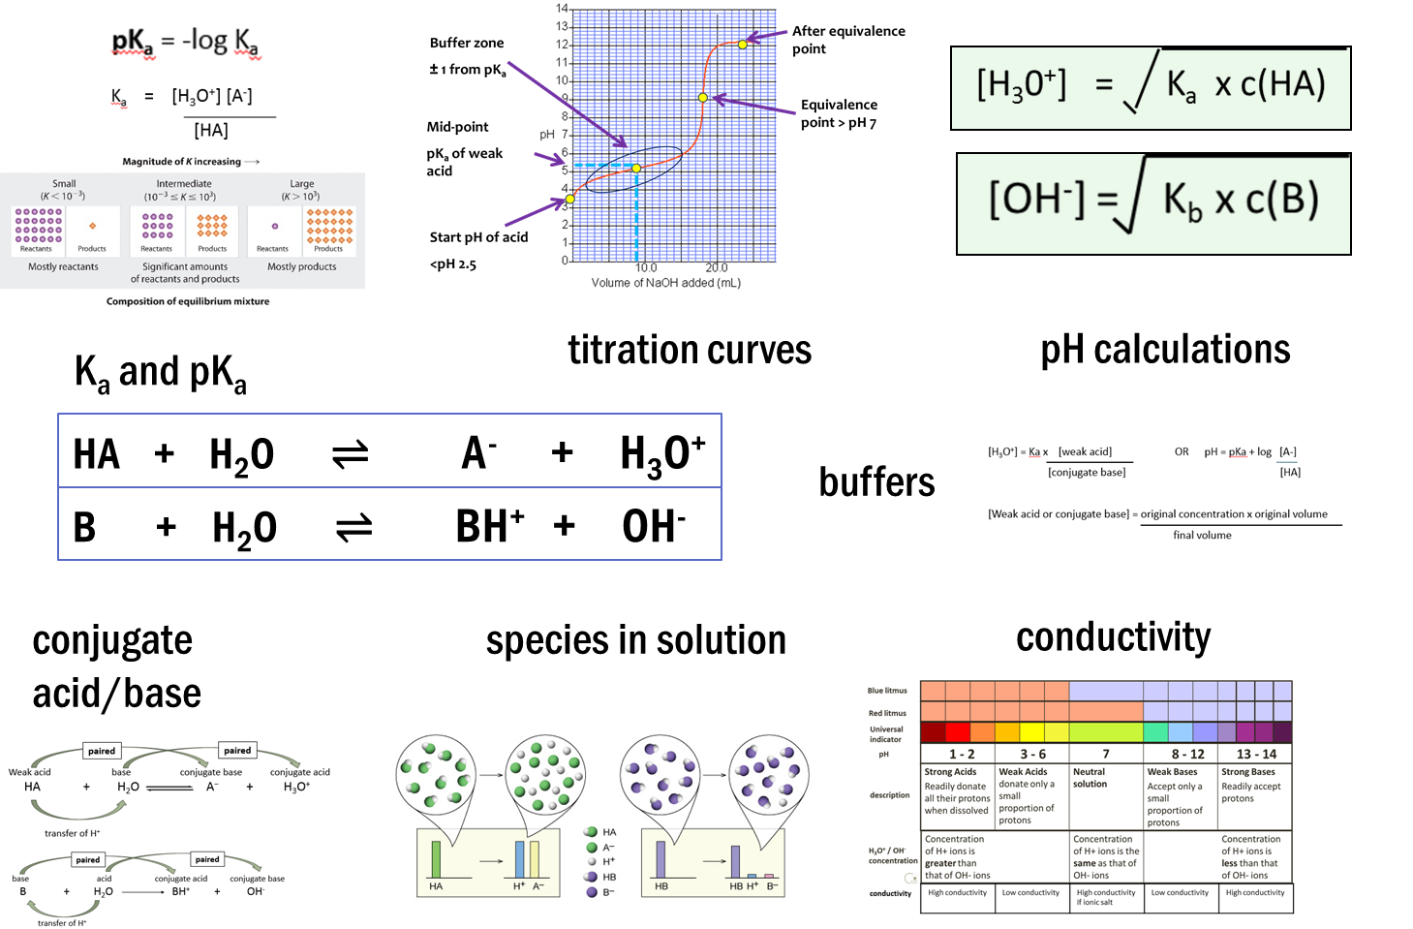

Definitions
Acid: A solution that has an excess of H⁺ ions.
Alkali: A base in solution that has an excess of OH⁻ ions.
Amphiprotic: A substance that can act as either an acid or a base.
Aqueous: A solution that is mainly water.
Base: A substance that accepts H⁺ ions.
Neutral: A solution that has a pH of 7. It is neither acidic nor basic.
Strong Acid: An acid that has a very low pH (0-4).The H⁺ ions completely disassociates in solution
Strong Base: A base that has a very high pH (10-14). A substance that readily accepts all H⁺ ions.
Weak Acid: An acid that only partially ionizes in an aqueous solution. That means not every molecule breaks apart. They usually have a pH close to 7 (3-6).
Weak Base: A base that only partially ionizes in an aqueous solution. That means not every molecule breaks apart. They usually have a pH close to 7 (8-10).

