**Chemistry AS 91165**

C2.5 Organic Chemistry

**Achievement Standard**

This achievement standard involves demonstrating understanding of the properties of selected organic compounds.

**Selected organic compounds are limited to:**

* alkanes, alkenes, alkynes, haloalkanes, primary amines, alcohols, and carboxylic acids.

**Properties are limited to:**

* constitutional and geometric (*cis and trans*) isomers
* classification of alcohols and haloalkanes as primary, secondary or tertiary
* solubility, melting and boiling points
* chemical reactions.

**Chemical reactions are limited to:**

* addition reactions of alkenes with H2/Pt, Cl2, Br2, H2O/H+ (conc. H2SO4/H2O) and hydrogen halides (including identification of major and minor products on addition to asymmetric alkenes), polymerisation
* substitution reactions of:
  + alkanes with halogens (limited to monosubstitution)
  + alcohols with hydrogen halides, PCl3, PCl5, SOCl2
  + haloalkanes with ammonia and aqueous potassium hydroxide
* oxidation of:
* primary alcohols to form carboxylic acids with MnO4-/H+ or Cr2O72-/H+
* alkenes with MnO4–
* elimination of (including identification of major and minor products for asymmetric reactants):
* water from alcohols
* hydrogen halides from haloalkanes
* acid–base reactions of carboxylic acids and amines.

**Organic Chemistry**

We define organic chemistry *as the chemistry of compounds that contain both* ***carbon*** *and* ***hydrogen***.

Carbon has four valence electrons. The electronegativity of carbon is too small for carbon to gain electrons from most elements to form C4- ions, and too large for carbon to lose electrons to form C4+ ions. Carbon therefore forms covalent bonds with a large number of other elements, including the hydrogen, nitrogen, oxygen, phosphorus, and sulfur.

**Covalent bonding between atoms**

**Covalent bonding** occurs where valence electrons around atoms are shared between neighbouring atoms. This type of bonding is found between the C and H atoms in hydrocarbons, and between the C, H and O atoms in alcohol. It is called **intramolecular** bonding - this bonding is very strong. The bonding between molecules is called **intermolecular** bonding and this is much weaker. When hydrocarbons are heated and they change state into liquids and gases it is this bonding that is broken **not** the covalent bonding.

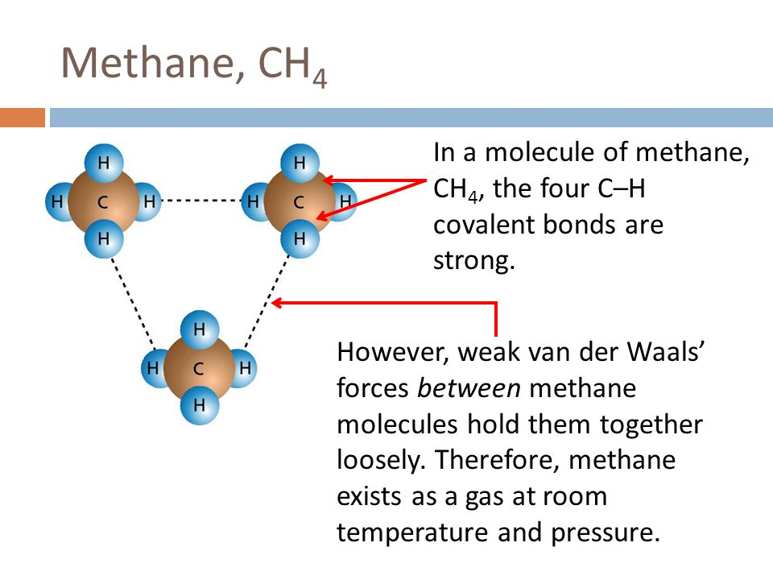

**Organic Chemistry Formula**

**Molecular Formula** – type and number of each atom. i.e. Propane C3H8

**Structural Formula** – placement of each atom.

**Condensed Structural Formula** CH3-CH2-CH3

Structural **isomers** are molecules with the same molecular formula but **different** structural formula.

**Functional groups**

Organic compounds are divided into main functional groups. This is determined by the type and arrangement of atoms – this also determines chemical properties. The families of organic compounds, which have the same general formula and functional group, are called a **homologous series.** The compounds, which make up a homologous series, will have same chemical properties. The selected functional groups covered at this level include alkanes, alkenes, alkynes, haloalkanes, primary amines, alcohols, and carboxylic acids

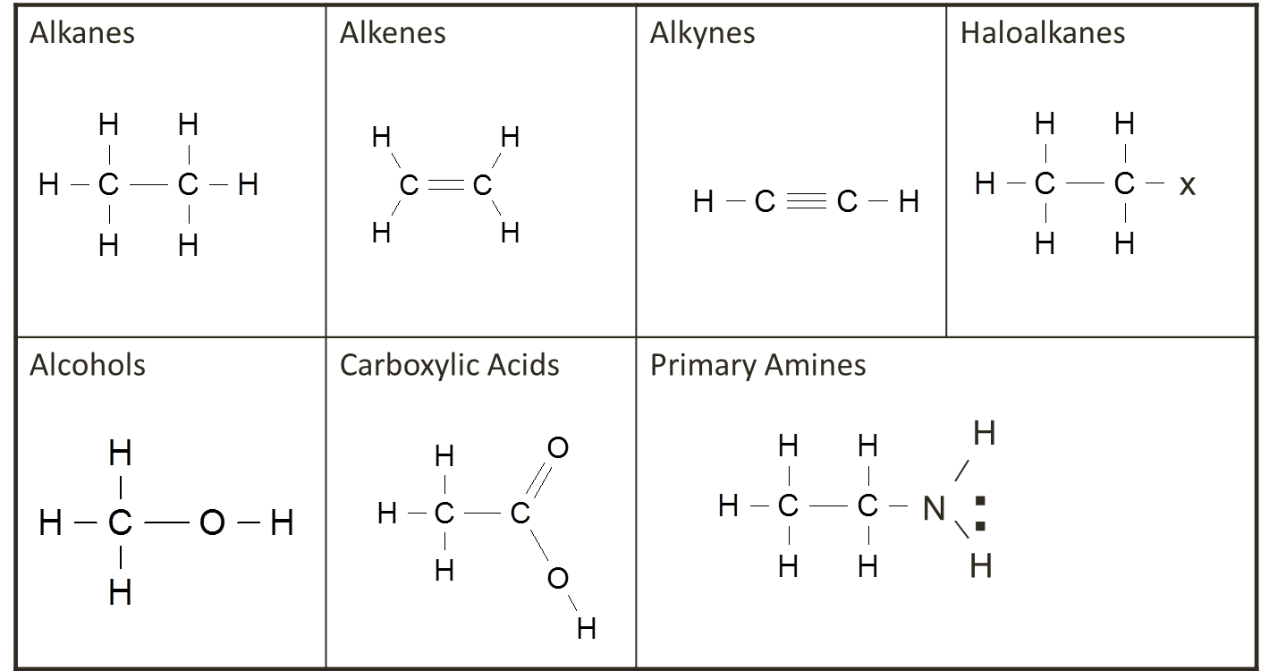

**Prefixes**

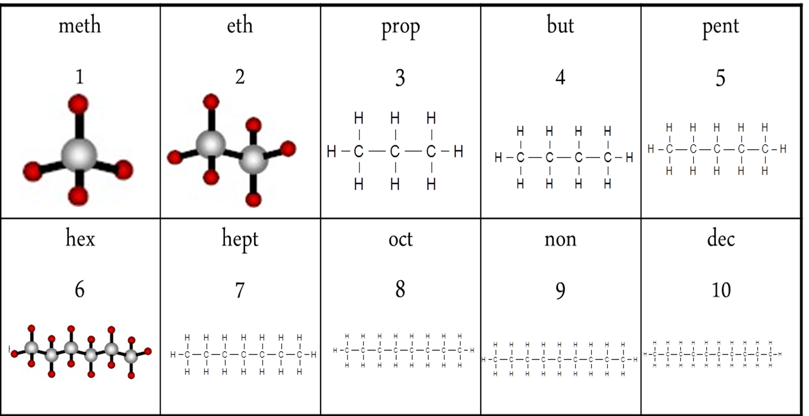

**Alkanes**

Compounds that contain only carbon and hydrogen are known as **hydrocarbons**. Those that contain as many hydrogen atoms as possible are said to be *saturated*. The saturated hydrocarbons are also known as **alkanes**.

**Sources of Alkanes**

Alkanes are found in petroleum (either crude oil or natural gas). They are formed by the **anaerobic** decomposition of marine plant and animal organisms. The main components in New Zealand natural gas are methane (one-carbon alkanes) and carbon dioxide.

Crude oil is imported into New Zealand from other countries and contains a mixture of different hydrocarbons with different length carbon chains. The different chain length hydrocarbons are separated by a process called **fractional distillation,** as they have different boiling points.

**Alkane Functional Group**

Generic formula C*n*H2*n*+2

**Straight-chain hydrocarbons**: in which the carbon atoms form a chain that runs from one end of the molecule to the other .i.e. butane

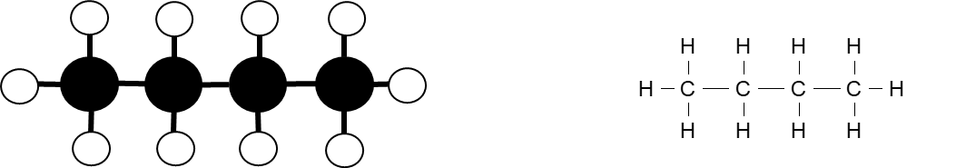

Alkanes also form **branched** structures. The smallest hydrocarbon in which a branch can occur has four carbon atoms. This compound has the same formula as butane (C4H10), but a different structure. Compounds with the same formula and different structure are called **structural isomers**.

**Physical properties**

The smaller the alkane molecule the lower the boiling point and the more volatile (easier to combust) the alkane. As the molar mass (Mass number of all the atoms combined) increases, the boiling points also increase as the strength of the intermolecular (between molecules) attractions increases.

Methane to butane (C1 – C4) are all gases at room temperature Alkanes with between 5C and 15C atoms are all liquids Alkanes with over 15 C atoms are soft solids

Alkanes are **not soluble in water.** These molecules are non-polar (there is no negative or positive ends to the molecule) compared with water which is polar (having a negative area near the oxygen atom and positive area near the hydrogen atoms) so they are not attracted to each other. Alkanes are **immiscible** (two or more liquids that will not mix together to form a single homogeneous substance) and form a distinct layer from the water. Smaller C chained alkanes are less dense than water and float on top.

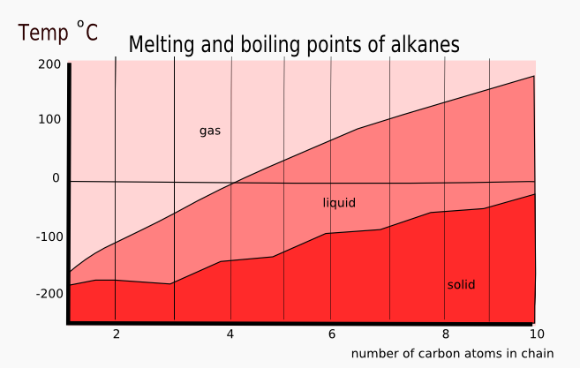

As the number of carbons increase so does the Molar Mass of the molecule. The larger the molar mass the more total valence electrons are available. These valance electrons can randomly cluster on one side or the other creating an instantaneous polar end – thereby creating a bond to another molecules instantaneous polar end

The greater the number of carbons; the stronger the bond between molecules and therefore the higher the melting and boiling point.

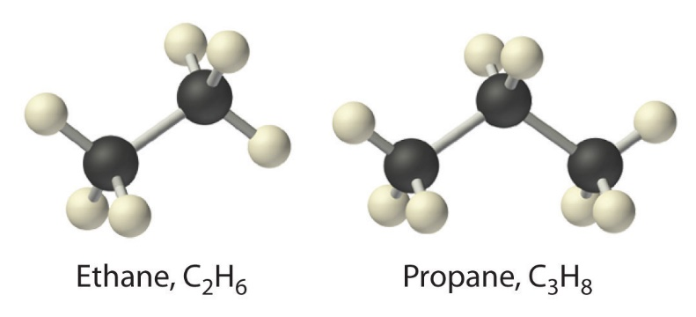

**Naming alkanes**

Write name by:

1. Identify the longest C chain 2. Identify any branches, 3. Number the C atoms in longest chain so branches are on the lowest numbers Write the name: 4. Location of branch 5. Name of branch, listing groups in alphabetical order. 6. If more than one branch use the prefixes di, tri, tetra if the same 7. Prefix of long chain 8. -ane

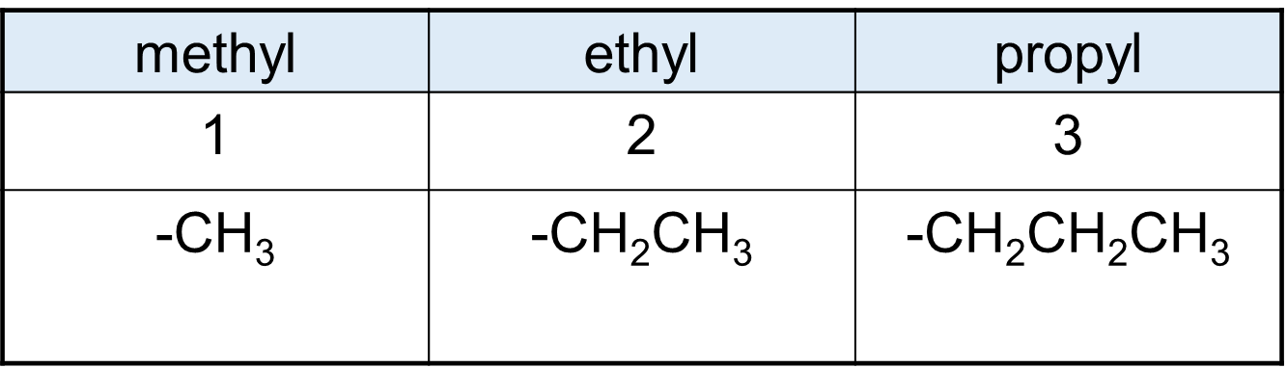

Always make sure the **longest possible chain** of carbons – and therefore the shortest possible branches – is used.

**Naming cyclic Alkanes**

Alkanes can also form cyclic molecules. These are named by placing cyclo- in front of the longest chain. At this level, knowledge of **branched chain** cyclic alkanes is not required

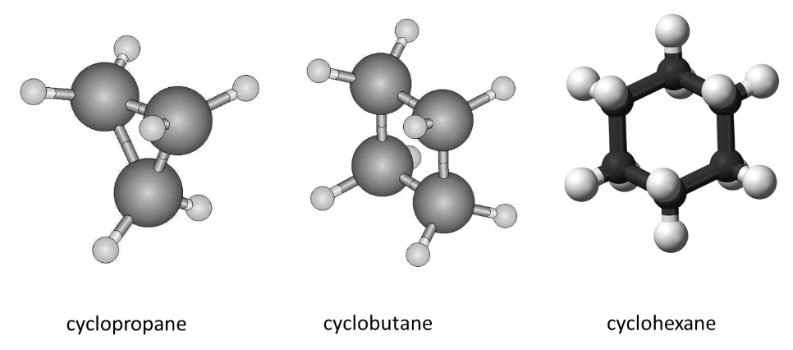

**Alkenes**

**Alkenes** are known as *unsaturated* hydrocarbons. The carbons do not contain as many hydrogen atoms as possible because two or more carbons are joined by a double bond. Each carbon atom involved in the bond shares two of its valance electrons therefore four electrons (in two pairs) are involved in the covalent bond.

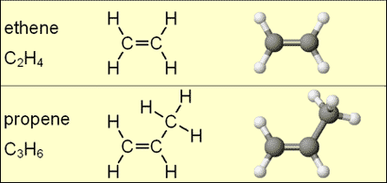

**Alkene Functional group**

**Functional Group** – One double carbon-carbon bond C=C

A **functional** group is the part of the molecule responsible for reactions typical of the homologous series.

Alkenes are named in a similar way to alkanes, *but the longest continuous carbon chain is numbered to give the carbon atoms in the double bond the lowest possible numbers*.

The position of the double bond is given by the smaller number of the two carbon atoms involved.

After numbering the longest chain C1-C2=C3-C4, the compound is named but-2-ene, but not but-3-ene.



**Physical Properties**

The melting point and boiling point of each alkene is very similar to that of the alkane with the same number of carbon atoms. Ethene, propene and butane are gases at room temperature.

Intermolecular forces of alkenes gets stronger with increase in the size of the molecules

For each of the same carbon chain length: the alkene has a boiling point, which is a small number of degrees lower than the corresponding alkane. Each alkene has 2 fewer electrons than the alkane with the same number of carbons and this decreases the strength of the molecular bonding therefore decreases the boiling and melting points of alkenes. The same principle of increasing molar mass (more carbons in the chain) causes a higher MP/BP applies to alkenes as it did alkanes.

The MP/BP is still very low as these hydrocarbons are non-polar molecular solids with weak intermolecular bonding.

Alkenes are also **not soluble in water and** are **immiscible** to form a distinct layer from the water, for the same reasons as alkanes.

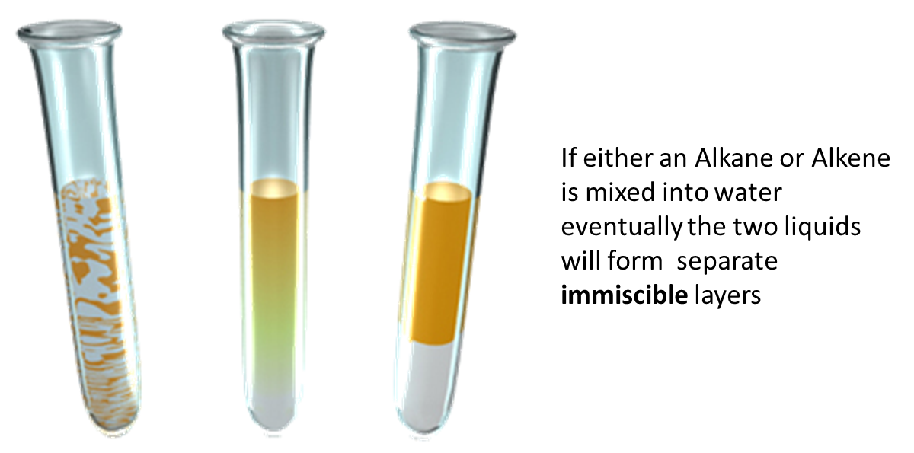

**Naming Alkenes**

Number carbons so double bond has the lowest number.

Write name as:

1. Location of branches

2. Name of branch, listing groups in alphabetical order.

3. If more than one branch use the prefixes di, tri, tetra if the same

4. Prefix of long chain

5. Location of C=C

6. –ene

The Alkene shown below is found to be 4-methylhex-2-ene by numbering the chain C1-C2=C3-C4-C5-C6.



**Cis – Trans Isomerism (geometric isomers)**

Geometric isomers of an alkene can occur because carbon-carbon double bonds do not rotate. Each carbon on the double bond must have two different groups attached.

Cis isomers have the same groups on the same side of the molecule. Trans isomers have the same groups on opposite sides of the double bond.

Geometric isomers have different physical properties, but usually the same chemical properties.

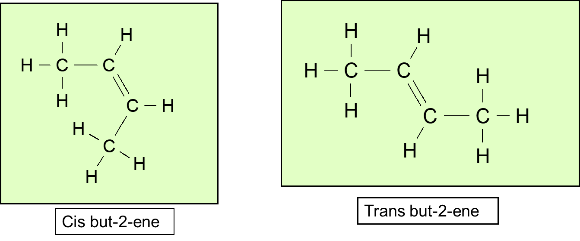

The double bond prevents the carbons on either end rotating like single bonds do and therefore the groups coming off the carbons remain “fixed” on their respective sides

SUMMARY

Cis if chain on **same** side of C=C (shaped like a C) Trans if on **different** sides (a transverse line)

**Alkyne Functional group**

Generic formula C*n*H2*n – 2* Alkynes have similar physical properties to alkanes and alkenes but tend to be less reactive than both groups.

Write name as

1. Location of branch 2. Name of branch, listing groups in alphabetical order. 3. If more than one branch use the prefixes di, tri, tetra if the same 4. Prefix of long chain 5. Location of C=C 6.-yne

The Alkyne shown below is named 4-methylhex-1-yne by numbering the chain C1-C2-C3-C4-C5-C6.



**Haloalkanes (alkyl halides) Functional Group**

Haloalkanes have one or more halogens bonded as a branch(es) to an alkane molecule. Naming indicates the position of the halogen given by the appropriate number of the carbon that it is attached to in the chain.

The Boiling Point (due to the halogen group) are considerably higher than those of the hydrocarbons of comparable molecular mass. As we go down in homologues series of haloalkanes, the forces of attraction becomes stronger due to increase in molecular size and it’s mass, hence the boiling point increases down the homologues series, but the boiling point decreases with branching.

Haloalkanes are slightly soluble in water. This is because of the relatively larger amount of energy required to break bond between halogen and carbon and the smaller amount of energy released, when bond is formed after dissolution ion and water.

A halogen is an element found in group 17 of the periodic table and includes chlorine (Cl), fluorine (F), iodine (I) and bromine (Br)

**Naming Haloalkanes**

Haloalkanes are classified according to the position of the halogen atom bonded in the molecule.

This leads to the existence of

>primary (1°) – bonded to a C that is bonded to only 1 other C

>secondary (2°) – bonded to a C that is bonded to 2 other C

>tertiary (3°) – bonded to a C that is bonded to 3 other C

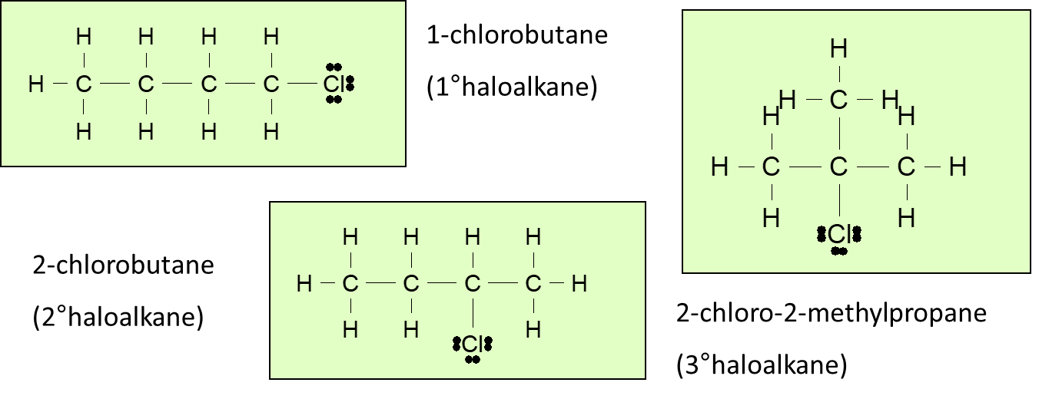

1. Location of branches,

2. Name of branches (bromo-, chloro-, fluoro-, iodo-) listing groups in alphabetical order.

3. Prefix of long chain

4. -ane

5. If more than one branch use the prefixes di, tri, tetra if the same

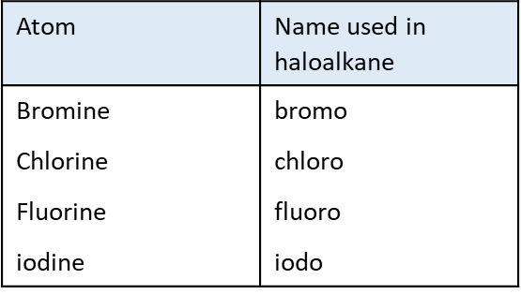

**Alcohol Functional group**

Alcohols are not considered hydrocarbons as they have one or more oxygen atoms attached in addition to the hydrogen and carbon atoms. Alcohols are organic substances however and share many of the same chemical and physical properties of the alkanes and alkenes. Alcohols are used as solvents and fuels and ethanol (a two-carbon alcohol) is used as a drink.

**Physical Properties**

The **boiling point** trend is similar to both alkanes and alkenes where the larger the number of C atoms in the chain the higher the boiling point. The boiling point is higher than both alkanes and alkenes as the intermolecular bonding is stronger due to being a polar molecule– which creates a positive and negative end and hold the individual alcohol molecules together stronger and thus needs more energy to break them (heat energy). Even small chain alcohols are liquid at room temperature

Alcohols are **Soluble in water.** Small alcohol molecules are polar and the presence of the OH group means their intermolecular bonding is stronger than non-polar alkanes and alkenes. The large difference in electronegativity (ability to “grab” electrons from another atom due to their pull from the combined positive protons in their nucleus) between the O and H atoms means the O-H bond is very polar and the slightly positive charge on this H atom is attracted to the non-bonding electron pairs of the oxygen on another molecule. However, as the length of the non-polar hydrocarbon chain increases this solubility in water decreases.

**Carboxylic Acids**

All the simple, straight-chain carboxylic acids up to ten carbons are liquids at room temperature. The liquids have sharp pungent odours and all have high boiling points.

Smaller molecules, less than 10 carbons, are completely miscible in water due to the formation of hydrogen bonds with the water.

The highly polar carboxylic acids dimerise (bond as 2 molecules) in the liquid phase and in non-aqueous solvents (CCl4) and form two hydrogen bonds between each pair.

This extra degree of hydrogen bonding causes carboxylic acids to have higher boiling points compared to their corresponding alcohols.

**Carboxylic Acid Functional group**

Naming

1. Longest –C chain with –COOH

2. Identify branches

3. No. 1 C is the C in –COOH

4. Location of branches

5. Name branch, listing groups in alphabetical order.

6. If more than one branch use the prefixes di, tri, tetra if the same

7. Prefix

8. -anoic acid

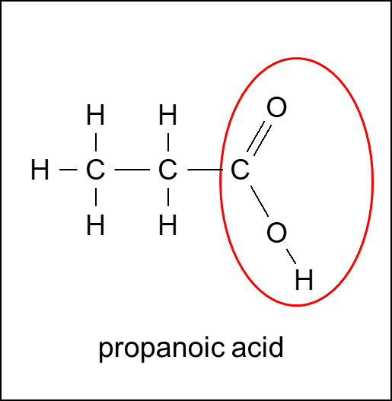

**Physical properties**

All the simple, straight-chain carboxylic acids up to ten carbons are liquids at room temperature. The liquids have sharp pungent odours and all have high boiling points.

Smaller molecules, less than 10 carbons, are completely miscible in water due to the formation of stronger intermolecular bonding with the water.

The highly polar carboxylic acids dimerise (bond two molecules together) in the liquid phase and in non-aqueous solvents (CCl4) and form stronger intermolecular bonds between each pair.

This extra degree of stronger intermolecular bonding causes carboxylic acids to have higher boiling points compared to their corresponding alcohols.

**Amine (primary) Functional group**

Functional group is the amino group –NH2

Amines are found in many natural products as well as used in many industrial processes. Amines have an unpleasant “fishy” smell. The smaller amines, up to C5, are soluble in water but larger amino alkanes are insoluble, as the size of the non-polar hydrocarbon chain cancels out the effect of the polar amino functional group.

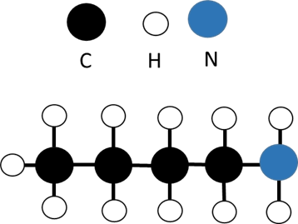

**Naming Primary Amines**

Write name as –

1. Identify the longest C chain -Identify any branches
2. Number the C atoms in longest chain so number Carbon 1 attached to amino group (NH2)
3. Write the name
   1. Location of branch
   2. Name of branch
   3. Amino-
   4. Prefix of long chain
   5. -ane

e.g. aminobutane (4C)

**Alternative naming method**

1. Identify the longest C chain - Identify any branches
2. Number the C atoms in longest chain so number Carbon 1 attached to amino group (NH2)
3. Write the name
   1. Location of branch
   2. Name of branch
   3. Prefix of long chain
   4. -anamine

e.g. butanamine (4C)

Either will be accepted in NCEA assessments

**Reaction types**

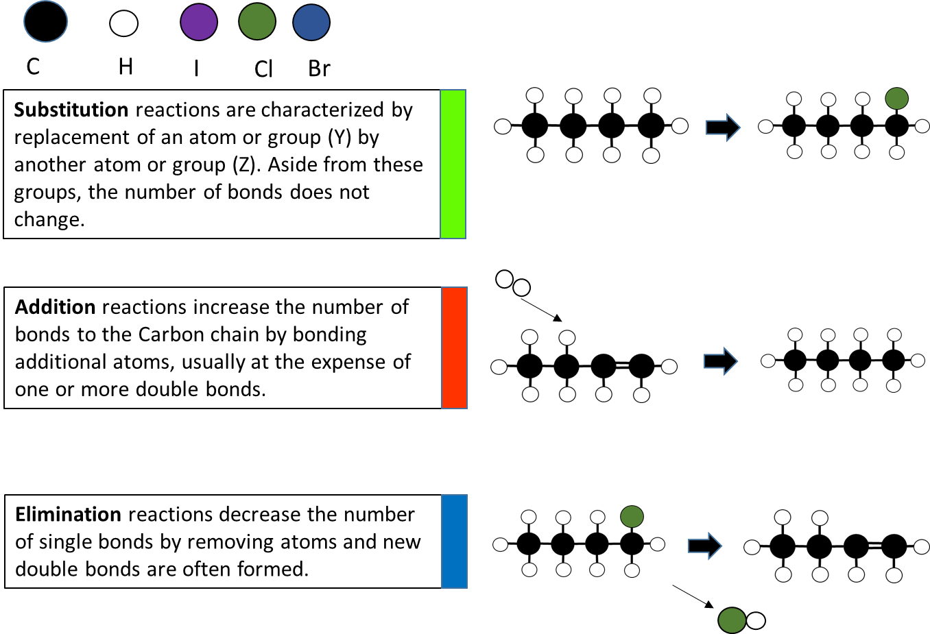

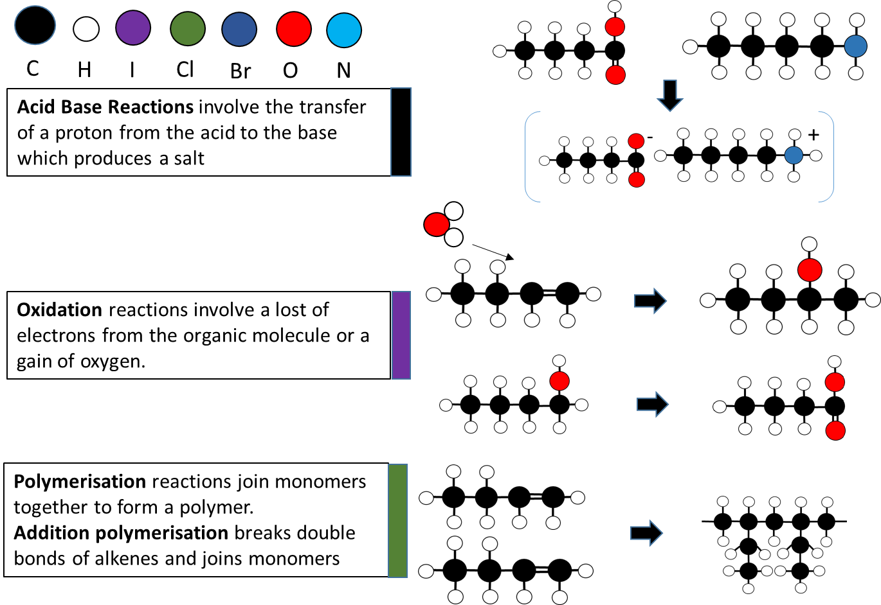

**Alkane Reactions - Substitution**

Alkanes are **saturated** molecules, because every carbon atom has the maximum amount of atoms bonded to it. If any other atoms are to be added to an alkane one atom must be removed first.

This reaction is known as a **substitution** reaction. For this reaction to proceed enough energy must be available to overcome the activation energy required to break the strong C-H bond. The available site can then be occupied by the provided atom. This energy may be provided by heat or **UV light** to provide the activation energy for the reaction to proceed. This is a **slow reaction** that can take several minutes.

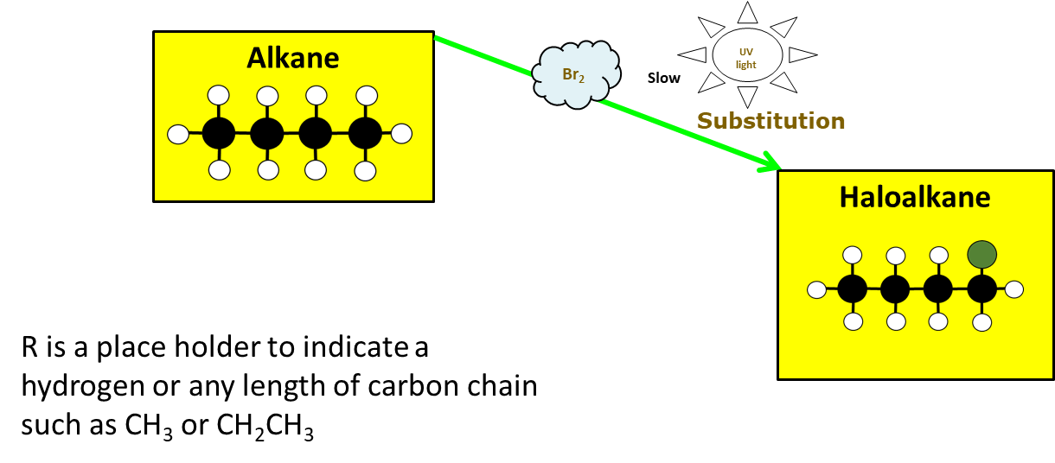

**Alkene Reactions - Addition**

Alkenes are **unsaturated** molecules because not every carbon atom has the maximum amount of atoms bonded to it because it has one or more double bonds. If another atom is added to an alkene, the double bond can be broken down to a single bond and the available site can be occupied by another atom.

This reaction is known as an **addition** reaction. This reaction has a lower activation energy requirement than substitution, which requires less energy to break a double bond than break a C-H bond, therefore it can proceed easier than a substitution reaction.

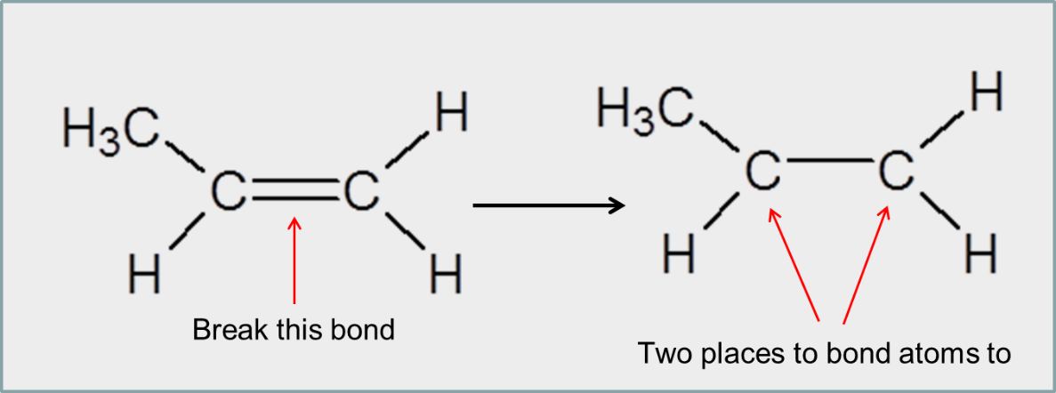

**Markovnikov’s Rule**

Sometimes called the “rich get richer” rule. When Asymmetric molecules such as HBr, HCl and H2O are added to asymmetrical alkenes, this results in the formation of two possible products: a major and minor product.

The major product is the one in which the H atom of an unsymmetrical molecule such as HBr attaches to the C atom with the most H atoms already. The major product is made in higher proportions than the other, the minor product.

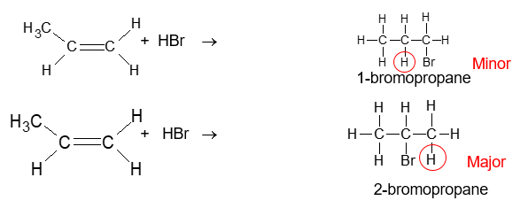

**Oxidation reactions with alkenes**

Alkenes can also undergo an **oxidation** reaction (this could also be classified as an addition reaction). The reagent is an oxidant, potassium permanganate (acidified), MnO4-/H+, performed under reflux conditions.

The reaction creates a diol. Two hydroxyl groups join onto the carbons on either end of the broken double bond.

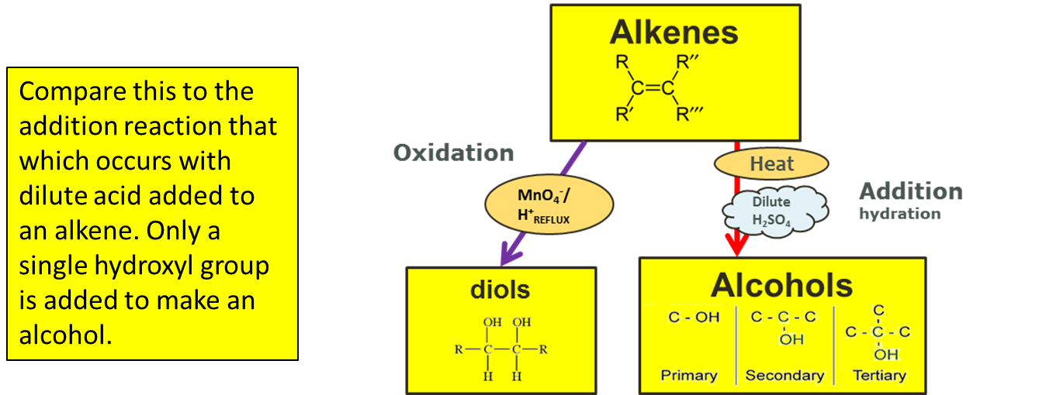

**Reflux**

The rate of the oxidation reaction is increased by heating the reaction mixture under **reflux.** Reflux is a system of heating the solution with a condenser attached to the reaction vessel so that any organic substance, which evaporates, will be condensed and returned to the container. This way the reaction can be heated for a period of time without the organic substance (reactant, product or solvent) evaporating away.

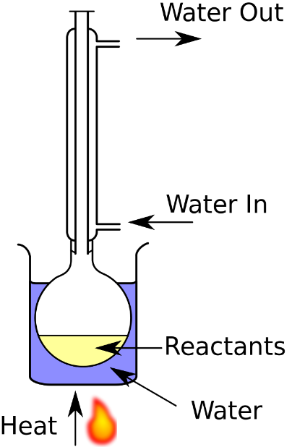

**Alkene Reaction Summary**

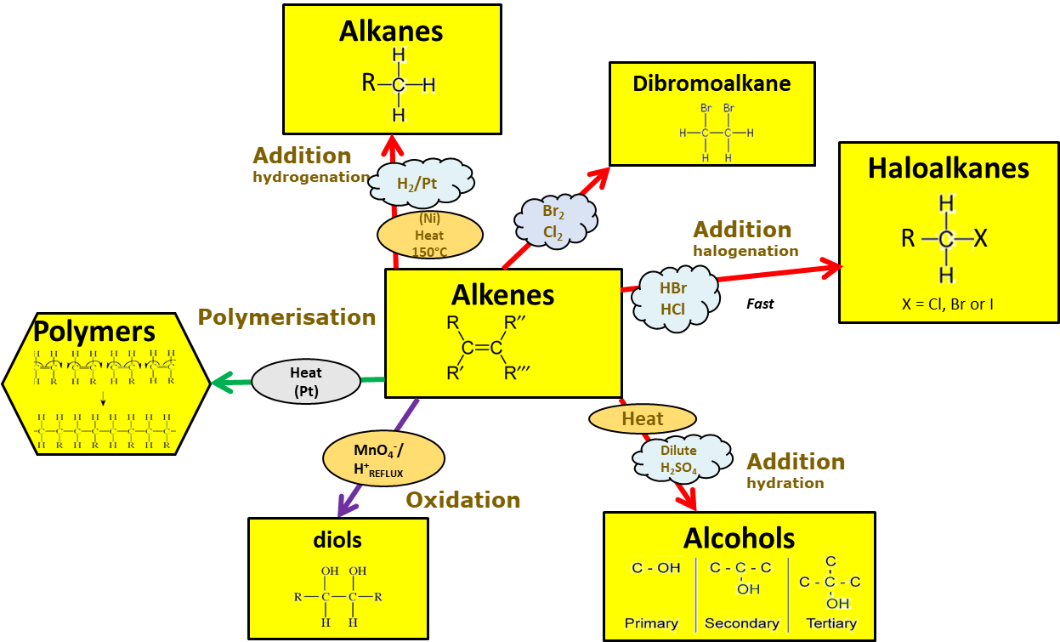

**Testing for Addition and Substitution reactions**

Alkenes undergo **addition** reactions - this means they can undergo addition of a halogen atom (chlorine, bromine, iodine) across the double bond to form a haloalkane.

The common test for an unsaturated hydrocarbon (alkene) to distinguish it from a saturated hydrocarbon (alkane) is the **rapid** decolourisation of an orange solution of bromine in the **addition reaction of an alkene**. This occurs much **slower** in the **substitution reaction of an alkane** and requires the presence of **UV light** (sunlight) to provide the activation energy to break the bond of the C-H

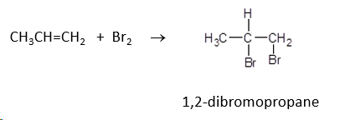

**Tests to distinguish between Alkanes and Alkenes**

We can use these to identify whether the molecule is an alkene or alkane

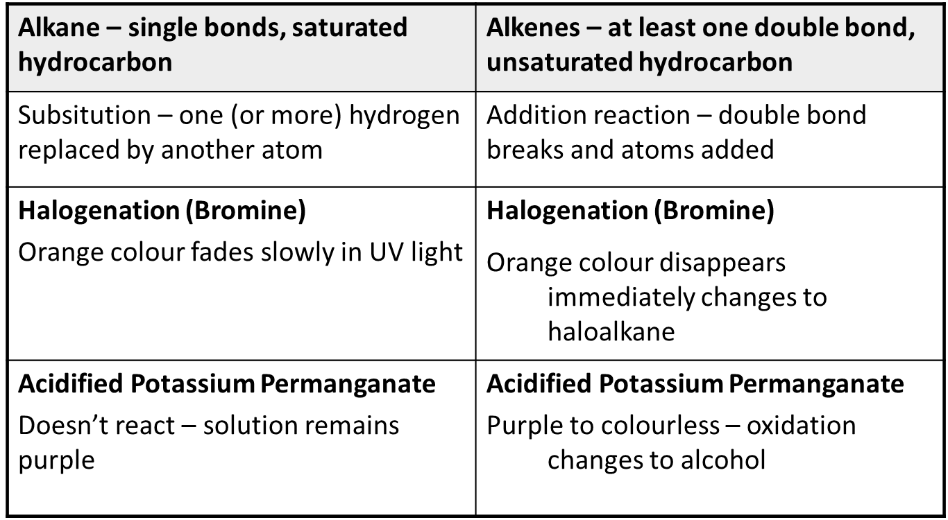

**Haloalkane reactions**

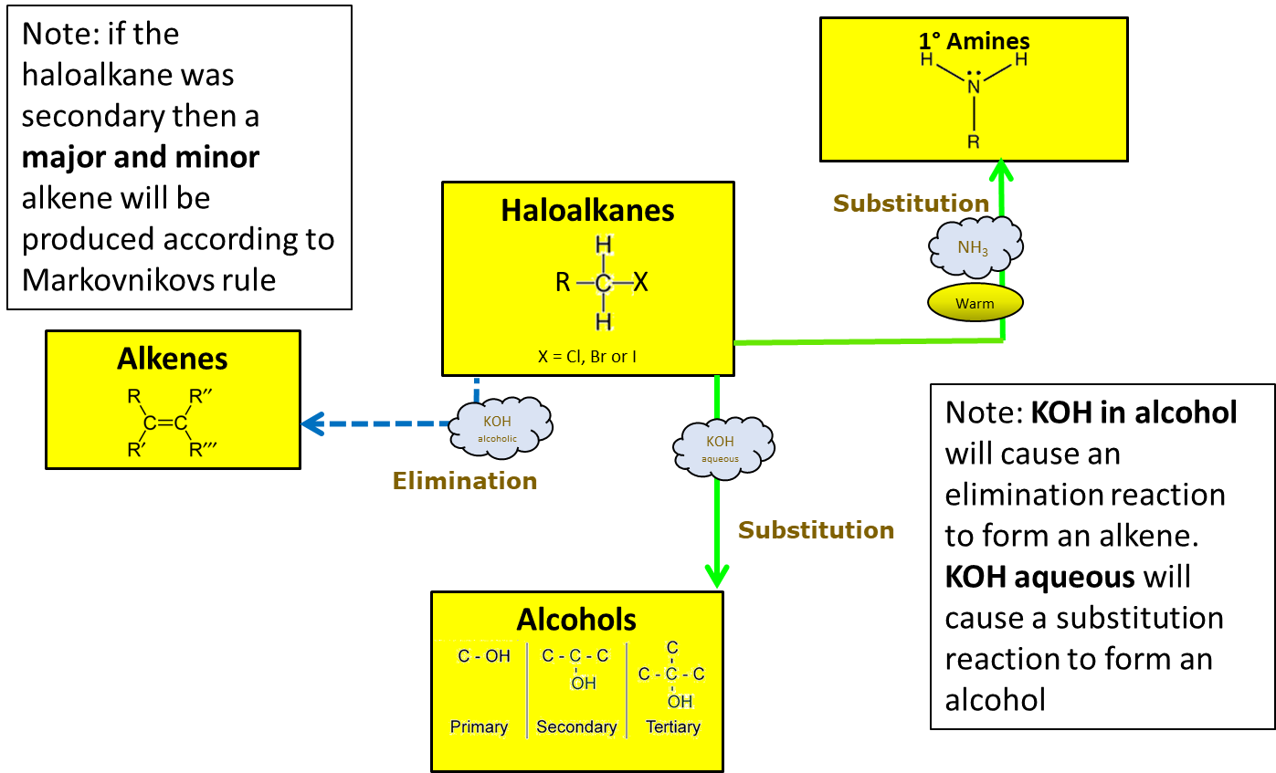

**Elimination Reactions**

Elimination reactions decrease the number of single bonds by removing atoms and new double bonds are often formed.

The Halogen atom is removed and a double bond forms between the two carbon atoms.

**More than one product will be formed**. The alkene may form a major and minor product if the original halogen was secondary. The newly formed (major) alkene may also form a cis and trans geometric isomer if they are unsymmetrical.

Another product, the removed halogen will join with a removed hydrogen atom to form a hydrogen halide i.e. HCl or HBr.

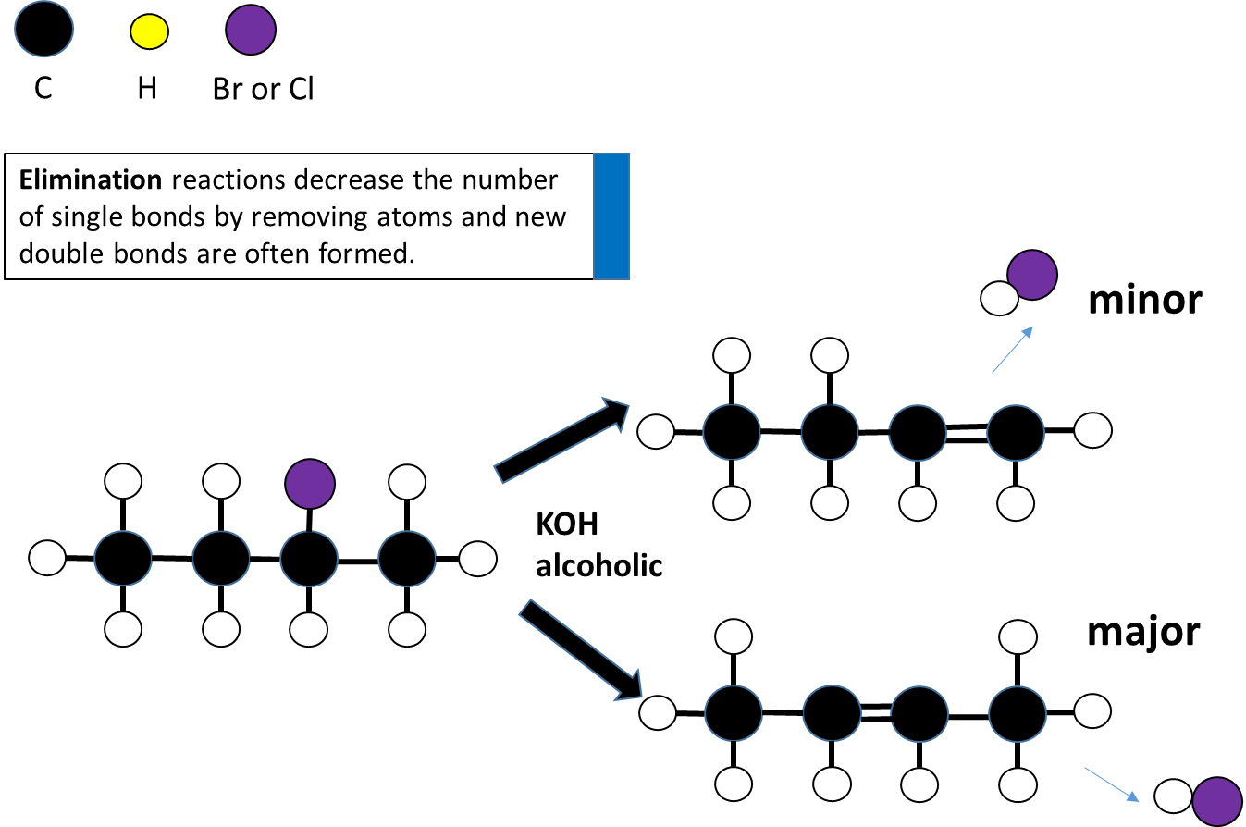

**Elimination – major and minor products** - **Saytzeff’s rule (poor get poorer)**

When an elimination reaction occurs on a **secondary haloalkane** (with more than 3 carbons in the longest chain) then the H removed along with the halogen (Cl/Br) can come from either side. This produces 2 types of products; major or minor.

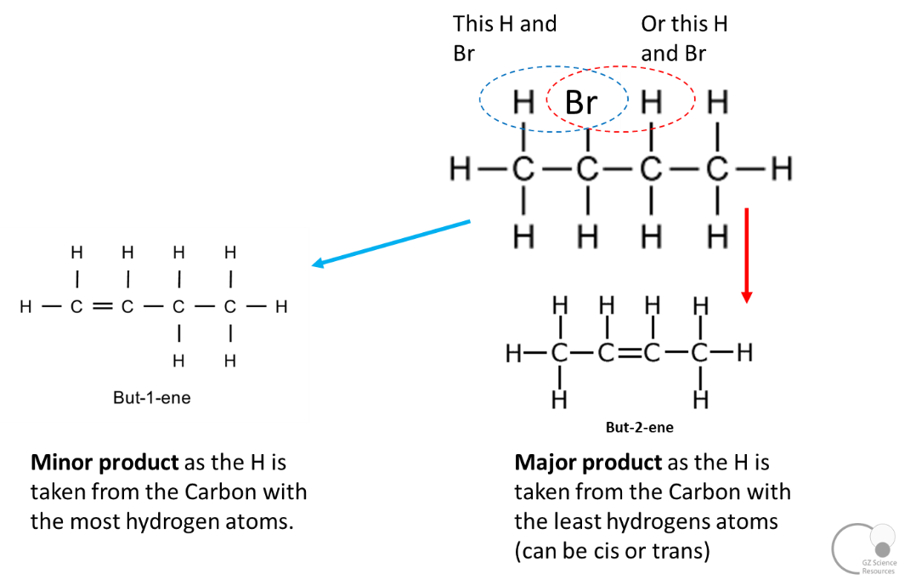

**Substitution Reactions**

Substitution reactions do not change the number of single bonds. The Halogen atom is removed and a hydroxyl (OH) group is substituted.

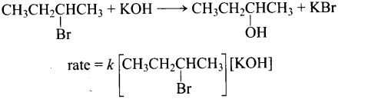

Substitution of Haloalkanes isfavoured when the solvent used is polar e.g. **aqueous** (rather than alcoholic) **KOH.**

The OH bonds with the **same** carbon that the halogen is removed from. A primary halogen will become a primary alcohol and a secondary halogen will become a secondary alcohol

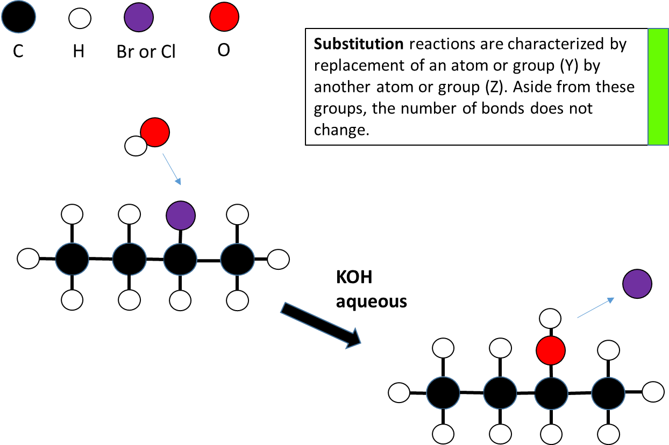

**Haloalkane preparation**

Haloalkanes are relatively nonpolar overall (despite the polarity of the C-X bond) and are insoluble in water forming two layers. A haloalkane can be formed by

a) **Substitution** of propane using Br2. (Forming two products, the bromoalkane and HBr)

b) **Addition** of HBr to propene will produce a major and minor product in an unsymmetrical alkene

c) **Substitution** of the OH on an alcohol with a halogen using e.g. PCl3, PCl5, SOCl2 or conc HCl/ZnCl2

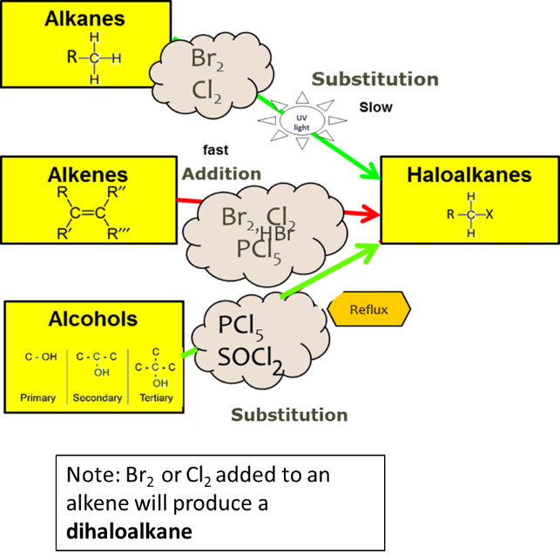

**Alcohol Reactions - Oxidation**

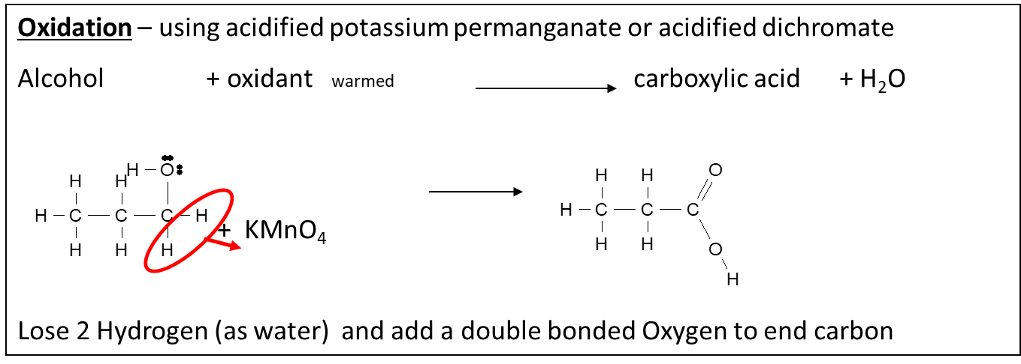

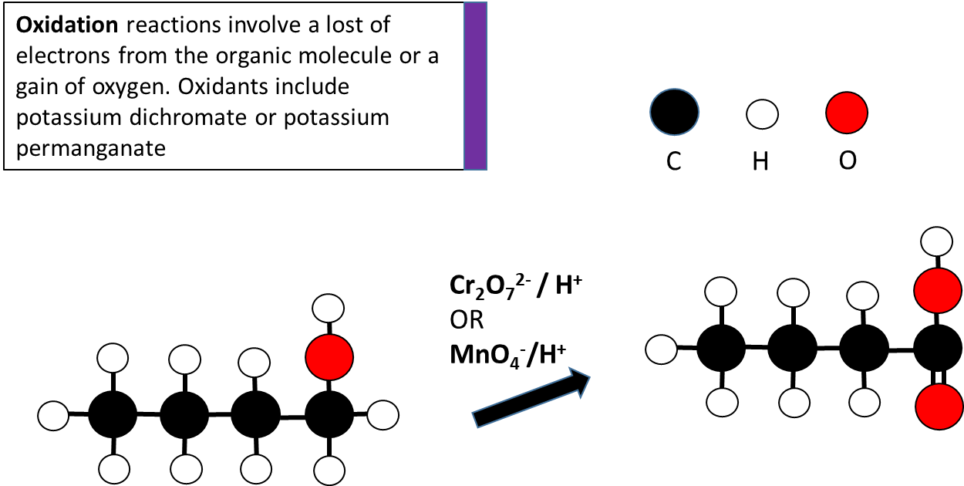

**Alcohol Reactions - Elimination**

**Elimination** reactions occur when the hydroxyl group (OH) plus a hydrogen from an adjacent (beside) carbon atom is removed. The OH and the H removed form a water molecule. The two carbons with the OH and H taken off join to form a double one. Concentrated sulfuric acid is used as the reagent. This type of elimination reaction is also known as a dehydration reaction because water is removed.

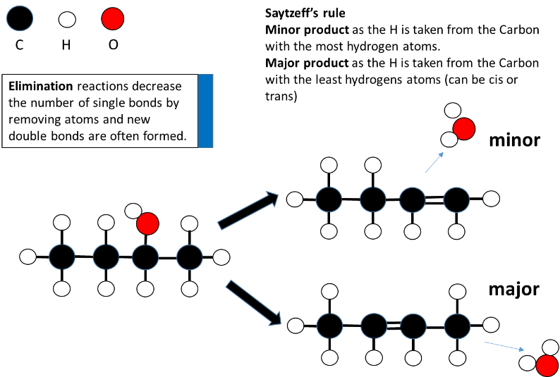

When an elimination reaction occurs on an **asymmetrical** **secondary** alcohol (with more than 3 carbons in the longest chain) then the H removed along with the OH can come from either side. This produces 2 types of products: major or minor.

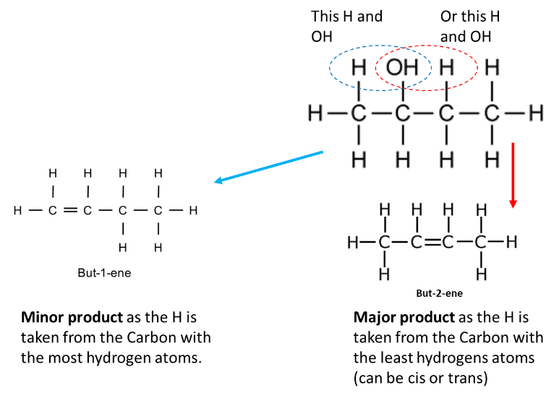

**Alcohol reactions – Substitution**

**Substitution -** of the OH− by a Cl*−* to form a chloroalkane.

This substitution removes the hydroxyl group (plus one hydrogen to form water) and replaces the two bonding sites on the carbons with a H and Cl (from HCl).The haloalkane formed is nonpolar and insoluble in the aqueous solution so forms a cloudy emulsion that separates out as two layers.

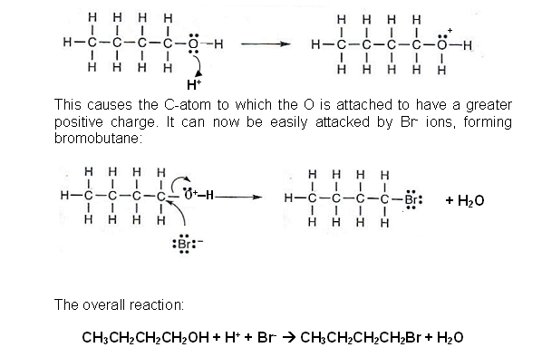

**Polymers**

Alkenes can be used to make polymers (which we also refer to generally as plastics). The **chemical properties** of these polymers such as low chemical reactivity with air, water and many chemicals make them ideal as containers for liquids and chemicals as they will not corrode or decompose. Polymers are also ideal as clothing that can be washed repeatedly.

The **physical properties** of polymers such as their density (low) and strength also make them ideal for strong yet light containers and clothing. Their ability to be melted and shaped makes production of moulded shapes efficient and cheap, as well as making polymers easy to recycle and reuse.

As polymers are insoluble in water they will not dissolve when exposed to water. Polymers are thermal and electrical insulators they have many uses in electrical applications, appliances and insulating wires.

**Addition polymers**

**Addition polymers** are formed when alkene monomers with a double C=C bond undergo addition to form a polymer with single C-C bonds and spaces are freed up to form bonding spaces e.g.. polythene from ethene, P.V.C. from vinyl chloride (chloroethene), polypropene from propene.



Naming polymers is not tested for. However, to name most polymers place the prefix poly- in front of the monomer name.

**Drawing Addition polymerisation**

Monomers - smallest repeating unit with a double bond

Polymers – long chains of monomers joined single bonds

Polymerisation – breaking of the double bond of each monomer and joining together with single bonds

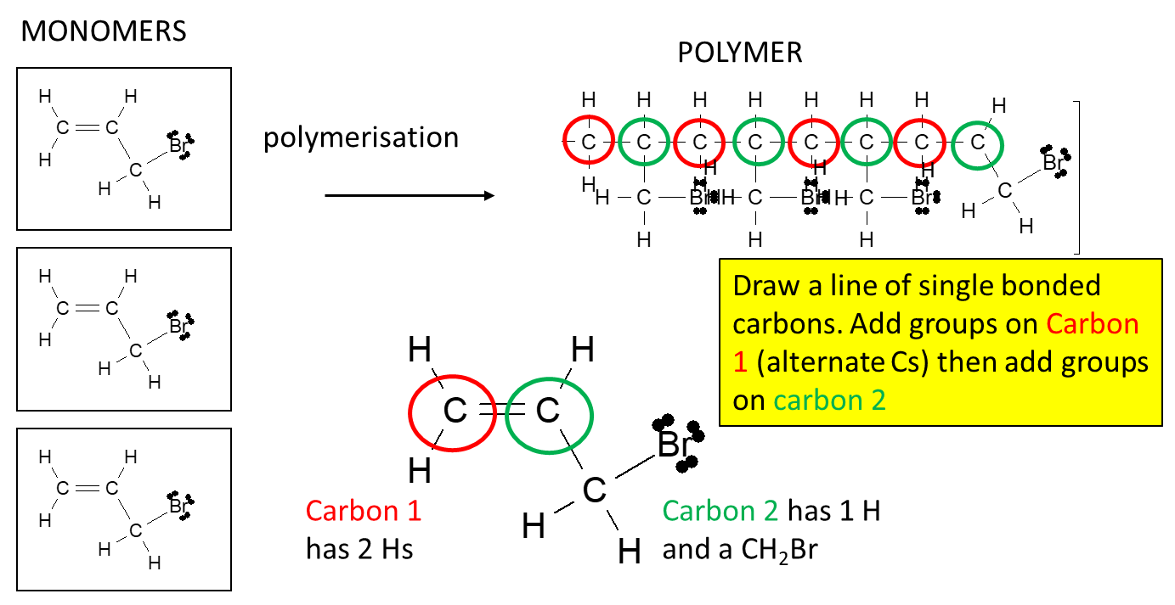

**Carboxylic Acid Reactions**

Carboxylic Acids are Weak Acids and are proton donors in water

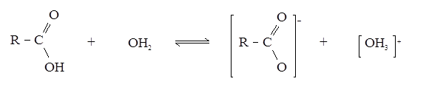

React with magnesium to give hydrogen gas (a useful test)

CH3COOH + Mg 🡺 Mg(CH3COO)2 + H2(g)

React with calcium carbonate to give CO2(g) (a useful test)

CH3COOH + CaCO3 🡺 Ca(CH3COO)2 + CO2(g) + H2O

Carboxylic acids act as a weak acid by partially dissociating and **neutralising** bases:

For example

RCOOH + NaOH 🡺 RCOONa + H2O

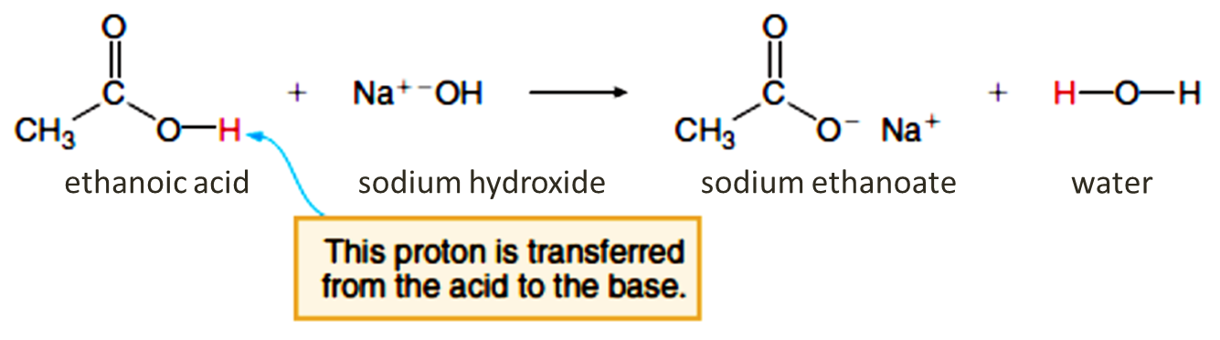

When carboxylic acids react in an acid-base reaction, they form a conjugate, the carboxylate ion. This ion is an anion and can join with a cation (formed from a base such as NaOH) to produce a neutral salt. It can also form a salt from an amine conjugate (such as CH3CH2NH3+)

**Amine reactions**

Amines behave like ammonia due to a non-bonding pair of electrons, which act as proton acceptors (i.e. bases)

*Reaction with water e.g.*

CH3NH2 + H2O → CH3NH3+ + OH-

aminomethane methylammonium hydroxide

This reaction can occur in solution, or in the air as vapours given off solutions of both chemicals meet and combine to form a smoke. This smoke is made of the salt in solid form.

*Reaction with acid to form salts e.g.*

 CH3NH2 + HCl → CH3NH3+ + Cl-

aminomethane hydrochloric acid methylammonium chloride

**Amine (ammonium) ion + Carboxylic ion reactions (Extension)**

Naming salts.

The amine ion effectively becomes an **ammonium ion** – and acts as the cation in forming the ionic salt. The organic group attached to it becomes a “branch” and is named as such. i.e. CH3NH3+ becomes methyl ammonium

The **carboxylic ion** becomes the anion and takes on the suffix –anoate. i.e. CH3COO- becomes methanoate. Therefore, a salt made of the 2 ions CH3NH3+ CH3COO- is called methyl ammonium methanoate

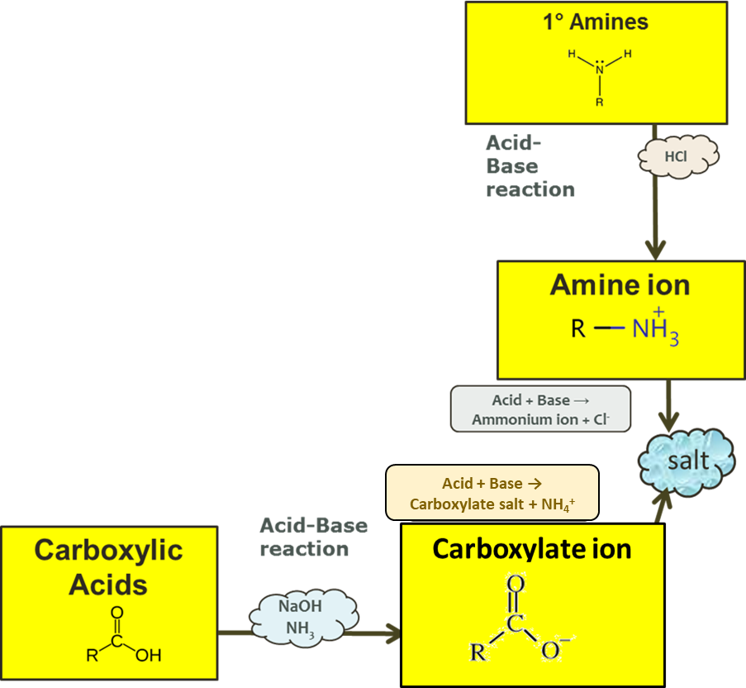

**Identifying unknown Substances (example flow chart)**

When identifying unknown substances, using the substances physical properties such as solubility, as well as chemical properties, such as whether they turn Litmus Red blue and Litmus Blue red or produce bubbles (CO2) when reacting with a base can help identify the functional group a substance belongs to. We can also use standard tests such as the observation of Bromine water or potassium permanganate to distinguish between alkanes and alkenes.

