**Physics 1.1 AS 90935 Investigation leading to linear relationship**

**WORKBOOK**

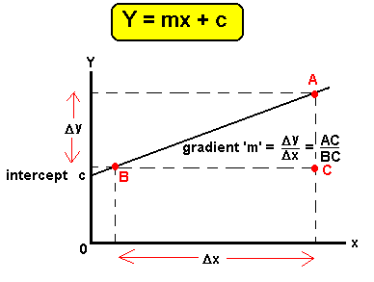

**CONTENTS**

1. Identifying Independent and dependent variables

2. Planning the Investigation

3. Processing the Data

4. Writing conclusions

5. Developing a Discussion



**Physics 1.1 AS 90935 Investigation leading to linear relationship**



Identifying Independent and dependent variables

**Success Criteria:** We know we have achieved this when we can:

* Identify the main steps of a Scientific Investigation
* Define the terms 'Independent variable, dependent variable and control'
* Be able to write an Aim / focus question to a given investigation

**1.** Put the following **terms into the correct order** for a typical Scientific Investigation (Number 1 – 5)

|  |  |  |  |
| --- | --- | --- | --- |
|  | **Number** |  | **Number** |
| method |  | conclusion |  |
| discussion |  | results |  |
| aim |  |  |  |

|  |  |
| --- | --- |
| **Definitions** | **What is that variable?** |
| **a.** You should only change one variable at a time which is called the: |  |
| **b.** You should be able to measure a variable changing which is called the: |  |
| **c.** The variables / factors you keep the same in your fair test are called**:** |  |

**2.** A 'fair test' is one in which you only change one thing (variable). **Complete the following definitions**

**3.** Your Aim or focus question **must include both variables**. For example: If I change (independent variable) how will it affect (dependant variable). Write down the **independent and dependent variables** then the **Aim** for the following investigations

a. A student wondered if the variegated (green and white) patches on a leaf made a difference to whether the leaf was able to make starch through the process of photosynthesis

|  |  |  |
| --- | --- | --- |
| **Independent variable** | **Dependent variable** | **Aim** |
|  |  |  |

b. Students observed a rubber ball bouncing back to different heights after it was dropped at different heights.

|  |  |  |
| --- | --- | --- |
| **Independent variable** | **Dependent variable** | **Aim** |
|  |  |  |

c. Cars appeared to take longer to brake on the same stretch of road in the wet weather compared to when the road was dry.

|  |  |  |
| --- | --- | --- |
| **Independent variable** | **Dependent variable** | **Aim** |
|  |  |  |

**Physics 1.1 AS 90935 Investigation leading to linear relationship**



Planning the Investigation

**Success Criteria:** We know we have achieved this when we can:

* Understand a method must be 'repeatable'
* Explain how variables can be controlled
* Define a 'range' for independent variables
* Explain the importance of multiple trials

**1.** An author of a cookbook is very careful to write out recipes that produce the same result every time someone uses it to cook food. Explain how this is **similar to writing the method** of an investigation and **why this is important.**

|  |
| --- |
|  |

**2.** given the following Aim of an investigation: write down the variables that **need to be controlled** and **how you will control them**: How does the roughness (grade) of sandpaper effect the distance a marble will roll along it?

|  |  |
| --- | --- |
| **Variables controlled** | **How will you control them?** |
|  |  |
|  |  |
|  |  |

**3.** Decide on a **suitable range** (and units) for the **Independent variable** in following investigations:

|  |  |
| --- | --- |
| **Investigation** | **Range and units** |
| a. Dropping a rubber ball at various heights and measuring how high it bounces |  |
| b. Changing the concentration of hydrochloric acid to see what effect it has on the reaction rate of magnesium metal (for a 1cm piece to disappear) |  |
| c. How will the number of bulbs affect the voltage in a series circuit? |  |

**4.** Discuss how increasing the number of trials, (times you repeat the investigation/ measurement for each value of the independent variable) can help make the **investigation more reliable**:

**Physics 1.1 AS 90935 Investigation leading to linear relationship**



Processing the Data

**Success Criteria:** We know we have achieved this when we can:

* Construct a line graph from given data
* Make sure your line graph has the following features; line of best fit, title, labels, units
* Understand that the relationship of variables can be written as a mathematical equation
* Calculate the gradient in a line graph

**1.** Make the **headings for the data table** (in the shaded boxes) below from the following Aim: How does the length of string on a bob of a pendulum, affect the time for one complete swing?

|  |  |  |  |  |
| --- | --- | --- | --- | --- |
|  |  | | | |
| Trial 1 | Trial 2 | Trial 3 | Average |
| 10cm | 0.7s | 0.7s | 0.8s |  |
| 15cm | 0.8s | 0.9s | 0.9s |  |
| 20cm | 1.3s | 1.3s | 1.4s |  |
| 25cm | 1.5s | 1.5s | 1.6s |  |
| 30cm | 1.8s | 3.8s | 1.9s |  |

**2.** From the data above which of the values does not appear to look correct? ____________________________

When a value looks much different from what an expected value it is called an **outlier** and we remove it by placing a line through it.

**3.** Average the following data in the table above. (After removing the outlier)

**4.** Using the following information draw a line graph below. Include title, line of best fit, labels and units



**5.** Calculate the gradient from the graph above using the following formula



* Remember the y axis will be the dependent variable
* The x axis will be the independent variable
* Select a good length of the straight line to calculate the gradient
* Do not start the gradient at 0,0

**6.** The relationship of the variables is stated as a mathematical equation **Y = gradient x X + intercept**

Write the equation for the line above.

**7.** A conclusion looks for patterns in collected data from an investigation. Both the variable that is changed (independent) and the variable that is measured (dependant) **must be included in the conclusion statement**.

The **data is used as evidence** in the conclusion. Write a conclusion for the investigation above.

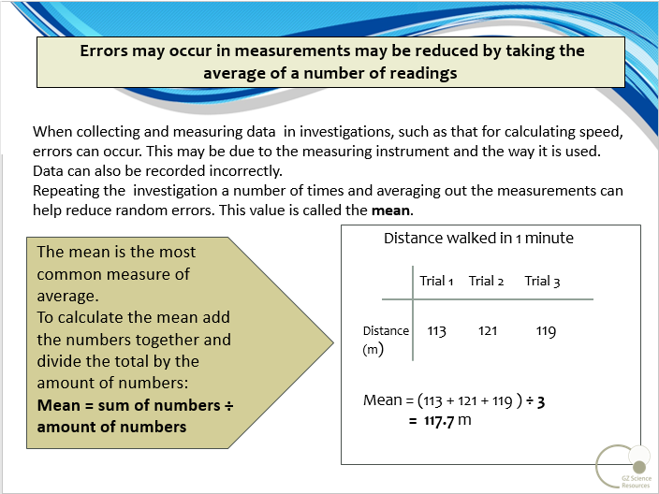

**Physics 1.1 AS 90935 Investigation leading to linear relationship**

**Physics 1.1 AS 90935 Investigation leading to linear relationship**



Writing conclusions

**Success Criteria:** We know we have achieved this when we can:

* Write a conclusion including the independent and dependent variables, linking to your aim
* Use data as evidence in your conclusion
* Include in your conclusion whether the relationship between Independent and Dependent variables is positive or negative

**1.** Use the following graph to **write a conclusion**



**2.** Write a suitable **title** for the graph. Remember to include both the **Independent** and **dependent** variable

**3.** Is this linear relationship negative or positive?

This would indicate that the dependent variable **increases / decreases** as the independent **increase / decreases**

(cross out one)

**4.** Calculate the gradient on the graph below

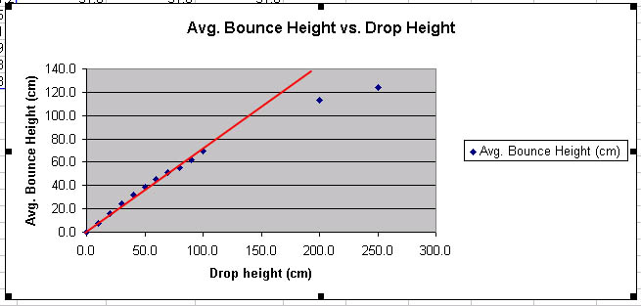



**3.** Is this linear relationship negative or positive?

**5.** Write a mathematic equation for the graph above. (Assume the intercept is 0,0)



**6.** Write a **Conclusion** for the investigation above.

Remember: Both the variable that is changed (independent) and the variable that is measured (dependant) **must be included in the conclusion statement**. The **data is used as evidence** in the conclusion.

**7.** Write the key features that your conclusion must include when writing **your Internal Assessment** in order to work towards an **Excellence** level

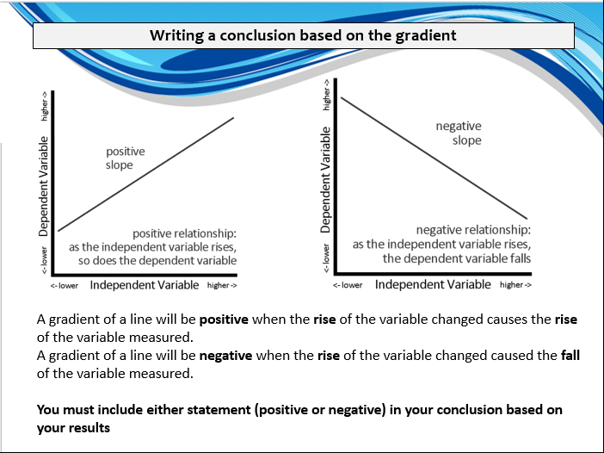

**Physics 1.1 AS 90935 Investigation leading to linear relationship**



Developing a Discussion

**Success Criteria:** We know we have achieved this when we can:

* Understand the key areas needed in a discussion; reliability, accuracy, Science ideas, areas of improvement
* Define and explain 'parallax error'
* Define and explain 'zero error'

**1.** Using the information from the conclusion below write a suitable Aim, list the Independent and dependent variables as well as variables that would need to be controlled.

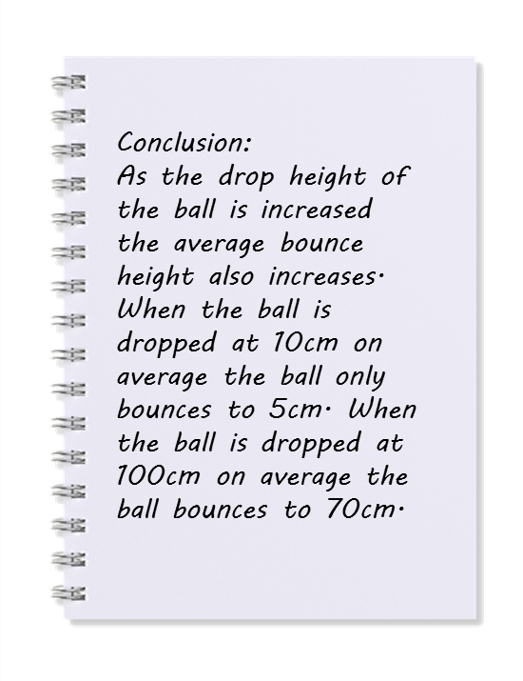

|  |  |  |
| --- | --- | --- |
| **Aim** | **Independent variable** | **Dependent variable** |
|  |  |  |

|  |  |
| --- | --- |
| **Controlled variable** | **How will the variable be controlled?** |
|  |  |
|  |  |
|  |  |

**2.** Accuracy: How will you ensure **parallax error** is avoided when measuring the height ball bounces?

**3.** **Accuracy:** How will you ensure **zero error** is avoided when measuring the height the ball bounces?

**4.** How was the **reliability** (the investigation can be repeated with **similar results**) ensured in this investigation? Name **TWO** key features of this investigation.