Chemistry 2.4 AS 91164 Demonstrate understanding of bonding, structure, properties and energy changes
Writing Excellence answers to Molecule Polarity questions
Molecule Polarity QUESTION
Question: The Lewis structures for two molecules are shown.
Ammonia, NH₃, is polar, and borane, BH₃, is non-polar. Justify this statement.
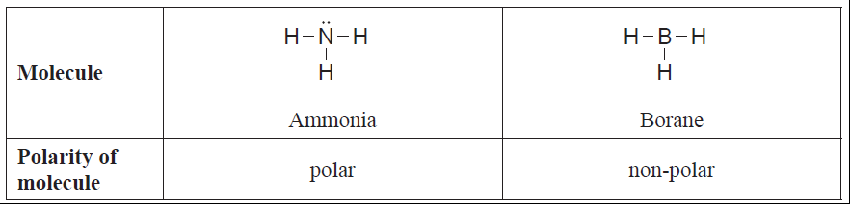

ANSWER
1. For the first molecule (name) state the types of bonds present (name atoms) and state whether they are polar (form a dipole) or non-polar due to electronegativity.

2. link electronegativity differences to sharing of electrons for your bond

3. state the shape of your molecule and link to being symmetrical or not and result in dipoles cancelling (or not)

4. link to final polarity of molecule

5. For the second molecule (name) state the types of bonds present (name atoms) and state whether they are polar (form a dipole) or non-polar due to electronegativity.
6. link electronegativity differences to sharing of electrons for your bond

7. state the shape of your molecule and link to being symmetrical or not and result in dipoles cancelling (or not)

8. link to final polarity of molecule

NOTE: The white column is how your answer would appear on your test paper so make sure you write out complete sentences. The grey area is just to help you structure your answer and would not appear in the question.

