Chemistry 2.6 AS 91166 Demonstrate understanding of chemical reactivity
Writing Excellence answers to Reaction Rates of Acids questions
Reaction Rates of Acids QUESTION
Question: The pH values of 0.100 mol L^{–1} solutions of two acids, HA and HB, are given in the table below.
(i) Compare the relative strengths of the two acids, HA_{(aq)} and HB_{(aq)}, using the information given above.
Your answer should include equations and calculations.
(ii) Predict and compare, with reasons, what would be observed when two 5 g samples of calcium carbonate chips, CaCO_{3(s)}, are reacted, separately, with excess HA and HB.
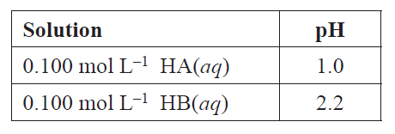
ANSWER
1. Write an equation for HA
[Remembering H₃O⁺ must be produced]
2. Calculate H₃O⁺ for HA
[H₃O⁺] = 10^{-pH}

3. For HA link concentration of ions formed to level of dissociation AND compare to concentration of acid (are they the same?)
4. Write an equation for HB
[Remembering H₃O⁺ must be produced]
5. Calculate H₃O⁺ for HB
[H₃O⁺] = 10^{-pH}

6. For HB link concentration of ions formed to level of dissociation AND compare to concentration of acid (are they the same?)
7. For HA link observation of reaction to concentration of ions

8. then For HA link collision frequency to rate of reaction

9. For HB link observation of reaction to concentration of ions

10. then For HB link collision frequency to rate of reaction

NOTE: The white column is how your answer would appear on your test paper so make sure you write out complete sentences. The grey area is just to help you structure your answer and would not appear in the question.

