Science 1.9 AS 90948 Demonstrate understanding of biological ideas relating to genetic variation
Writing Excellence answers to Test Cross questions
Test Cross QUESTION
Question: Discuss how a farmer could develop a group of sheep that are pure breeding for white wool. Use R to represent the dominant allele for common white wool, and r to represent the recessive allele for black wool.
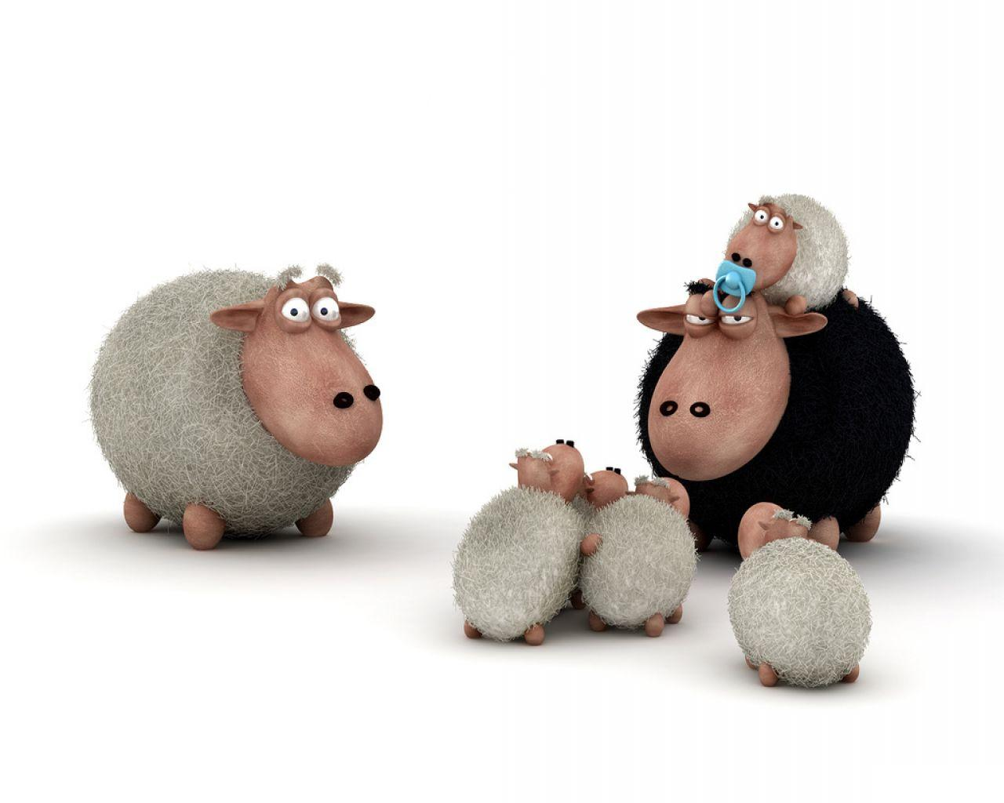
In your answer you should:
• state the genotypes of the male and female sheep the farmer should use to
breed from
• explain how the animal breeder can determine the genotypes of the male
and female to produce sheep that all have white wool.
You should include at least two Punnett squares with your explanation
• explain how the animal breeder could make sure that the offspring would
always be pure breeding.
ANSWER
1. Explain the genotype of the parents needed to produce a pure breeding white group

2. describe how a test cross could be used to find out a sheep genotype (RR or Rr)
Draw 2 Punnett Squares
3. explain the results of the test cross if the sheep was RR (Homozygous dominant) or pure breeding – link to Punnett Square

4. explain the results of the test cross if the sheep was Rr (Heterozygous)or not pure breeding – link to Punnett Square

5. explain the need for many crosses and link to chance
6. explain the requirements for a pure breeding white flock of sheep

7. discuss how a farmer could continue to develop a pure breeding white flock of sheep

NOTE: The white column is how your answer would appear on your test paper so make sure you write out complete sentences. The grey area is just to help you structure your answer and would not appear in the question.

