Chemistry 3.6 AS 91392 Demonstrate understanding of equilibrium principles in aqueous systems
Writing Excellence answers to Titration Curve – Equivalence Point pH questions
Titration Curve – Equivalence Point pH QUESTION
Question: 20.00 mL of 0.320 mol L^{–1} ammonia, NH₃, is titrated with 0.640 mol L^{–1} hydrochloric acid, HCl.
pK_{a}(NH₄⁺) = 9.24
Show, by calculation, that the pH at the equivalence point (point C) is 4.96.
K_{w} = 1 x 10⁻¹⁴
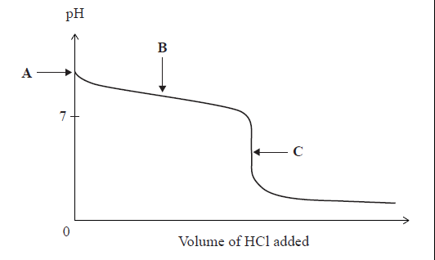
ANSWER
1. determine if equivalence point is greater or less than 7 (from curve or strong base/weak acid strong acid/weak base
And write down all available information
2. Write down neutralisation equation

3. calculate n(Base) to neutralise (and reach equivalence point and therefore n(Acid) from 1:1 equation)
n = cv
also assume n(NH₃) = n(NH₄⁺)
3sgf and units
4. calculate v(Acid) to neutralise
(n(NH₃) = n(HCl) from 1:1 equation)
v=n/c
3sgf and units
5. calculate c(B⁺)
c = n/total v

also assume n(B) = n(B⁺) see step 3.
B = NH₃ B+ = NH₄⁺
total v = start volume base + v acid added
3sgf and units
6. calculate [H₃O⁺]
K_{a} = 10^{-pKa}
[H₃O⁺] = √ Ka x c(B⁺)

3sgf and units B⁺ = HA
7. Calculate pH
pH = -log [H₃O⁺]
3sgf
Check pH against estimate on curve
NOTE: The white column is how your answer would appear on your test paper so make sure you write out complete sentences. The grey area is just to help you structure your answer and would not appear in the question.

