**Mechanics 1.1 AS 90940 Mechanics**



Formula revision Part 1

**Success Criteria:** We know we have achieved this when we can:

**Remember to answer questions:**

1. Write down formula

2. Rearrange formula if needed

3. Show working

4. Give answer with units

* Construct a Formula equation for Motion, Force and Pressure
* Be able to give the names and units used in each Formula
* Be able to solve a simple question using each Formula

**1.** Calculating **speed (velocity)** - Fill in triangle and give names and units for each Letter

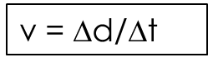

|  |  |  |
| --- | --- | --- |
| Letter | Name | Units |
| v |  |  |
| d |  |  |
| t |  |  |

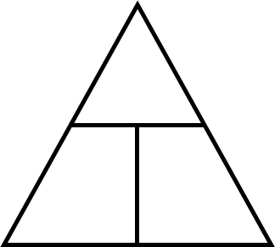

Sample Question: A cyclist rides at a speed of **20 m s–1** for **30 seconds**. Calculate the **distance** she travels.

____________________________________________

____________________________________________

____________________________________________

____________________________________________

**2.** Calculating **acceleration** - Fill in triangle and give names and units for each Letter

|  |  |  |
| --- | --- | --- |
| Letter | Name | Units |
| a |  |  |
| v |  |  |
| t |  |  |



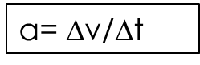

Sample Question: A car accelerates from **5 m s−1** and reaches a speed of **20 m s−1**

If the car takes **12 s** to reach this speed, calculate the **acceleration** of the car.

____________________________________________

____________________________________________

____________________________________________

____________________________________________

**3.** Calculating **Force (general)** - Fill in triangle and give names and units for each Letter

|  |  |  |
| --- | --- | --- |
| Letter | Name | Units |
| F |  |  |
| m |  |  |
| a |  |  |





Sample Question: A car broke down and needs to be pushed. Three people pushed the car with a force of **450 N.** Friction can be ignored. If the car with the driver inside it had a mass of **900 kg**, calculate the car’s **acceleration.**

____________________________________________

**Remember to convert mass to weight:**

F (weight) = Mass x Gravity

Acceleration due to gravity = 10ms-2

____________________________________________

____________________________________________

____________________________________________

**4.** Calculating **pressure** - Fill in triangle and give names and units for each Letter

|  |  |  |
| --- | --- | --- |
| Letter | Name | Units |
| P |  |  |
| F |  |  |
| A |  |  |





Sample Question: A **70 kg** snowboarder stands uses a snowboard which has a mass of **2.5 kg.** The snowboard has a surface area in contact with the snow of **0.60 m2.** Calculate the pressure on the snow.

____________________________________________



____________________________________________

____________________________________________

____________________________________________



