Chemistry 3.6 AS 91392 Demonstrate understanding of equilibrium principles in aqueous systems
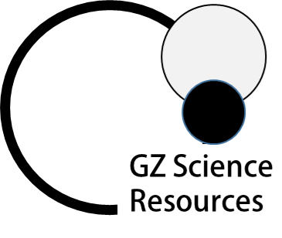
Writing Excellence answers to Concentration of Species questions
Concentration of Species QUESTION
Question: Ethyl ammonium chloride, CH₃CH₂NH₃Cl, is a weak acid that will also react with water.
List all the species present in a solution of CH₃CH₂NH₃Cl, in order of decreasing concentration.
Do not include water.
Justify the order you have given.
Include equations, where necessary.

ANSWER
1. write the equation for the dissociation of salt

2. link to complete dissociation AND formation of an (spectator) ion that does not react further so will be in greatest concentration

3. write the equation for the weak acid (formed from equation above) in water
4. link to partial dissociation due to being a weak acid AND most will remain so will be next in concentration

5. Explain H₃0⁺ ions are formed during reaction in same quantity as conjugate PLUS small contribution from water AND so will be next in concentration

6. Explain conjugate base are formed during reaction in same quantity as H₃0⁺ AND so will be next in concentration
(but both H₃0⁺ ions and conjugate will be at smaller concentration to acid as only weak acid)
7. Finally Explain OH- ions present in small amounts from water dissociation only AND so will be last in concentration

8. list species in order

NOTE: The white column is how your answer would appear on your test paper so make sure you write out complete sentences. The grey area is just to help you structure your answer and would not appear in the question.

