Science 1.1 AS 90940 Demonstrate understanding of aspects of mechanics
Writing Excellence answers to Distance in a speed-time graph questions
Distance in a speed-time graph QUESTION
Question: In 16 s, Bird B travelled 121.5 m.
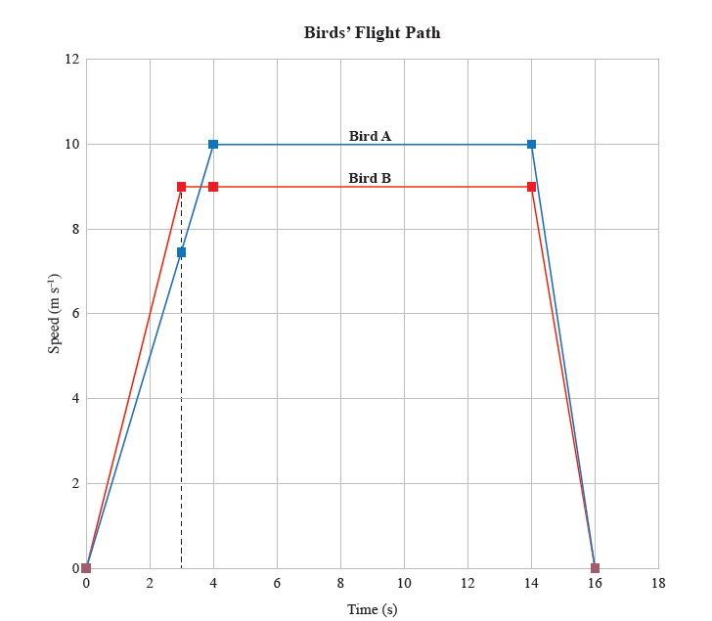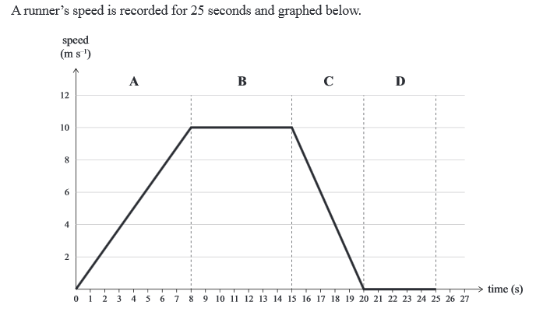
How much further did Bird A travel in the same time?
Show all working.

ANSWER
1. divide the are under the graph (for bird A) in the smallest number of rectangles and triangles

2. calculate the area for section A – a triangle

Area = ½ base x height
Or Distance = ½ v x t
3. calculate the area for section B – a rectangle

Area= base x height
Or Distance = v x t
4. calculate the area for section C – a triangle

Area = ½ base x height
Or Distance = ½ v x t
5. add all 3 sections together and show working plus units

6. subtract one distance from the other to show the differences in distance

7. compare between the distances of both birds and state which has flown the furthest

NOTE: The white column is how your answer would appear on your test paper so make sure you write out complete sentences. The grey area is just to help you structure your answer and would not appear in the question.

