Science 1.9 AS 90948 Demonstrate understanding of biological ideas relating to genetic variation
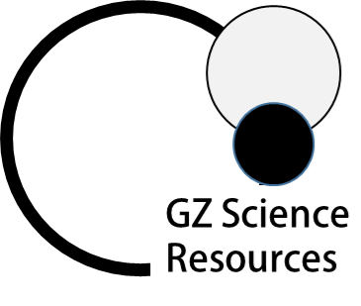
Writing Excellence answers to DNA and Genes questions
DNA and Genes QUESTION
Question: Use the diagram below to help you explain the relationship between chromosomes, genes, alleles, phenotype, genotype, and the molecule DNA.

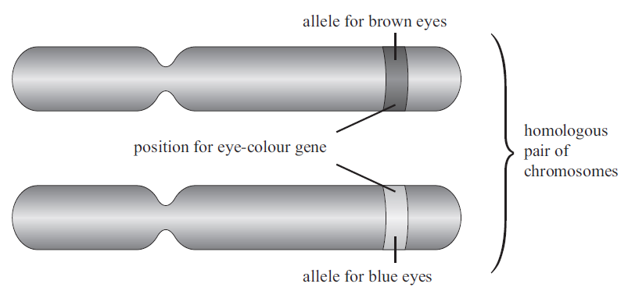

ANSWER
1. explain link between chromosomes and DNA

2. describe the physical structure of DNA

3. Explain the pairing rule of DNA

4. link the base sequence to trait and gene (use example)

5. Give the definition for an allele (use example)

6. link pair of chromosomes to pair of alleles
7. link alleles to base sequence

8. give the definition of a genotype

9. link genotype to phenotype

10. give definition of dominant alleles
11. give definition of recessive alleles

NOTE: The white column is how your answer would appear on your test paper so make sure you write out complete sentences. The grey area is just to help you structure your answer and would not appear in the question.

