Chemistry 2.6 AS 91166 Demonstrate understanding of chemical reactivity
Writing Excellence answers to Equilibrium – Pressure questions
Equilibrium – Pressure QUESTION
Question: The two reactions shown in the following table are both at equilibrium.
Compare and contrast the effect of increasing the pressure on both reactions, with reference to the equilibrium positions.
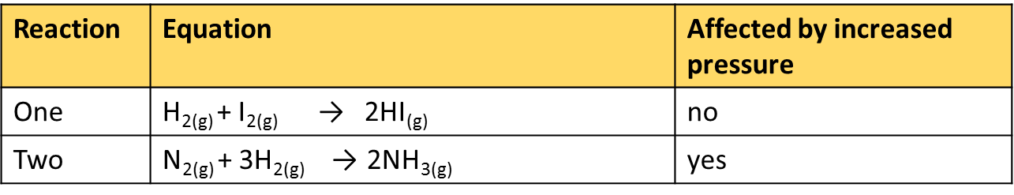
ANSWER
1. State the equilibrium principle

2. Describe the factor in your question AND Link increasing the principle to how the system responds

[some questions will be decreasing]

3. Generally, explain which side of the equation is favoured (relate to moles) AND the general observations – at visible and particle level.

4. Specifically, in reaction one describe number of moles in both sides of the equation AND link to which direction of reaction would be favoured (and observation)

5. Specifically, in reaction two link number of moles in both sides of the equation to observation AND link to which direction of reaction would be favoured

6. Describe how the system shift in reaction two would effect at particle level AND final observation.

NOTE: The white column is how your answer would appear on your test paper so make sure you write out complete sentences. The grey area is just to help you structure your answer and would not appear in the question.

