Chemistry 2.6 AS 91166 Demonstrate understanding of chemical reactivity
Writing Excellence answers to Equilibrium – Temperature questions
Equilibrium – Temperature QUESTION
Question: In a reaction, the brown gas nitrogen dioxide, NO_{2(g)}, exists in equilibrium with the colourless gas dinitrogen tetroxide, N₂O_{4(g)}. The equation for this reaction is represented by:
2NO_{2(g)} ↔ N₂O_{4(g)}
brown gas colourless gas
The table below shows the observations when changes were made to the system. Analyse these experimental observations.
In your answer you should:
• link all of the observations to equilibrium principles
• justify whether the formation of dinitrogen tetroxide from nitrogen dioxide is endothermic or exothermic.
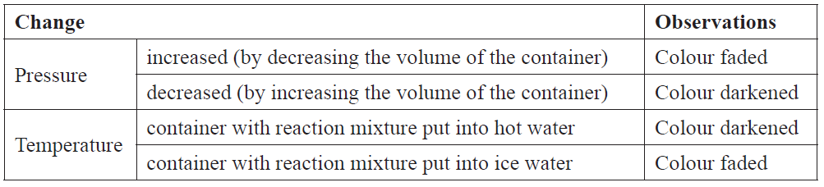
ANSWER
1. State the equilibrium principle

2. Describe the factor in your question AND Link the principle to how the system responds to cooling or heating

3. Generally, explain which side of the equation is favoured (relate to endothermic or exothermic)

4. Specifically, for your reaction with heating, link the observation to which direction of reaction would be favoured (endothermic or exothermic)
5. Describe how the system shift in heating would affect which products are made AND final observation.

6. Specifically, for your reaction with cooling, link the observation to which direction of reaction would be favoured (endothermic or exothermic)
7. Describe how the system shift in cooling would affect which products are made AND final observation.

NOTE: The white column is how your answer would appear on your test paper so make sure you write out complete sentences. The grey area is just to help you structure your answer and would not appear in the question.

