Science 1.9 AS 90948 Demonstrate understanding of biological ideas relating to genetic variation
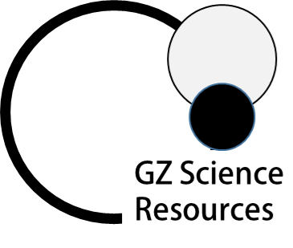
Writing Excellence answers to inheritable or non-inheritable variation questions
inheritable or non-inheritable variation QUESTION
Question: The Venus flytrap plants come in a number of different types, such as
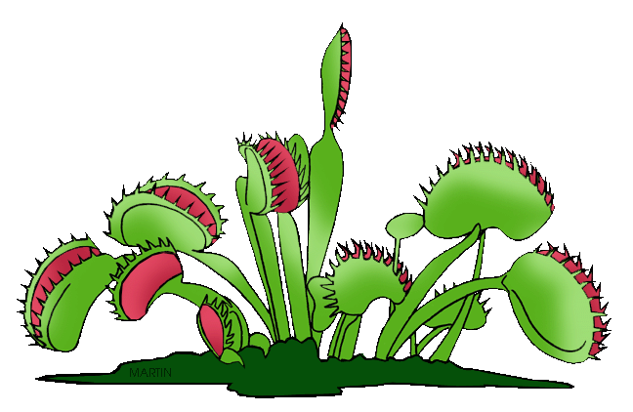
the “B-52” with a red leaf. A teacher brought two identical plants to class and put
them in different parts of the classroom. The Venus flytrap put near a window grew
short leaves and the Venus flytrap in the shade grew long leaves. Colour variation in
the leaves of the Venus flytraps can be passed on to a plant’s offspring, but the
different leaf length cannot.
Explain why. In your answer you should:
•define inheritable and non-inheritable variation
•explain what causes inheritable and non-inheritable variations.
ANSWER
1. define the term inheritable variation

2. Explain what effect inheritable variation has

3. define the term non-inheritable variation

4. Explain what effect non-inheritable variation has

5. link the phenotype related to inherited variation (give example from question)

6. link the phenotype related to non-inherited variation (give example from question)

7. complete the final statement | Genetics determines the characteristics you will be born with and this is called __________________________, but environment then affects these characteristics once you are born and this is called __________________________.

NOTE: The white column is how your answer would appear on your test paper so make sure you write out complete sentences. The grey area is just to help you structure your answer and would not appear in the question.

