Science 1.9 AS 90948 Demonstrate understanding of biological ideas relating to genetic variation
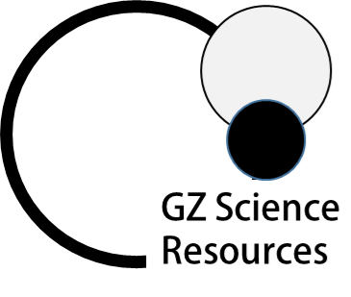
Writing Excellence answers to Inheritance predictions questions
Inheritance predictions QUESTION
Question: Huntington’s disease is a genetic disorder in humans. It is caused
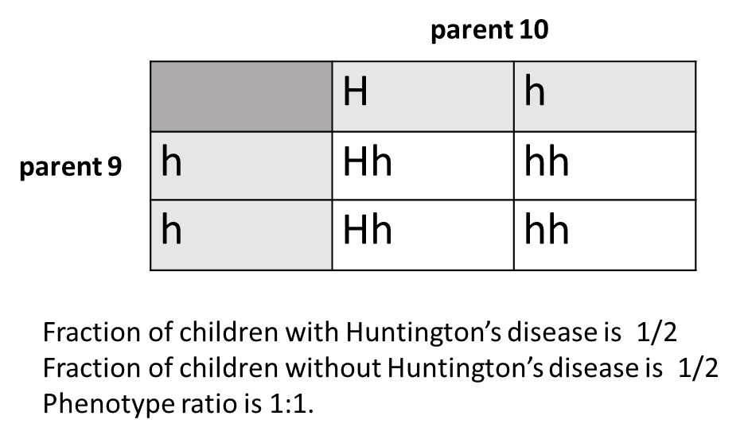
by a dominant allele (H). The normal allele is recessive (h).
In the pedigree chart the phenotype ratio of Huntington’s disease
in the children of parents 9 and 10 is not the same as the predicted ratio in the
Punnett square
Give reasons why the predicted ratio in the Punnett square and the observed
ratio in the children may NOT be the same.

ANSWER
1. describe the purpose of Punnett squares

2. describe the purpose of a pedigree chart.

3. explain fertilisation as a random event

4. link phenotype of offspring to allele they have inherited (use example from question)

5. give phenotypes of offspring in pedigree chart and number of each | 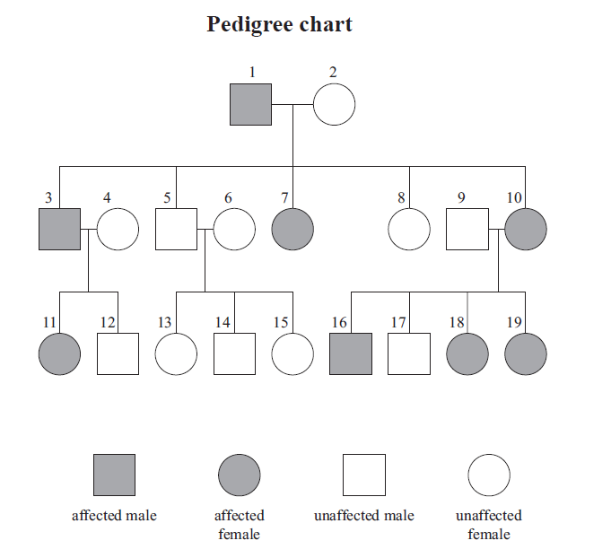
6. compare to phenotypes predicted in Punnett square and number of each

NOTE: The white column is how your answer would appear on your test paper so make sure you write out complete sentences. The grey area is just to help you structure your answer and would not appear in the question.

