Chemistry 2.6 AS 91166 Demonstrate understanding of chemical reactivity
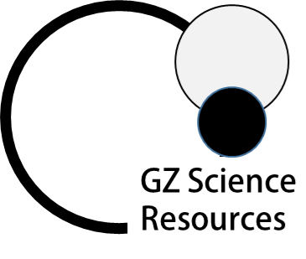
Writing Excellence answers to Ions and Conductivity questions
Ions and Conductivity QUESTION
Question: Some properties of three aqueous solutions A, B and C, of equal concentration are shown in the table below. It is known that the solutions are NH_{3(aq)}, HCl_{(aq)} and NH₄Cl_{(aq)}
Justify the identification of all three solutions.
• refer to both pH and electrical conductivity of the solutions
• link your answers to appropriate chemical equations.
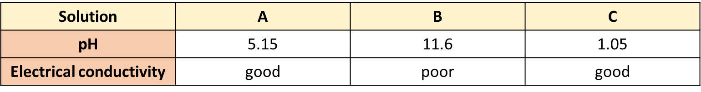
ANSWER
1. Identify each solution as either A, B or C by linking to being a weak or strong acid or base and also to the pH
2. State requirements for conductivity

3. Solution A (pH 5.15) weak acid salt.
Equation 1. [A salt will first dissociate fully into ions]

Write equation AND link ions formed to conductivity and level of dissociation
4. Solution A (pH 5.15) weak acid salt.
Equation 2.[One of the products of dissociation will further react as an acid]

Write equation AND link ions formed to conductivity and level of dissociation (must form H₃O⁺ ions)

5. Solution B (pH 11.6) weak base.

Write equation AND link ions formed to conductivity and level of dissociation (must form OH⁻ ions)

6. Solution C (pH 1.05) strong acid.

Write equation AND link ions formed to conductivity and level of dissociation (must form H₃O⁺ ions)

NOTE: The white column is how your answer would appear on your test paper so make sure you write out complete sentences. The grey area is just to help you structure your answer and would not appear in the question.

