Chemistry 2.6 AS 91166 Demonstrate understanding of chemical reactivity
Writing Excellence answers to Reaction Rate Factors – Temperature questions
Reaction Rate Factors – Temperature QUESTION
Question: A particular reaction is complete when the solution turns cloudy and the paper cross under the flask can no longer be seen. The following experiments were carried out, and the times taken for the cross to disappear recorded. Elaborate on why the reaction in Experiment 2 occurred faster than the reaction in Experiment 1.
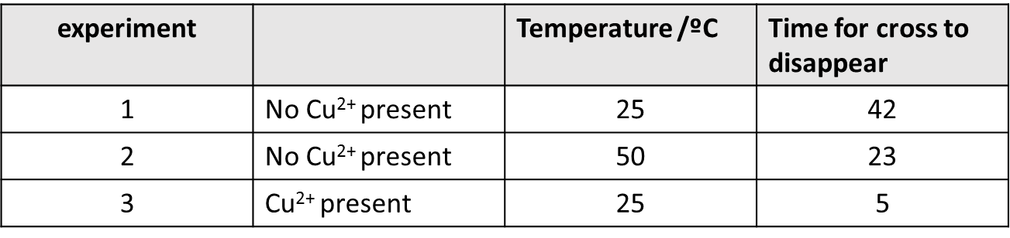
ANSWER
1. state the collision theory

2. Describe the reactants in your reaction and state which factors are the same

3. Describe the reactants in your reaction and state which factor is different (the factor affecting reaction rate)
4. link the factor to the collision theory (activation energy)

5. link the reaction to more of the collisions being successful occurring per unit of time
6. next link the factor to the collision theory (faster moving particles)

7. link the reaction to more successful collisions occurring per unit of time
8. link to more products (name products) being formed per unit of time AND link to a faster reaction rate
9. summarize the reaction with the slower reaction rate

10. Explain that both reactions will produce the same amount of product eventually as they started with the same amount of reactants

NOTE: The white column is how your answer would appear on your test paper so make sure you write out complete sentences. The grey area is just to help you structure your answer and would not appear in the question.

