Chemistry 2.4 AS 91164 Demonstrate understanding of bonding, structure, properties and energy changes
Writing Excellence answers to Molecule shapes and bond angle questions
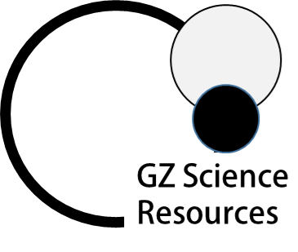
Molecule shapes and bond angle QUESTION
Question: Carbon atoms can bond with different atoms to form many different compounds. The following table shows the Lewis structure for two molecules containing carbon as the central atom, CCl₄ and COCl₂.
These molecules have different bond angles and shapes. Evaluate the Lewis structure of each molecule to determine why they have different bond angles and shapes.
In your answer you should include:

- The approximate bond angle in each molecule
- The shape of each molecule
- Factors that determine the shape and bond angle
for each molecule.

ANSWER
1. for first molecule (name) state number of regions of negative charge around the central atom (name central atom)

2. state the Valence shell electron pair repulsion (VSEPR) theory

3. state the base arrangement of negative regions and the bond angle they form

4. state the number of bonded and non-bonded regions AND the final shape of the first molecule

5. for second molecule (name) state number of regions of negative charge around the central atom (name central atom)
6. state the Valence shell electron pair repulsion (VSEPR) theory

7. state the base arrangement of negative regions and the bond angle they form

8. state the number of bonded and non-bonded regions AND the final shape of the second molecule

9. compare differences in bond angle linked to number of regions of negative charge.

NOTE: The white column is how your answer would appear on your test paper so make sure you write out complete sentences. The grey area is just to help you structure your answer and would not appear in the question.

