Science 1.9 AS 90948 Demonstrate understanding of biological ideas relating to genetic variation
Writing Excellence answers to Variation and Survival questions
Variation and Survival QUESTION
Question: Discuss why variation caused by sexual reproduction in a population
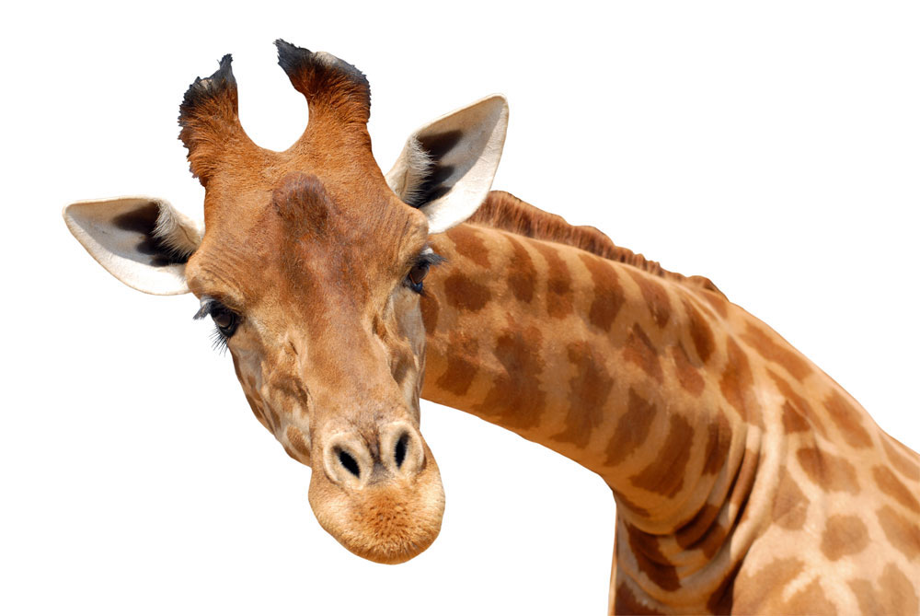
of plants or animals is an advantage in a changing environment, such as a period
of drought (a period of time of very dry weather, when there is no or very little rain).
Support your answers with examples.

ANSWER
1. define genetic variation

2. explain sexual reproduction as the process that gives individuals genetic variation

3. link advantage to survival to changing environment

4. discuss your example and link to how it is an advantage in a drought (or other changing environment)

5. link survival of some to survival of the species

NOTE: The white column is how your answer would appear on your test paper so make sure you write out complete sentences. The grey area is just to help you structure your answer and would not appear in the question.

